Filozofická fakulta
Media Literacy in EFL
Magisterská diplomová práce
Bc. Tomáš Pelc

Vedoucí práce: Mgr. Jana Kubrická, Ph.D.
Katedra anglistiky a amerikanistiky
Program Učitelství anglického jazyka a literatury pro střední školy
Brno 2023

Bibliografický záznam
Autor: Bc. Tomáš Pelc
Filozofická fakulta
Masarykova univerzita
Katedra anglistiky a amerikanistiky
Název práce: Media Literacy in EFL
Studijní program: Učitelství anglického jazyka a literatury pro střední školy
Vedoucí práce: Mgr. Jana Kubrická, Ph.D.
Rok: 2023
Počet stran: 103
Klíčová slova: Mediální výchova, mediální gramotnost občanské online uvažování, akční výzkum, dezinformace, kritické myšlení

Bibliographic record
Author: Bc. Tomáš Pelc
Faculty of Arts
Masaryk University
Department of English and American Studies
Title of Thesis: Media Literacy in EFL
Degree Programme: Upper Secondary School Teacher Education in English Language and Literature
Supervisor: Mgr. Jana Kubrická, Ph.D.
Year: 2023
Number of Pages: 103
Keywords: Media education, media literacy, civic online reasoning, action research, disinformation, critical thinking

Anotace
Tato magisterská diplomová práce se zabývá výukou mediální gramotnost v hodinách Anglického jazyka a literatury. Práce si klade za cíle pomocí akčního výzkumu vyzkoušet aplikaci existujících zahraničních materiálů v českých školách. Práce obsahuje obhajobu mediální výchovy, přehled dostupných materiálů a školení, a limitace současného poznání, společně s návrhy pro budoucí výzkum. Výstupem empirické části práce jsou tipy na zavedení existujících materiálů do výuky anglického jazyka, identifikace nutných dovedností vyučujících, a doporučení pro zasazení občanského online uvažování do školních osnov.
Abstract
This master’s thesis deals with teaching media literacy in English as a foreign language lessons. The aim of the thesis is to trial out existing foreign language materials in Czech schools via an action research design. The thesis contains a justification of media education, an overview of existing materials and teacher training opportunities, and limitations of current knowledge, accompanied by suggestions for further research. The outcomes of the empirical part are tips for the incorporation of existing materials into EFL lessons, the identification of abilities necessary for the teachers, and advice on the incorporation of Civic Online Reasoning into school curricula.

Declaration
I hereby declare that the thesis titled Media Literacy in EFL that I have submitted for assessment is entirely my original work, and that no part of it has been taken from the work of others unless explicitly cited and acknowledged within the text of my thesis.
Brno April 30, 2023 ....................................... Bc. Tomáš Pelc

Acknowledgements
I would like to sincerely thank my supervisor Mgr. Jana Kubrická, Ph.D. for her help, suggestions, feedback and mostly her interest in the topic of my thesis. I would also like to thanks my mentors Mgr. Karel Buchta and Mgr. Kristýna Jochová for allowing me to trial out the materials in their lessons. Another thanks goes to my close ones for their moral support, and last but not least to my friends for setting an impossibly high bar.

Table of Contents
Glossary 13
List of Appendices 14
1 Introduction 15
2 Theoretical part 17
2.1 State of media literacy 17
2.2 The need for school interventions 21
2.3 Bringing COR into classrooms 26
2.4 Epistemology 31
2.5 Civic Online Reasoning in the Czech education system 35
3 Literature review 39
3.1 Review of Czechoslovak journals 45
3.2 Available materials 46
4 Empirical part 49
4.1 Research question 49
4.2 Methods 50
4.3 Participants 51
4.4 Procedure 52
4.5 Results 54
4.6 Discussion 56
4.7 Limitations 58
5 Conclusion 59
Bibliography 61
Appendix A Lesson plans 76
A.1 Who’s behind the information? 76
A.2 What’s the evidence? 83
A.3 What do other sources say? 93
Appendix B Evaluation criteria 100

Glossary
COR – Civic Online Reasoning
EFL – English as a Foreign Language
LLM – Large Language Models
CRAAP – Currency, Relevance, Authority, Accuracy, Purpose
OECD – Organisation for Economic Cooperation and Development
JSNS – Jeden svět na školách (One World in Schools)
IPS – Information Problem Solving
FEP – Framework Education Programme

List of Appendices
Appendix A [Lesson plans] 74
Appendix B [Evaluation criteria] 98

Introduction
In recent years, there has been a rise in misinformation. To put it bluntly, the Internet is filled with lies. From the resurrection of the flat earth society (Burdick, 2018), through a satirical Birds are not Real conspiracy (Lorenz, 2021), to the infamous stolen election conspiracy and the subsequent insurrection in the United States. Simply, it does not take much effort to fall down a rabbit hole of “alternative facts” (Political Dictionary, 2023).
Although conspiracy theories and misinformation are not a new phenomenon, after all, it was nearly twenty years ago when an aid to president George W. Bush mockingly referred to his critics as the “reality-based community” (Suskind, 2004), there is no doubt that the impact of false information on the Internet is nowadays greater than before.
Education pundits have been calling for more “critical thinking” in schools, as a way of solving the rise in extremism and populism, and they have been calling for this for a while now. In spite of this, it does not seem that the callings have been heard, as students still fall for biased and unwarranted information online (Jeden svět na školách, 2023, p. 13).
This thesis will thus aim to unravel how media literacy could be incorporated into school curricula, specifically into the lessons of English as a foreign language. The thesis will mostly deal with Civic Online Reasoning, which is a subsection of media and digital literacy. Civic Online Reasoning, or COR for short, is a set of knowledge and abilities that are needed in order to consume only warranted and trustworthy information from online sources if possible, and if not, evaluating the sources and the evidence in order to spot any conflict of interests, or manipulation attempts. Theoretically, efficient wielders of COR will locate the most trustworthy and useful sources for their query, and use biased sources with a justifiable amount of scepticism, fact-checking and cherry-picking arguments from those sources as needed.
In order to promote COR, the thesis will start with a justification for its need, referencing literature on the rise of misinformation, the inability of people to use the Internet effectively, and also citing strategic documents that are shaping the Czech education system. After that, a short overview of what actually constitutes a good behaviour on the Internet will be provided along with guidelines for implementing COR into classrooms. A chapter on epistemology, which affects the success with which people use the Internet to obtain information, will of course not be omitted.
After that an overview of the literature on COR will be presented, with a short chapter on the state of the Czech literature on this topic. As this thesis aims to be of practical value to educators, a separate chapter will be devoted to the summary of easily accessible materials and workshops.
Finally, the empirical part will consist of me trialling out existing materials, and via the action research methodology, trying to figure out whether they are suitable for implementation in EFL lessons in Czech public schools. Although the thesis will not advance the literature in any significant way, my hope is that it will not be in vain and that at the very least the overview of materials will help teachers interested in this topic with the preparation of their lessons.

Theoretical part

State of media literacy
Despite being born in the 21st century, with the Internet and digital services widely available for anyone from the youngest age, current students do not seem to live up to the idea of “digital natives”. On the contrary, a vast number of studies suggest that today’s youth is no better equipped to navigate the overwhelming amount of news and content that is available to them, than the older generations (Keengwe, 2007; Kirschner & De Bruyckere, 2017; Margaryan et al., 2011; McGrew et al., 2018; Nygren & Guath, 2019; Rowlands et al., 2008, 2008). As Lurie & Mustafaraj (2018, p. 107) say, “digital natives are mostly a myth” which means that modern educators need to discard this idea in order to prepare their students for success in the real world.
To present just one example of current youth not behaving responsibly in the online world, students “rarely ask who created online sources” (McGrew et al., 2018, p. 183), and they bring this lack of concern even into their studies, not evaluating their sources and the information they include even when doing class projects or writing papers (Walraven et al., 2013, p. 126). This is not a new finding, Bendixen & Rule warned about the lack of an evaluativist mindset nearly twenty years ago (2004, p. 76), yet their warnings have not been headed, as will now be shown.
When looking for information online, students often do not concern themselves with the reliability of the sources (Kammerer et al., 2016, p. 60), mostly clicking on the first handful of websites in their search results page (McGrew et al., 2018; McGrew & Chinoy, 2022), even when the results were manipulated so as to include less reliable websites at the top of the page and the most reliable website at the bottom (McGrew et al., 2018, p. 167). In this way, students rely on complicated and obscure algorithms of the search engines that they use to provide them with the most trustworthy and relevant sources. With the advent of advanced Large Language Models (LLMs), this should pose a great concern, as the new search engines might be even less transparent than the ones currently in use (Roose, 2023).
Another problem is that even when students decide not to click on the first search result but try to be more selective of the sources used, they mostly rely on their imperfect intuitions during evaluation. One of the most cited criteria of source evaluation is the design of the webpage (Goldman, 2011; Lurie & Mustafaraj, 2018, p. 109; McGrew, 2021a, 2021b; McGrew et al., 2018, p. 183; McGrew & Chinoy, 2022, p. 47; Muis et al., 2022, p. 239; Wineburg & McGrew, 2019). Design or typography is also mentioned in the CRAAP test (Meriam Library, 2010), which is a widely referenced checklist designed to be a helpful tool for website evaluation. But being designed in early 2000s, it is no longer relevant. The fake news that can be encountered today is not full of typos, as the infamous e-mails from supposedly disposed princes from various African countries were. When disinformation creators can create pictures of Anthony Fauci being arrested in mere minutes (S. Thompson, 2023), identifying unreliable sources by the appearance of the site they are located on is neither appropriate nor effective.
Another outdated criterion by which students often evaluate their sources of information (and coincidentally a criterion also included in the CRAAP test) is the domain of the website and the date of publication (Breakstone et al., 2021; Durante, 2022; Lurie & Mustafaraj, 2018, pp. 107–108; McGrew et al., 2018). Although the date of publication is an important aspect when evaluating credibility, it should hardly be the foremost criterion on the minds of internet users. Concerning the domain name, in the United States, .gov domain is generally taken to be more trustworthy than other domains, but that might not always be the case, and the students should keep any potential bias of the governmental institutions on mind. Furthermore, there is no specialised domain for the Czech governmental institutions, thus, even in case of the .gov domain name being a helpful evaluation tool, it would not be transferable into the Czech context.
To come to the most troubling finding, when researching various topics, students often selectively pick information and sources of information that are the most useful to the task at hand, ignoring their reliability (Al Bulushi, 2022; Argelagós & Pifarré, 2012; List et al., 2016; McGrew, 2020, p. 516, 2021a; Walraven et al., 2009, p. 244); and judge the trustworthiness of sources based on their intuition or pre-existing views (Lurie & Mustafaraj, 2018, p. 113; Pretorius, 2018, p. 402; Walraven et al., 2009, p. 235, 2010, p. 717). This strategy guarantees that the students will not create a complex mind-map of a given problem, but instead they will succumb to their innate and potent confirmation bias, resulting in important contradictory information being omitted from their decision making, leading to worse results in their potential academic lives, and worse outcomes of their political, financial or personal decisions.
Furthermore, these gloom findings come from research done on a variety of demographic groups in several countries, suggesting a lack of a systematic approach to teaching COR (or media literacy in general). Walraven et al. (2009, p. 235) present an overview of the research on this topic done up to 2009, and point to the fact that the lack of COR skillset is shared amongst all age groups, including university students. In 2014 Mason et al. (2014, p. 144) provided a similar overview, concluding that “inappropriate behaviour does not disappear with age and grade level as skills of epistemic evaluation of online information may be unsophisticated even at college level.” There surely are differences between younger and older learners (Goldman, 2011, pp. 238–239), for example, teenagers seem not to have developed useful strategies for locating valid and relevant sources (i.e. they use inefficient keywords or do not define their problem/task correctly) (Argelagós & Pifarré, 2012, p. 516), whereas college students, look in the wrong places, such as Wikipedia or pop-science articles, instead of scientific databases (McGrew & Chinoy, 2022, p. 46). Sadly, the lack of COR skillset does not end with college students, but was also detected in university professors (Breakstone et al., 2018, p. 28). That said, despite different problematic areas, the result are students who cannot appropriately evaluate information online (Gerjets et al., 2011, p. 221).
If the aim of educators is to prepare their students for success and survival in the real world, then these findings must be of concern to them. In a research done by McGrew et al. (2018, p. 185), most students were unable to identify a financial article being sponsored by a bank. If college students cannot identify that an article about financial advice was sponsored by a player with a financial interest, surely they have not been properly prepared by the education system. Similar results were published by Goldman (2011, p. 239) and Breakstone (2021) who report that students were not able to identify a bias of an article about government action concerning climate change, even if that bias was the sponsorship of that article by an oil company (notice that these results were published ten years apart, yet without any measurable improvement). Simply, a concerning number of students treat articles online as not being written by an author with potential biases (Kammerer et al., 2016, p. 53), taking knowledge presented to them as being absolute and non-changing (which is true even for sources encountered offline) (Goldman, 2011, p. 241), and thus when asked to retrieve a specific piece of information, students approach in copying and pasting answers at the very top of the search results (McGrew & Chinoy, 2022, p. 47).
When it comes to the Czech Republic, the limited amount of research conducted on this topic suggests that the situation is no different from the rest of the OECD countries. Specifically, JSNS (Jeden svět na školách / One World in Schools) conducted a media literacy survey in 2018 which revealed that only a handful of students participating were able to solve all the tasks requiring COR skillset, such as revealing bias or sponsorship of an online article (Jeden svět na školách, 2018c, p. 9) or using valid criteria for judging the trustworthiness of online news portals (Jeden svět na školách, 2018c, p. 54). This is further corroborated by an OECD report on literacy, in which Czech students were well bellow average in distinguishing facts and personal opinions (Boudová et al., 2021, p. 2).
In 2022 JSNS conducted a second round of their survey, noting that in the span of those four years, media literacy in Czech students decreased for about 8 % (Jeden svět na školách, 2023, p. 10, 2023, p. 58), which might come as a surprise since the need for more media literacy had been one of the most talked about topics in debates about the Czech education system (Jeden svět na školách, 2023, p. 13). A noteworthy finding is that students of vocational schools were on average worse than students in the 8th and 9th grades of elementary schools (Jeden svět na školách, 2023, p. 16).
When it comes to criteria that Czech students mention are important for source evaluation, students of vocational schools mention similarly weak heuristics as were those mentioned above, for example whether the article contains a photograph or a video, or how many people shared it (Jeden svět na školách, 2018c, p. 96). In contrast, in 2018, 53 % of grammar schools students mentioned corroboration as an important criterion (Jeden svět na školách, 2018c, p. 96). This result should be taken with caution though, as some researchers point to the fact that students often do not use the criteria that they mention are important (Lurie & Mustafaraj, 2018, p. 113; Walraven et al., 2009). Pretorius (2018, p. 402) suggests that students might have heard about how to evaluate information online, for example that they should always look for references, but do not actually know what constitutes a proper reference, which creates a mismatch between their theoretical knowledge and their behaviour. This begs a question whether students do not have a proper training in COR or whether they consider evaluating information to be a burdensome waste of time, as Barzilai et al. suggest (2020, p. 2).
In summary, students lack either the required skills or the mindset to properly navigate information online (Breakstone et al., 2022), and even when explicitly asked, there is a mismatch between their strategies and strategies that historians and professional fact-checkers employ (Lurie & Mustafaraj, 2018; McGrew, 2022; Wineburg & McGrew, 2019). Students tend to neglect the source expertise and author competence (Abed & Barzilai, 2022; Macedo‐Rouet et al., 2019), rely too much on their intuition or on information provided by their friends (Hargittai et al., 2010), and can be in general easily fooled by sponsored articles or malicious actors. This dismal state of affairs is of course not the only reason for the inclusion of media literacy into one’s lessons. The next chapter will provide additional information that will justify the need to teach one’s learners the COR skillset.

The need for school interventions
The inability to critically evaluate information online would not have to be of greater concern to educators if students did not receive a significant amount of information from online sources. However, that is not the case. According to OECD, about 80 % of the citizens of OECD countries use the Internet daily, and 75 % of them use it to “obtain information about goods and services” (OECD, 2022, p. 54). Furthermore, the nature of the information that teenagers receive online goes beyond simple consumerist information (Belova et al., 2022). More than fifty per cent of US teenagers for example get their information on climate change from Youtube and TikTok (Prothero, 2023), and the reliability of citizens on online news can be expected to grow even further (Gerjets et al., 2011, p. 220). This state of the matter ought to be of special interest to English teachers, as the content found online is overwhelmingly in the English language (W3Techs, 2023), yet, as was shown in the previous chapter, the media literacy of students worldwide remains dismal (McGrew et al., 2018, p. 187).
In its report on the state of education, OECD equals “high quality education” with “fostering strong digital literacy; equipping all learners with the competencies needed to search, evaluate and use information and knowledge” (OECD, 2022, pp. 54–55). As the nature of political and civic life changes, education has to change with it to make students better prepared (McGrew et al., 2018, pp. 166–167). Before the advent of social media, a vast amount of information was curated by gatekeepers, such as newspaper or encyclopaedia editors, who controlled the content spread to the public for its accuracy and reliability. Nowadays, the role of these gatekeepers is substantially diminished, which leaves the task of assessing credibility up to the consumers (Mason et al., 2014, p. 143), which in turn requires them to assume some of the responsibilities of editors, or other media professionals (Kammerer et al., 2016, p. 60).
Yet news consumers are not equipped with the necessary skills to bear this responsibility. Simpson (2019), for example, says that about four in five people worldwide claim to have encountered fake news online, and eighty-six per cent of those people at first believed the information presented to them. This finding might of course be considered an upbeat one, as the majority of the respondents seem to have identified false information that they originally believed. However, when research about the inability of laypeople to distinguish fake news from trustworthy news, both in an experimental environment (Bråten et al., 2011; Jeden svět na školách, 2023, p. 9) and the real world (Cantarella et al., 2023; Munger et al., 2022; Wallenius, 2022, pp. 10–11) is taken into account, the results of Simpson (2019) should cause the reader to be rather sceptical. If people do not know how to distinguish between a lie, misinformation, and a trustworthy piece of information, what credibility do their claims possess?
It was mentioned in the previous chapter that a concerning number of students, when searching for information online, do not engage in click-restraint, instead, they stay on page one of the search results and click on the first handful of webpages suggested by the engine. If the algorithms of those search engines distinguish between untrustworthy and trustworthy sources, the credibility of users’ sources might be improved, as was demonstrated by Schwarz & Morris (2011), but there is no guarantee that the engineers will keep those features in their algorithms. In the case of removing those features, or of a modification of the algorithms so they alter the search results to fit the financial (or other) interests of the company providing the service, non-credible information will spread far more potently than it spreads today, because of the “implied truth effect”. This effect is one of the negative outcomes of fact-checking organisations. If misinformation fails to gain the attention of a fact-checker and is thus not flagged as problematic, it gains a false attribute of being perceived as valid (Pennycook et al., 2020). In the same manner, if most search engines today serve as gatekeepers, any information they list at the very top of the results is considered to have undergone some sort of automatic review and thus can be trusted. A grotesque example of false information not being detected by the search engine, and thus being promoted to billions of people, was presented in a paper by Lurie & Mustafaraj (2018, p. 110) who mention an example of a direct answer (an answer for a query directly displayed in the search results, which removes the need to click on the source) for the query “is Obama planning a coup”. The direct answer was taken from a conspiracy website and claimed that Barack Obama was planning a communist coup d’etat. This might be a bizarre example of a conspiracy theory managing to make its way into search results, but less obvious falsehoods might be doing the same without anyone being actively concerned about their validity.
With the introduction of chatbots into search engines (Stokel-Walker, 2023), this problem will only gain traction, as the search results will be less transparent (Stokel-Walker, 2023), while their human-like appearance will lead to the users lowering their thresholds of scepticism (Lu et al., 2022, p. 1). As a result, acquiring huge amounts of false information will cease to be the domain of consumers of conspiracy theories, but will infiltrate the world of academia as well (Tiller, 2022).
If the improvement of civic life in one’s country is not a reason enough to teach Civic Online Reasoning, there are other advantages of teaching students how to evaluate sources and evidence. The first one is that if you want students to do their own research, you should teach them how to do that research if it is to be of any quality (Barzilai, Mor-Hagani, et al., 2020, pp. 1–2; Graesser et al., 2007, p. 103; Kiili, 2013, p. 248; Pretorius, 2018, p. 389; Walraven et al., 2013, p. 127). At its very core, Civic Online Reasoning is a specific application of Information Problem Solving (IPS), which is solving a problem by looking up the needed information, evaluating and organising it, and then applying it to the problem. COR is only IPS online, and as such can be argued to be of the same benefits to students (Walraven et al., 2009, p. 234). Henceforth, the benefits of COR should also include improvements in argumentation (Muis et al., 2022, p. 241), text comprehension (Mason et al., 2014, p. 144), the success of using the Internet as a learning tool (Wiley et al., 2009), planning and monitoring ones learning (Greene et al., 2018), and of course judging the accuracy ofminformation in general (Kahne & Bowyer, 2017).
As was the case in the previous chapter, the situation in the Czech Republic hardly differs in any significant way from the situation in the rest of the world. Approximately forty per cent of Czechs believe at least one conspiracy theory about Covid-19 (STEM, 2021), although it is important to note that the data collection of this study was finished before the lab-leak theory of the origins of the virus gained more support from the scientific community (Lenharo & Wolf, 2023), thus the classification of what constitutes a conspiracy theory in the survey might not correspond to the current status. That said, the number should still be of concern. Studying the Covid-19 conspiracies specifically, Ashley et al. (2022) identified media literacy as one of the key predictors of rejecting false information about the pandemic.
Various surveys done in the Czech Republic indicate that schools and teachers know about these problems and are interested in helping their students with orientation in the online world (Jeden svět na školách, 2018a, p. 12, 2018b, p. 8; Kopecký et al., 2021, pp. 24–25). This is in accordance with the conclusions by the Czech School Inspection which, based on the OECD findings mentioned above, suggested that schools taught their students how to critically evaluate information appearing in various types of media (Boudová et al., 2021, p. 36). However, as was said in the previous chapter, the students’ media literacy levels in 2022 were lower than 5 years before (Jeden svět na školách, 2023), meaning, either the schools do not teach what they would like to teach, their interventions yield no results, or combination of both (which is what research suggests). According to Kopecký et al. only a little more than half of the teachers include media literacy in their syllabi (2021, p. 26). JSNS then cite the greatest challenges that Czech teachers who want to teach media literacy encounter. The most frequent challenge is the lack of existing materials (Jeden svět na školách, 2018a, p. 26, 2018b, pp. 20, 24), which is followed by the absence of any sort of training opportunities for the teachers, as 80 % of respondents were unsure about their qualifications in this area (Jeden svět na školách, 2018a, p. 36). Paradoxically, only about one third of the teachers were willing to undergo a training or a workshop of media literacy (Jeden svět na školách, 2018a, p. 36). Equipping the Czech teachers with useful materials could thus improve media literacy of their students, however, as will be shown in the empirical part of the thesis, a proper teacher-training cannot be omitted.
Although it might be out of the scope of this thesis, it seems fitting to include a brief mention about the nature of military conflicts and great power competition in the 21st century. In 2016, the Chief of the General Staff of the Russian Federation, Valery Gerasimov, published an article on the value of military science. This article contained lessons that the Russian military should learn from the results of the Arab Spring, mainly about the role that information networks played in those conflicts (Gerasimov, 2016, p. 27). A lengthy quote, describing what can be now called a “Gerasimov doctrine” follows:
“The very “rules of war” have changed. The role of nonmilitary means of achieving political and strategic goals has grown, and, in many cases, they have exceeded the power of force of weapons in their effectiveness. The focus of applied methods of conflict has altered in the direction of the broad use of political, economic, informational, humanitarian, and other nonmilitary measures—applied in coordination with the protest potential of the population. All this is supplemented by military means of a concealed character, including carrying out actions of informational conflict and the actions of special operations forces. The open use of forces—often under the guise of peacekeeping and crisis regulation—is resorted to only at a certain stage, primarily for the achievement of final success in the conflict. […] Frontal engagements of large formations of forces at the strategic and operational level are gradually becoming a thing of the past. Long-distance, contactless actions against the enemy are becoming the main means of achieving combat and operational goals” (Gerasimov, 2016, p. 24, emphasis added).
Despite no specific operations or plans being mentioned, the context is clear. A military action should always be preceded by a range of hybrid warfare operations, including influencing the worldviews and attitudes of the population. Although the real effects of misinformation on the quality of civic life and democratic institutions are yet to be fully understood (Wallenius, 2022), there are a handful of strategies which can possibly influence attitudes of citizens in the favour of the sender of the manipulative information. Two of those strategies are using emotional language, rather than factual, and slowly reinforcing the readers’ current views in order to make them more extreme and less prone to debunking (Wallenius, 2022, p. 10). Unfortunately, the scarcity of studies of the effects of misinformation on voters’ behaviour makes it difficult to test the real world impacts, yet a study by Cantarella et al. supports “the view that exposure to fake news favours populist parties regardless of prior support for populist parties” (2023, p. 1). However the authors note that fake news cannot explain all the growth in populism, and are thus only a single piece in the puzzle. Furthermore, the study also needs to be replicated in other settings in order for the findings to be considered valid. That said, the value of misinformation as a political and military tool should not be underestimated.
Lastly, the reciprocal causation theory of IQ gains by Dickens & Flynn (2001) needs to be mentioned as the last potential benefit of teaching COR. Dickens & Flynn were interested in the IQ gap between the citizens of the developed and the developing world (2001, p. 346). They explained this gap by the fact that people in the developed world have more time and opportunities to engage in cognitively challenging pastime activities. This allowed their IQ to slightly grow, making even more cognitively challenging hobbies more attractive, which in turn made their IQ grow again. According to the theory, this slightly growing IQ of the population led to the whole society shifting from less to more cognitively challenging ways of spending their free time. Dickens & Flynn further argue that this effect is further amplified by people of above average IQ infiltrating groups of people with lower IQ (2001, p. 347) by the way of inflating the standards of pastime activities. In their model, even a small introductory influence can have a major effect in the span of only a few generations (2001, p. 365). IQ might not be necessarily connected to a better outcomes in Civic Online Reasoning, but Dickens & Flynn suggest that this effect is not limited to IQ alone, but can be applicable to a wide range of traits (2001, p. 366). To connect this theory to media literacy, Bendixen & Rule apply reciprocal causation to personal epistemology (2004, p. 76), arguing that it is enough to change the epistemic character of just a handful of students for media literacy interventions to have a wide-spread effect. Although made almost twenty years ago, this claim still remains understudied, as the intended effect might prove fruitful only after a larger amount of time has passed since the intervention. That said, if both of the theories are proven to be correct, then even a relatively small amount of students undergoing complex media literacy education might be of a great benefit to the whole society.

Bringing COR into classrooms
Civic Online Reasoning is without a doubt a difficult area for educators to bring into their lessons. As such, this chapter will provide an overview of the cognitive and epistemic foundations that teachers should take into account when teaching COR (or any related topics). Any reader of this chapter should keep in mind, though, that the topics of misinformation, decision-making, and epistemology are vast and complicated, and as such, this thesis cannot offer an extensive review of the current understanding of those areas. As has been partly shown in the previous chapters, and as will be further expanded upon, the phenomenon of misinformation is still understudied, and the same is true for the neurological understanding of how believes, attitudes and personal epistemic characters of individuals are formed. That said, the aim of this chapter is not to provide a deep philosophical or neuroscientific understanding of the topic, but rather to present pieces of knowledge that could be applied practically in classrooms.
Starting with the most important question for those teachers who want to prepare their students for a responsible navigation in an online environment. What actually constitutes a good COR skillset? What are the characteristics of a good and trustworthy source? What has been written above applies even for this question, a whole separate thesis could be written on this topic. Yet, the discussion of peer-reviewed journals, p-hacking, and other various problematic aspects of the scientific method are out of the scope of this thesis, and, what is more important, are not of a greater use for high school students. In accordance with the theory of the epistemic division of labour (Tvrdý, 2018), these areas should be left to be dealt with by universities, and high school teachers should focus on preparing their students for distinguishing opinions from facts, unbiased reporting from manipulative articles, and sponsored content from a regular news report.
One of the first thorough attempts for creating a checklist that would help students with assessing sources and information online, was the already mentioned CRAAP test (Meriam Library, 2010). The acronym CRAAP stands for Currency (when was the information published), Relevance (is the information useful for the task at hand), Authority (can the author be considered an expert on the topic), Accuracy (are the claims neutral and supported by evidence) and Purpose (is there a bias or is it sponsored). Although this test can still be useful today, as proven, for example, by Muis et al. (2022) or Lurie & Mustafaraj (2018, p. 108), the criteria mentioned are no longer satisfactory, and the test should thus be considered a mere precursor to more useful methods. It has already been mentioned in this thesis that one of the criteria in the CRAAP test is the typography of the source. Bearing in mind the Gerasimov doctrine mentioned in the previous chapter, this criterion is now utterly redundant, as it is ridiculous to think that various intelligence agencies would make grammar errors in their influencing materials.
Another problematic criterion included in the CRAAP test is a question about the tone of the material. The test asks “Does the language or tone seem biased and free of emotion?” (Meriam Library, 2010). This is of course an important question, but it is possible that an article free of emotion is biased. Furthermore, there are better ways to reveal a bias than by the tone. An emotional tone may lead the readers to be subjected to a labelling bias (Muis et al., 2022, p. 241), but that can be done even via a neutral sounding wording. Thus, placing too great of an emphasis on the tone is problematic.
A more general problem of checklists is that they simply cannot keep in touch with the fast changing nature of the Internet (Meola, 2004). Interventions in Civic Online Reasoning should hence move away from using checklists, and instead focus on improving the heuristics of students (McGrew, 2021b). Going through a lengthy checklist created some time ago is not only time-consuming, but eventually quite useless (Breakstone et al., 2018). Instead, McGrew et al. suggest to ask three simple questions: “Who is behind the information? What is the evidence? What do other sources say?” (McGrew et al., 2018, p. 168). Developing a set of intuitive and quickly employable heuristics concerning these three areas seems to be an efficient way of improving the students’ sourcing skills. A shift from checklists towards heuristics can surprisingly be inferred from the CRAAP test itself, as the authors warn its users that “different criteria will be more or less important depending on your situation or need” (Meriam Library, 2010). From this, it can be inferred that if the CRAAP test is to be of any value, its users need to possess certain skills and knowledge which cannot be found in the test itself.
To describe the nature of the heuristics mentioned, a specification of the problem needs to come first. The previous chapters brought an overview of the evidence of poor media literacy and naïve epistemologies of current students, yet what is constituted by those terms was not thoroughly discussed. Walraven et al. (2009, p. 235) consider a behaviour on the internet a sub-type of information problem solving. According to them, IPS consists of defining an information problem, searching for relevant information, scanning the information, processing and organising it, and then presenting it. The second step in this series, searching for information, can be considered an IPS on its own, as the key words need to be first defined and then refined, the sources gathered need to be scanned, evaluated and organised, and only then the learner can proceed to the actual scanning of the information itself. COR can thus be considered an IPS within an already existing IPS. This definition then agrees with the findings of how fact-checking experts and historians approach an IPS (Wineburg & McGrew, 2019). Experts spend the greatest amount of time defining the problem itself (Brand-Gruwel et al., 2005, p. 502) and evaluating their sources by lateral reading, which is opening additional tabs with secondary sources, in order to evaluate the primary source or a specific claim (Wineburg & McGrew, 2019, p. 32). The positive returns of time invested in source evaluation is further supported by findings from interventions in schools, in which students who spent more time evaluating their sources, got better results in the tasks (Goldman, 2011; Goldman et al., 2012). The explanation of these findings is simple, students who do not spend enough time evaluating their sources will spend more time gathering less-than-adequate information, which will be negatively reflected in the outcomes of their work. Hence, teaching students how to evaluate their sources, might be the most profound way of improving the quality of information they consume (Barzilai, Mor-Hagani, et al., 2020).
Only after a relevant and trustworthy source is found, scanning and evaluation of the evidence can begin (Brand-Gruwel et al., 2005, p. 490), although it must be said that experts actually never abandon the source-evaluation step, as every encountered claim is again checked for its truthfulness against other sources and for its relevance against the task description (Brand-Gruwel et al., 2005, p. 491).
That said, how to determine a good source can, in reality, be a rather difficult task, even for experienced teachers. A simple advice is to go beyond topicality (a match between the topic of the task and the topic of the search result). Gerjets et al. (2011, p. 221) cite a number of studies suggesting that the majority of internet users choose their search results first and foremost by topicality. This attitude is understandable, it is only logical to choose a source that has the potential to help one to advance in their task. However, when researching the effects of smoking on health, for example, an article sponsored by a tobacco company does indeed match the topic at hand, yet cannot be fully trusted, because of the obvious conflict of interests. If people search hard enough, they will always find sources supporting their pre-made conclusions, so a person not trusting the risks that are connected with smoking will surely be able to find favouring evidence (Ferguson et al., 2012, p. 103), yet there seems to be no doubt among the scientific community that smoking does indeed increase the risk of developing lung cancer (CDC, 2022).
Bearing this in mind, instead of relying on topicality, the first step on everybody’s minds should be checking the source itself, by the way of lateral reading (McGrew, 2022, p. 511), and investigating whether the source has any financial, or personal interests, whether the content is sponsored, and whether the claims are made by someone with the correct expertise (Mason et al., 2014, p. 144). Only a combination of topicality and evaluation of the source for any potential biases will result in the choice of reliable and valid sources of information. This means that educators introducing COR to their students should keep lateral reading at the foremost place on their minds, and continually prompt students to open new tabs and search for secondary sources, instead of focusing solely on the source being dissected at the time (McGrew & Byrne, 2022). This will not only lead to students possibly acquiring more appropriate internet behaviour, but also to better understanding of the topic and better retention of information, because of the cognitively challenging nature of integrating multiple sources that lateral reading inherently encompasses (Kiili, 2013, p. 249).
Even if appropriate sources are located, students will need to evaluate the evidence that the sources present. Even if this might be considered a mere afterthought, as reliable sources should also contain reliable evidence, it is not so. Peer-reviewed studies might contain weak evidence, news reports on scientific findings might not discover flaws in the papers reported on, and biased sources, on the other hand, might still make valid arguments (Goldman, 2011, p. 241). As such, students need to be taught how to evaluate evidence, ideally using specific examples of problematic claims (McGrew et al., 2018, p. 186). How to teach evaluating evidence, though, has proven to be rather a difficult thing to do. Hendrick (2016) in his essay on why schools should not teach critical thinking makes a valid argument about the nature of knowledge. His main point being, there is a great amount of things to know, and a great amount of ways to manipulate knowledge. No single teacher can thus aim to prepare their students to evaluate every single piece of knowledge that they could encounter on the Internet. Instead, the successful evaluation of evidence rests on the necessity for a robust knowledge of the particular topic.
Moreover, the number of logical fallacies and advanced manipulative techniques, which are based on cognitive biases inherent to human beings, resits brief interventions. Tackling these issues requires an extensive set of lessons. That said, some experimentally tested techniques could have the potential of being transferable to a sizable number of topics and situations. Kiili (2013, p. 250) suggests that creating argumentation graphs (or mind-maps for that matter) might result in better evidence evaluation outcomes. Argelagós & Pifarré (2012, p. 518) then review evidence claiming that peer-interaction improves mistake detection capabilities of students. The value of group-work in COR lessons is further supported by the findings of Pérez et al. (2018, p. 62) and Macedo-Rouet et al. (2013), making it a universally valuable tool when teaching COR. The nature of group work also requires the students to have some “hands-on” task to do, or at least a question to debate or answer, effectively diminishing the frontal input of the teacher. As a simple theoretical “delivery” of fact-checking techniques has been criticised for not being effective (Graesser et al., 2007, p. 103), COR lessons should make use of specific tasks and group-work as much as possible.
Moreover, the significantly high number of logical fallacies should not prevent teachers from presenting at least the most common ones to their students, as it can be argued that it improves the students’ ability to discern between “real news and fake news” (Hruschka & Appel, 2023). The same argument can be applied to manipulative techniques in general (Yuhas, 2023).
In recent years, a so-called inoculation theory of battling misinformation has been proposed. The theory is a response to the backfire effect, which is a rather unpleasant side-effect of fact-checking. The backfire effect is a situation in which a person whose original opinion was corrected by a factual counterargument, does not change their mind, but instead reinforces their original view, oftentimes making it more extreme. Despite there being a discussion of the actual influence of the backfire effect (Nyhan, 2021), there is no doubt that this sort of cognitive dissonance, or resistance to changing ones opinion (APA, n.d.), is a troublesome aspect of fact-checking and scientific communication. There are numerous suggestions on how to overcome this effect, one example for all is the use of satirical fact-checking, instead of the traditional approach (Boukes & Hameleers, 2023, p. 69). For teachers, though, the inoculation theory seems to be the most promising tool. The theory is trying to overcome the backfire effect by teaching people about manipulative techniques being used by disinformation spreaders before they actually encounter said technique (Goldberg, 2021). The inoculation theory was tested by Roozenbeck et al. (2022), with positive results, yet more research is needed to validate the findings. If proven correct, this theory may yield strong results when utilised by educators, as suggested by Sander van der Linden who uses Star Wars to “vaccinate” his students against false dichotomy (sometimes also called the black-and-white fallacy) (B. Thompson, 2023). For a successful inoculation, teachers should use specific examples of the fallacies studied. In the Czech Republic, the site Bezfaulu.net (Burýšek, n.d.) offers real-world examples of logical fallacies. Sadly, a similar databank of real examples of logical fallacies from the Anglophone realia was not located.
Lastly, concerning the evaluation of evidence, teachers should instruct their students to re-employ the IPS sequence in the same way they did during the source evaluation. Evidence evaluation thus logically follows from source evaluation, in its reliance on lateral reading. Every time students encounter a new piece of evidence, an additional tab should be opened in there browsers, and the students should search for sources confirming or falsifying the evidence.

Epistemology
Teachers who want to improve their students’ reasoning online have another way of approaching this topic, other than teaching their students the specific strategies outlined in the previous chapter. A number of studies documented that sourcing skills can be influenced by prior attitudes (Ferguson et al., 2012, p. 106; Frerejean et al., 2018; Munyaka et al., 2022) or the epistemic character of consumers (Barzilai et al., 2015; Barzilai & Eshet-Alkalai, 2015; Barzilai & Zohar, 2012; Nygren & Guath, 2019, 2022; Schommer-aikins & Hutter, 2002; Yang et al., 2019). Examining those attitudes and changing the personal epistemology of students is another possible approach that educators can take.
There has been a wide array of different categorizations of personal epistemology (Ferguson et al., 2012, p. 104), and as such a brief overview of the terminology used is in place. The most widely accepted categorization is “the developmental sequence of absolutism-relativism-evaluativism” (Bendixen & Rule, 2004, p. 70). This sequence was first introduced by Kuhn et al. (2000), who describe the stages in the following manner. Absolutists consider knowledge to be absolute and dichotomous; multiplists (or relativists) consider knowledge to be constructed by humans, which leads them to consider all opinions to be of the same value. Lastly, evaluativists, despite considering knowledge to be constructed by humans as well, place an emphasis on the process of discovering knowledge via evidence and judgment and thus distinguish between more and less valid opinions.
Another possible categorization is epistemic naivety, corresponding with epistemic absolutism; and epistemic sophistication, corresponding with evaluativism (Kienhues et al., 2008, p. 546). Tvrdý (2021) then makes use of the psychological work of Kahneman (2012), who described two different systems in the brains of humans, one slow, deliberative, and energy costly; and the other fast, intuitive, less thorough and easily accessible, and devised the term “epistemic impairment” (Tvrdý, 2021, p. 737), which vaguely corresponds to the multiplist stage of Kuhn et al. (2000) combined with the Dunning-Kruger effect (Kruger & Dunning, 1999). According to Tvrdý (2021), epistemic impairment is the number one predictor of believing in conspiracy theories and pseudo-science. Whatever the terminology, the findings of studies investigating the relationship between ones epistemic character and sourcing skills mostly favour those with complex, evaluativist, and deliberative mindsets (Barzilai et al., 2015; Barzilai & Eshet-Alkalai, 2015; Nygren & Guath, 2019, 2022; Schommer-aikins & Hutter, 2002; Yang et al., 2019).
This would lead to an obvious conclusion of the advantage of influencing the epistemic characters of students, which would in turn improve their Civic Online Reasoning, but the matter seems not to be that simple. There are authors suggesting that personal epistemology is not uni-dimensional, as was the case in the categorisations above (Ferguson et al., 2012, p. 104), but a set of non-related dimensions, each deserving its own attention (Valanides & Angeli, 2005, p. 315). To complicate the overview even further, there is a good evidence for considering personal epistemology as domain-specific rather than domain-general (Ferguson et al., 2012, p. 106; Lee et al., 2021, p. 883), or that a person can possess both types of epistemic believes, specific and general (Kienhues et al., 2008, p. 548). This hypothesis would explain the existence of experts in one area propagating pseudo-science in a different area of expertise (Tiller, 2022), and unfortunately, it would also suggest nearly a Sisyphean task for teachers, as any sizable impact would have to be preceded by improving personal epistemologies in every domain.
That said, making use of the theory of domain-general epistemology, examples of practices having the potential of moving the students from absolutism and relativism towards evaluativism follows. A rather straightforward approach was suggested by Bendixen & Rule (2004, p. 74) who simply advise to challenge students’ believes about the nature of knowledge, triggering a dissonance that will hopefully lead to more sophisticated believes. That said, the paper acknowledges the emotional distress inherently connected to cognitive dissonance (2004, p. 75), which can lead to rejection of the information. To avoid this, the authors suggest using peer-learning and debates in epistemic interventions, as one’s peers can have a greater impact at one’s believes (Bendixen & Rule, 2004, p. 75; Valanides & Angeli, 2005, p. 322), yet, the authors acknowledge that epistemically more naïve but rhetorically more proficient learners can lead their peers astray (2004, p. 75). Teachers should keep these dangers in mind when designing lessons on the topic of knowledge.
How epistemic interventions can unobtrusively fit into a COR lesson was shown by Ferguson et al. who claim that integrating multiple information sources requires the learners making judgments about the nature of knowledge (2012, p. 103), which in turn will lead to a positive epistemic development (2012, p. 117). As working with multiple sources is the backbone of Civic Online Reasoning, teachers can integrate these two topics, or one can logically follow from the other.
Lastly, the inoculation theory presented in the last chapter can also be applied to this topic. Teaching students about flaws in human epistemology and cognition can draw their attention to their own faulty reasoning. The question of which epistemic vices and cognitive biases to choose for this inoculation is a difficult one, the following paragraphs will thus provide only a limited glimpse into what biases are thought to be the most responsible for the success of misinformation, and thus should be tackled preferentially.
The first aspect is the already mentioned theory of two systems developed by Tversky and Kahneman (1974). This theory posits human mind being split into an evolutionarily older system (called System 1) which is very quick, intuitive and does not require a lot of energy expenditure to use; and an evolutionarily younger System 2 which is slow, costs a lot of energy, but is more precise in its judgements (Kahneman, 2012, pp. 20–21). In Kahneman’s view, System 1, being fast and programmed for survival in fast changing situations, is prone to biases (2012, p. 25). These biases can be corrected by System 2, however, System 2 is engaged only when rules of conduct maintained by System 1 are violated (2012, p. 24). The term epistemic laziness proposed by Tvrdý (2021) is the inability of a person to activate their System 2 to correct the flawed reasoning of System 1. Kahneman suggested that this epistemic laziness (this term was not used by Kahneman, as it was invented only in recent years) is mostly impossible to overcome, as either System 2 needs to be willingly activated, which is difficult and costly, or System 1 needs to spot a flaw in its own working, which is the one thing System 1 is not great at (Kahneman, 2012, p. 28). In the book Thinking, Fast and Slow, Kahneman (2012) lists a sizable number of biases which are caused by epistemic laziness, thus teaching students about these two systems might be an effective first step towards overcoming those biases at least to some degree.
To offer practical tips for how to employ this knowledge in a lesson, the use of the Critical Reflection test developed by Frederick (2005) might prove beneficial. This test of three items does not measure the intelligence of students, but rather their ability to reject the intuitive answer offered by System 1, and activate their System 2 in order to solve the problem (Kahneman, 2012, p. 46). Teachers can use this test at the beginning of a lesson and to build a lesson on the discussion of the test items. The test items are the following:
“(1) A bat and a ball cost $1.10 in total. The bat costs $1.00 more than the ball. How much does the ball cost? _____ cents
(2) If it takes 5 machines 5 minutes to make 5 widgets, how long would it take 100 machines to make 100 widgets? _____ minutes
(3) In a lake, there is a patch of lily pads. Every day, the patch doubles in size. If it takes 48 days for the patch to cover the entire lake, how long would it take for the patch to cover half of the lake? _____ days” (Frederick, 2005, p. 27)
Each of the test items does have an intuitive answer, which is not correct, though. Most people immediately provide the answer 10 cents for question number 1, 100 minutes for number 2, and 24 days for number 3 (Kahneman, 2012, p. 45). Yet after a while of deliberation, these answers will be rejected as false. Answering those questions correctly is thus not a matter of intelligence or mathematical prowess (Kahneman, 2012, p. 49), and teachers could ask their students to think about why those questions might be difficult for some people to answer, which will then allow the teacher to present the theory of two systems. A useful material might also be a video of Muller (2017) in which this problem is discussed and is accompanied by another relatable examples.
Bringing the students’ attention towards the formidable influence which System 1 has on their decision making (Kahneman, 2012, p. 13) might be a great way of raising awareness of their biases, which in turn might make the students more sensitive to flaws in reasoning of other people. Unfortunately, there is a reason to believe that these drivers are hard-wired into human reasoning (Shermer, 2022) and cannot be effectively overcome (Tvrdý, 2021, p. 747). That said, drawing an analogy with intelligence once again, the estimates of the heritability of IQ are around 75 % (Neisser, 1998), yet a massive grow of the population IQ has been documented to had taken place in the developed world (Trahan et al., 2014), meaning, even if any sort of epistemic laziness is genetically given, a possibility of improvement through environmental means cannot be completely rejected, and further investigation of the influence of instruction on the population epistemology is needed.
A topic worth exploring in classrooms is the newly discovered misinformation paradox (Munyaka et al., 2022). This paradox says that people who are most cynical of information presented in the media do the least amount of fact-checking, and thus often are led to believe the least founded conclusions. A greater understanding of different types of media, their business models and their working could therefore lead to greater resiliency against fake news. Effron & Helgason then suggest a lesson on the ethical implications of misinformation to take place (2022), because even if students know how to distinguish facts from fiction, matters will get only worse if people “intentionally spread misinformation they do not believe” (Effron & Helgason, 2022, p. 4). Discussing the impacts of spreading unwarranted claims could thus also prove to be of benefit. Lawson et al. (2023) bring another piece of knowledge into the debate by analysing the social costs of not sharing fake news on social networks, suggesting that peer pressure plays an important role, and as such should be tackled. A collective of authors then analysed the personalities of believers in fake news (Escolà-Gascón et al., 2023), and reported higher rates of psychopathology (2023, p. 1), and a frequent surrender to the Barnum effect (2023, p. 7), providing additional aspects to focus on in classrooms.
Lastly, tackling the problem of personal epistemology possibly being domain-specific, rather than domain general, teachers should think about the initiation of transfer of learned skills from one area to another. This was studied by Walraven et al. who suggest “induction or construction of abstract rules” to take place in the lessons (2013, p. 127), initiating the lesson with a specific task and concluding it with a generally applicable rule (2010).

Civic Online Reasoning in the Czech education system
At this point, a question arises. Is the Czech government aware of the need for greater media literacy, and is this need reflected in the strategic documents that determine the shape of the Czech education system? The latest Policy Statement of the Czech Government contains a specific mention of promoting critical thinking and media literacy (The Government of the Czech Republic, 2022, sec. Quality of Education). This chapter will analyse strategic documents that are shaping the Czech education system to try to locate mentions of media literacy and Civic Online Reasoning, and thus to reveal whether the policy statement is in any way reflected in reality.
Beginning with the oldest document, the analysis of the so-called White Paper, or the National Programme for the Development of Education in the Czech Republic (Kotásek, 2001) follows. This document, published in 2001, was one of the first attempts at the reformation of the Czech education system, and some argue that its influence is still present (Hrubá, 2021). Although the White Paper is no longer in use, it might be of interest to mention that media literacy was considered by the authors to be an “essential part of education for democratic citizenship” (Kotásek, 2001, p. 15) and an area “important for life within an increasingly integrated Europe” (Kotásek, 2001, p. 95). Despite these claims, the White Paper offers almost no specific areas or guidelines concerning the nature of media literacy. Nevertheless, it is still mentioned as an integral aspect of education.
Moving onto the current documents, according to the Education Act (2004), the documents governing the schools’ curricula are the Framework Education Programmes (FEP). There is a number of these programmes, differentiated according to the stage and the aim of the education programme. As the empirical part of this thesis was conducted at a grammar school and an ICT-focused vocational school, a review of FEPs for those two programmes follows.
All FEPs contain “a set of knowledge, skills, abilities, attitudes and values which are important for the personal development of an individual, his/her active participation in society and future success in life” (Jeřábek et al., 2007, p. 8). This set is known by the name of key competencies. For grammar schools, the skills that interventions in Civic Online Reasoning are trying to teach can be found in learning, problem-solving, communication, and civic competencies. Specifically, “a grammar school graduate:
- effectively employs various learning strategies in order to acquire and process knowledge and information (learning competency, author’s note)
- approaches information sources critically, processes the information creatively and employs it in his/her study and practice (learning competency, author’s note)
- interprets critically the acquired knowledge and findings and verifies them, finds arguments and evidence for his/her claims, formulates and defends well-founded conclusions (problem-solving competency, author’s note)
- employs modern information technologies effectively (communication competency, author’s note)
- takes and defends informed stances and acts for the common good as he thinks best (civic competency, author’s note)” (Jeřábek et al., 2007, pp. 9–11, emphasis added).
Key competencies for the graduates of ICT programmes contain similar wording. To be specific once again, graduates should “effectively look for and work with information, use various sources for their learning (learning competency, author’s note), gather information needed to solve a problem (problem-solving competency, author’s note), and verify acquired information and critically evaluate stances and actions of other people (personal and social competency, author’s note)” (MŠMT, 2007, pp. 8–9).
In this manner, the FEPs are in line with the Council Recommendation on Key Competencies for Lifelong learning (2018), which is a recommendation of the European Union to its members on what key competencies should their respective education systems promote. The Recommendation explicitly mentions media literacy and critical thinking, stating that “individuals should take a critical approach to the validity, reliability and impact of information and data made available by digital means” (Council Recommendation on Key Competencies for Lifelong Learning, 2018).
In addition to key competencies, both of the analysed FEPs also contain cross-curricular subjects, which are topics that are supposed to be taught across various subjects, and their aim is to “influence the pupil's attitudes, value systems and conduct” (Jeřábek et al., 2007, p. 65). The FEP for grammar schools includes media education as a cross-curricular subject, with the justification that mass-media influence “making decisions in miscellaneous life situations, ranging from intimate life to voting behaviour” (Jeřábek et al., 2007, p. 77). The authors of the document acknowledge that the power of mass-media is such that it cannot be “approached only in an intuitive but more so in an informed manner” (Jeřábek et al., 2007, p. 77), and as a part of this informed manner they mention “checking the information from the media critically in other sources” (Jeřábek et al., 2007, p. 78). That said, even though the authors see media education as inherently related to humanities, EFL is missing from the list of subjects that should contain media literacy instructions (Jeřábek et al., 2007, p. 78). However, this should be considered an unfortunate omission since, as has been mentioned in previous chapters, information on the Internet is overwhelmingly in English (W3Techs, 2023), and thus there seems to be no reason for excluding EFL from the list of subjects in which media literacy should be promoted. After all, authentic materials are already included in the realia that the students should work with in EFL lessons (Jeřábek et al., 2007, p. 18).
Although media literacy is missing from the FEP for ICT programmes, parts of it can be found in other cross-curricular subject which are included. For example, the democratic citizenship subject is supposed to train students to “resist manipulation” and to “be able to orient themselves in media and to critically evaluate [information from mass media]” (MŠMT, 2007, p. 64). More of what Civic Online Reasoning encompasses can be found in the digital world topic, which is supposed to prepare students to use digital technologies to “gather information from various sources” and, once again, to “critically evaluate the credibility, reliability and completeness [of information]” (MŠMT, 2007, pp. 69, 71).
The last Czech document analysed is the Strategy for the Education Policy of the Czech Republic up to 2030+, or Strategy 2030+ for short (Fryč et al., 2020). This document was created to „modernise education so that children and adults can cope in the dynamic and ever-changing world of the 21st century” (Fryč et al., 2020, p. 8). The authors specifically acknowledge the massive use of digital technologies, the unprecedented amount of easily accessible information that these technologies offer to their users, and the growing need for critical evaluation of said information (Fryč et al., 2020, p. 16). The document itself presents five strategic lines for the Czech education system, from which, only the first one is of interest to this thesis, the line being “transforming the content, methods, and assessment of education” (Fryč et al., 2020, p. 25). In the description of this strategic line, a handful of vague addresses to critical thinking are made (Fryč et al., 2020, pp. 18, 33), as well as rather numerous mentions of media literacy (Fryč et al., 2020, pp. 18, 32, 33). The need for the students to seek out and verify information is explicitly stated (Fryč et al., 2020, p. 33). Furthermore, Strategy 2030+ also encourages educators to “pilot” innovative approaches “that can benefit the whole system in the future” (Fryč et al., 2020, p. 29), which could encompass teaching COR as well.

Literature review
In 2005 Valanides & Angeli tried to change the epistemic characters of undergraduate students using three different methods. The first method was called the General method, in which students were taught about the significance of critical thinking; the second was the Infusion method in which this lecture was combined with explicit instruction, all while working on a specific task; and the Immersion method, which is similar to the Infusion method, but instructions are limited to the specific task and the skills learned are not generalised (Valanides & Angeli, 2005, p. 317). The aim of the study was to discover whether any of these approaches lead to epistemic change. The results suggested that the Infusion technique lead to the greatest amount of change in the personal epistemologies of the students (2005, pp. 326–327), and lead the authors to suggest that the best approach for the development of one’s epistemic character is lecturing the students about certain practices and then having them use those to solve a specific task (2005, p. 328). That said, the authors acknowledge certain limitations, limitations which, as will be shown, plague most of the studies in this area. Specifically, the study lacked a control group (2005, pp. 326–327), making it difficult to assess the effect of the intervention compared to a natural epistemic development; the interventions were complex, hence making it difficult to measure the impact of any singular aspect (2005, p. 327); and the studz was not longitudinal, meaning that the positive effects might be lost over time (2005, p. 328).
Two years later, Graesser et al. (2007) targeted the students’ sourcing abilities on the Internet and tried to improve these by introducing the SEEK Tutor. The SEEK Tutor was a tool which asked students questions via pop-ups while searching the Internet for information. The questions were very similar to the questions included in the CRAAP test (Meriam Library, 2010), meaning, even if the Tutor was a helpful tool, it would have to be modified for it to be useful today. However, despite there being minor improvements in the theoretical knowledge of the students (Graesser et al., 2007, p. 98), most of the measured criteria were not impacted (2007, pp. 98, 102), shifting the tendency from including software scaffolding towards improving instructions.
In the same year an interesting study by Nokes et al. (2007) was published which suggested that a simple introduction of multiple documents into lessons improved not only the students’ sourcing abilities, but also their content knowledge. This result means that it would be appropriate for teachers to use multiple documents in their lessons, which in turn leads to a greater need for sourcing skills, as the students will need to learn how to correctly integrate the sources.
Another attempt at changing epistemic beliefs was done by Kienhues et al. (2008) who built upon a body of literature claiming that inducing cognitive dissonance can lead to epistemic development. Although confronting students with dissonance-inducing instruction proved to alter their epistemic beliefs, the positive development was accompanied by students who faced regression into a more naïve epistemic stage. The stability of that change was also put into question.
The question of the transfer of web-searching skills from a controlled into a real-world environment was studied by Walraven et al. (2010). This study, already mentioned in this thesis, tested two transfer theories, one which tries to build an enormous bank of knowledge (rich representation), and the other which tries to move learned skills from concrete to general by the way of abstraction (high road to transfer). The study proved that both methods were effective in transferring sourcing skills from specific tasks in history lessons to a more general behaviour on the Internet, suggesting that an induction method could be of extreme use to teachers when it comes to Civic Online Reasoning. The rich representation group did generally better in the post-test, but the authors warn of inferring too much from this slight variance, as they say the instructions provided were subpar, and therefore the measured difference might have resulted from the various qualities of the teachers, not from the nature of the intervention itself, bringing attention to the need of better prepared teachers. Moreover, a replication of the study led to conflicting results (Walraven et al., 2013), putting the original findings in question. The authors explain the disparate results by the differing quality of the teachers in charge of the interventions, supporting their earlier claim of the importance of a quality teacher training in Civic Online Reasoning.
Gerjets et al. (2011) then tried to isolate the effect of instruction itself on the participants’ COR skills. This was done by asking the participants to search the Internet for information concerning dietary restrictions and to make a decision based on the results of their search. The intervention group was given instructions to say out loud any criterion that they deemed important in their decision making. The control group was simply asked to narrate what they were doing, without an explicit prompt to mention the criteria they were using. The aim of the study was to assess whether instruction itself can lead to improvement, and thus, whether the results of previous studies had been altered by this proposed phenomenon. Although the study measured a difference between the experimental and the control groups, the experimental group did not improve when it came to the justification of the sources used, suggesting that the effect of explicit instructions is minimal.
A shattering criticism of the COR studies done by the year 2011 came from a study by Goldman (2011) who identified limiting factors that those studies shared (and that many studies of Civic Online Reasoning still share to this day). One of the reoccurring criticisms of the studies reviewed was the lack of an authentic environment. According to the author, the positive results of the studies cannot be simply applied to the real world, as there is a difference between browsing the whole Internet and a few pre-selected sites (which had been the case in the studies reviewed). None of the studies reviewed (and none of the studies mentioned in this chapter so far) had its participants browse the whole Internet, any positive results were therefore only theoretical, limited solely to an experimental environment.
Even though the following study is not a part of the COR family of studies, as it neither includes the use of the Internet, nor it tries to change the personal epistemologies of students, the intervention in the study lead to a successful transfer of reasoning skills and knowledge, therefore it deserves a brief mention. The study (Reisman, 2012), taking place in history lessons, introduced a document-based approach to teaching history. These days, the approach could be called an activation method, as it required students to read two historical documents and construct their own interpretation of those documents using their already existing knowledge and a group discussion. The study lead to the students correctly applying their historical knowledge to current world problems. As Civic Online Reasoning started as a history project, this finding was of great use to researchers, as it provided further evidence that active participations could enable a transfer of skills to another area.
A study by Ferguson et al. (2012) was another in the line of studies focusing at changing the epistemic character of the participants. This study was already mentioned in the earlier chapter as one that proved a positive correlation between sophisticated epistemic characters and evidence evaluation. On top of that, the study measured an improvement in epistemic development after reading sources containing conflicting information, adding to the body of studies supporting the use of the state of dissonance in COR lessons. It is important to note, though, that the participants were volunteer undergraduates who might have been better predisposed towards positive epistemic change, hence the generalizability of the findings is problematic (2012, p. 118). That said, Braasch et al. conducted a study of a similar design (2012) which revealed that reading documents with conflicting evidence led to the participants referencing a greater number of sources.
Argelagós & Pifarré (2012), who studied effects of instruction on students’ web behaviour, were one of the first researchers who reacted to the criticism of Goldman (2011), by allowing their participants to use the whole unrestricted Internet in the assessment tasks. Unfortunately, their study differed from the rest by taking place over two academic years, meaning that the results reported point to positive effects of extensive instruction, yet the effect of intensive interventions was not measured. Despite that, their study provides a reason to believe that including COR in the curriculum has a real world impact (although spontaneous behaviour of participants was not observed). This body of knowledge was later expanded by Kiili (2013) who also studied the behaviour of students on the Internet without site restrictions. Alas, this study was not focused on COR interventions, but on a very specific tool of argumentation graphs (i.e. mind-maps). The study proved that the use of argumentation graphs had a positive effect on evidence evaluation. Source evaluation, however, was not measured.
The question of long-term effects of instruction on students’ online behaviour had still not been answered, and the study by Colwell et al. (2013) only further aggravated the problem. This study found out that any improvement in sourcing skills was quickly lost as students abandoned the more sophisticated, yet challenging, techniques when working independently. Although, once again, a long term effect was not measured, the quick regress to an original state provided a reason to believe that any positive effects of COR interventions are short lived. Mason et al. (2014), on the other hand, provided a reason to believe that epistemic instructions are at least somewhat long-lived by assessing the participants’ COR one week after an intervention. Although one week can hardly be considered a long-term effect, the findings are in contrast with the findings of Colwell et al. (2013), only further stressing the need for a longitudinal study. A post-test of one week was also conducted by Kammerer et al. (2015) who found positive results of COR intervention. Unlike the previous studies, the participants of this study were not students, but lay people, suggesting broader applicability of interventions (although the study regressed in methodology and limited the search results for its participants to about twenty pre-determined webpages).
A meta-study conducted by Abrami et al. (2015) provided an overview of instructional aspects that promote critical thinking. Although critical thinking, as defined by the authors, and Civic Online Reasoning are not the same, the checklist used by Abrami et al. based on which studies either were or were not involved in the meta-analysis, includes some aspects of COR, such as assessing claims and evidence, or diligence in seeking relevant information. As such, the findings of the study might provide useful for COR teachers. Specifically, the authors identified the importance of dialogue and exposure to authentic problems as aspects having positive effects on critical thinking. Yet another meta-analysis was conducted by Yang (2016) who identified cultural differences in epistemic believes. As epistemic believes are thought to influence one’s sourcing abilities (Barzilai et al., 2015; Barzilai & Eshet-Alkalai, 2015; Barzilai & Zohar, 2012; Nygren & Guath, 2019, 2022; Schommer-aikins & Hutter, 2002; Yang et al., 2019), this study creates a need for additional research on COR in different cultural environments.
A move from frequently criticised checklists was made by Pérez et al. (2018) who investigated the impact of teaching a limited number of general heuristics on sourcing skills. The intervention consisted of teaching three questions for the assessment of claims online, those three questions being about the expertise of the authors, about their motivation, and about the reliability of the website the claim appears on. These instructions were implemented into regular lesson of various subjects (from science to language). Overall, the participants in the intervention group outperformed the control group in the post-test, leading the authors to believe that even a limited number of heuristics can be effective at improving source and evidence evaluation.
A paper that further stressed the importance of scaffolds was a study by Frerejean et al. (2018) who aimed to assess the efficiency of modelling on Information Problem Solving. The authors reported that even a simple pre-recorded video of a researcher modelling their approach at solving a specific task led to a greater improvement at IPS for the participants than a practical task without a modelling example. Unsurprising as it might be, the study is a reminder of the importance of feedback and scaffolding. A lot of the previous studies highlighted the importance of group work, which was in no way refuted by this study, rather it provided additional evidence for the importance of teachers being trained in the arts of IPS (and COR in extension). These results were further supported by Mateos et al. (2018), who did not note any improvement at evidence evaluation at groups who did not receive explicit sourcing instructions.
In 2018 another meta-analysis was conducted, this time by Brante & Strømsø (2018). This study analysed 18 interventions in educational settings, and yielded some interesting results. One of the interesting results was the already mentioned study by Nokes et al. (2007) which suggests that better sourcing skills lead to better content knowledge, making Civic Online Reasoning an important skillset in the students’ repertoire. The other interesting results were the limitations of the reviewed studies. According to the authors, sourcing interventions generally lack a focus on the motivation of the authors of the source. Moreover, a flaw that has already been mentioned several times, none of the studies was of a longitudinal character, leaving the scientific community in the dark about the nature of the long-term effects of the interventions. In the same year, another meta-analysis was published, which added further set of limitations of the studies, mainly the lack of attention to interventions targeting students’ personal epistemologies, such as believes about the importance of multiple-source integration (Barzilai et al., 2018).
A practical implication for teachers was brought by Macedo-Rouet et al. (2019), who in their study noticed that asking students for a general assessment of a problematic document did not yield positive results. Instead, the group which was asked to assess a specific aspect of a document (e.g. topic mismatch or lack of expertise) performed better, implying that interventions in COR would benefit from dedicating a certain amount of time to assessing a single feature. This study might be considered a final blow to the checklist approach, as that asks students to consider a variety of different criteria.
An extensive line of research on the effects of instruction on Civic Online Reasoning was done by the Stanford History Education Group. The researchers aimed to develop a set of lesson plans that would promote the sourcing skills of students’ (Breakstone et al., 2018, 2021, 2022; McGrew, 2020, 2021a, 2021b, 2022; McGrew et al., 2018, 2019; McGrew & Byrne, 2021, 2022; McGrew & Chinoy, 2022; Wineburg et al., 2022; Wineburg & McGrew, 2019). Most of the interventions yielded positive results, which lead to the development of the Civic Online Reasoning website (The Stanford History Education Group, n.d.), which will be discussed later. The researchers focused on improving students’ heuristics, and divided the COR skillset into three areas, those areas being source evaluation, evidence evaluation and corroboration (i.e. using multiple sources to fact-check a single claim). However, the research done by this group has its limitations, mainly the lingering lack of longitudinal design, or small sample sizes.
Another series of papers was published by Barzilai et al. (Barzilai et al., 2015, 2018; Barzilai, Mor-Hagani, et al., 2020; Barzilai, Thomm, et al., 2020; Barzilai & Eshet-Alkalai, 2015; Barzilai & Zohar, 2012) who focused on the roles of personal epistemologies in source and evidence evaluation, and on fostering a positive development of epistemic beliefs. This line of research revealed a positive correlation between sophisticated epistemic beliefs and better sourcing skills, as well as source and evidence integration. At the same time, the studies proved the efficiency of having students read multiple conflicting documents. However, the authors also stress the lack of real-world impact, reminding that there is a lack of research on the spontaneous, unprompted behaviour of the participants, limiting all of the positive findings to experimental environment only.
Hämäläinen et al. (2020) build on the three dimensions created by SHEG and designed their own interventions according to the guidelines, testing the effectiveness in Finish primary schools. Although the study yielded positive results in general, evidence evaluation remained unchanged, suggesting a need for further work on the evidence evaluation aspect of COR interventions.
To finish the review, in the last few years there was a number of studies published proving the effectiveness of COR interventions. Axelsson et al. (2021) reported positive results of an online tutorial, while Brodsky et al. (2021) replicated the findings of Frerejean (2018). Muis et al. (2022) attempted to resurrect the CRAAP test, and while their intervention led to some improvement, no improvement in source integration was observed, completing the move from checklists to heuristics. Boukes & Hameleers (2023), and van der Meer et al. (2023) then warn about the potential side effects of fact-checking, supporting the use of the inoculation technique (Maturo, 2022) in educational settings, meaning, COR interventions should try to avoid topics which the students might already have strong beliefs about, instead covering real, but less known problems.

Review of Czechoslovak journals
As this thesis aims to apply COR interventions to the Czech context, a short overview of the literature published in Czechoslovak journals on this topic is in order. For this purpose, five Czech educational journals (Pedagogika, Studia Paedagogica, Československá psychologie, Komenský, Journal of Pedagogy) were browsed, and papers about Civic Online Reasoning, media literacy, epistemic development, or critical thinking, in general, were located. This search led to the location of three papers.
The first was qualitative research conducted by Wiseman and Wrenn (2018). This research paper was a first of its kind published in a Czech journal on education. The authors taught a lesson about the intentions of advertisers and media content producers. The outcome of the study is a list of suggestions for teachers, the main one being that “teachers take the role of selecting engaging texts and posing open-ended, purposeful questions that will allow students to explore the issues” (Wiseman & Wrenn, 2018, p. 268).
In 2019 the journal Studia Paedagogica published a monothematic issue about teaching argumentation. This issue was a response to the rise of fake news, and its aim was to provide aid to educators with helping their students “develop the commitment and the skills to search for better, more reasonable judgments” (Reznitskaya & Švaříček, 2019, p. 5). For this thesis, only the paper by Švaříček (2019) is of interest. The study sought to examine how an expert Czech language teacher conducts an epistemic lesson, specifically a lesson focused on improving students’ argumentation. The outcome of the study was the suggestion to depersonalize students’ arguments in order to dissect them without risking a backfire effect. It should be kept in mind that the study was a single-subject study, and, similarly to the previous one, was qualitative in nature, thus no assessments or comparisons took place.
The journal Komenský then made a contribution to the topic by publishing an interview with Hana Košťálová about her programme focusing on evidence evaluation and manipulation detection (Košťálová, 2020). Although no study was done, the interview brought attention to a specific programme being offered in the Czech Republic, as well as the need for evidence-based interventions (Košťálová, 2020, p. 8).
During the search, other interesting papers were located but none was strictly connected to the topic of the thesis. A noteworthy mention is a meta-analysis by Lieskovský et al. (2022) who reviewed literature on improving scientific literacy with the aim of promoting better science education in Slovak schools. Although scientific literacy is a distinct discipline from media literacy and Civic Online Reasoning, the two areas have a common denominator of valuing logical argumentation, and evidence evaluation, thus making the studies used potential sources for practical implication.

Available materials
The main aim of this thesis is to be of practical use to educators. This chapter will thus provide an overview of sources of materials for lessons, or workshops focusing on media literacy and Civic Online Reasoning.
Starting with the Civic Online Reasoning website (The Stanford History Education Group, n.d.) which was already mentioned in the literature review, this website is a collection of lesson plans and assessment tasks build on an extensive amount of research (Breakstone et al., 2018, 2021, 2022; McGrew, 2020, 2021a, 2021b, 2022; McGrew et al., 2018, 2019; McGrew & Byrne, 2021, 2022; McGrew & Chinoy, 2022; Wineburg et al., 2022). This makes the materials one of the few empirically tested sources on promoting COR. The lesson plans are divided into three areas, according to the foundational question that they aim to teach the students. The questions are Who is behind the information? (teaching students how to evaluate any potential bias or conflict of interests), What is the evidence? (focusing on evidence evaluation), and What do other sources say? (teaching the importance and the techniques of corroboration). In addition to the lesson plans, the website also contains video tutorials for both teachers and students. Teachers can also sign up for a newsletter or attend online training to improve their COR skillset.
Another useful source is the News Literacy Project (n.d.-b). The website provides a handful of lesson plans, as well as video tutorials and articles on fact-checking, or a set of quizzes on fake-news and conspiracy theories. The newsletter can also provide teachers with an overview of the latest fake news stories, providing the opportunity for the creation of a large bank of authentic materials for lessons. Probably of the greatest use. Though, will be the website Checkology (News Literacy Project, n.d.-a), which provides interactive lessons accompanied by assessments. Unlike the COR website, or the main News Literacy Website, Checkology is purely electronic, and the lessons are built as a complete curriculum, meaning, there is a logical progression and some lessons are thus locked at the beginning. Similar to the News Literacy Project is the Digital Citizenship Curriculum website created by Common Sense Education (n.d.).
For real-world examples, the Calling Bullshit website (Bergstrom & West, n.d.) is a great place to look. The website offers examples of fake news or manipulative content from US media along with explanations of the problem of the items. It also provides short online lectures and reading materials on spotting fake news. Just as the News Literacy Project, Calling Bullshit also provides some online tools, but these are more connected to scientific literacy, for example, they offer a tool explaining how graphs can manipulate. For the time being, the Which face is real? tool might prove to be a fun way of teaching students how to recognize altered, or AI generated, images, yet the usefulness of this tool is certainly time limited, as more advanced deep-fake tools are surely being developed.
It might also be worthwhile teaching students about manipulation online via making them to do the manipulation. For that, the Bad News game (n.d.) might be suitable. In this online game, the students will take up the role of a disinformation tycoon, choosing which fake information to post on a fictional Twitter account to maximize their followers. This game has the potential of teaching the students about what effective fake news look like, which might be an efficient way of inoculating them against similar manipulative techniques. That said, the impact of the game has not been empirically tested as of yet. For younger learners, the Breaking News generator (Tarr, n.d.) might be used instead, as it is much simpler, with possibly the same effect. This online tool lets the pupils upload their own image and create a fake news headline, showing how well made fake headlines can be made in matter of seconds.
Lastly, the National Center for Science Education (n.d.) offers a set of lessons on science literacy. Most of those lesson plans are not of interest to this thesis, but a set called “Nature of Science” contains lessons promoting epistemic development, thus, some of the materials might be of use.
In the Czech Republic, an exhausting amount of materials is offered by JSNS (n.d.). This organization might be considered a Czech equivalent of the Stanford History Education Group, at least when media literacy is concerned, as they offer not only lesson sets, textbooks, or audio-visual materials for teaching media literacy, but teachers can also register for workshops aimed at improving the skills needed for bringing media literacy into their classrooms. Besides this organisation, the Czech Republic lacks any other set of materials for teachers to use, with the exception of the Chytrá Škola (Smart School) project (O2, n.d.), though materials offered by this project are mostly of declarative nature (although the project offers interactive quizzes as well).
When it comes to teacher training or workshops in the Czech Republic, schools can order a gamified lesson on media literacy from Fakescape (Brejcha, n.d.), which offers workshops for students accompanied by card games and an e-learning site. Or, schools can contact the fact checking organisation Demagog (n.d.), which offers training for both teachers and pupils about fact-checking. This training consists of a short lecture, and several fact-checking group activities.

Empirical part

Research question
In the context of the Czech Republic, media literacy still remains largely an uncharted territory, and as such should be of greater interest to researchers. As has been shown in previous chapters, there is only a handful of materials that would help educators with teaching media literacy, and only a small portion of this handful is focusing on Civic Online Reasoning. Or, in other words, an educator that wants to teach their students how to critically evaluate information online has a rather limited scope of possible materials to use, many of them based on little research, and even fewer being tested in Czech schools. Hence, the purpose of this study is to trial already existing materials for improving COR in the context of the Czech education system.
The thesis thus aims to answer the following questions:
- Can already existing COR lesson plans be effectively adapted into EFL lessons in the Czech Republic?
- What alterations ought to be made in order for those materials to work?
- What skills are required of the teachers to effectively use these materials?
- Can these materials be used in different types of schools and with learners of different language levels, academic performances, and interests?

Methods
The aim of this thesis is to understand how to incorporate Civic Online Reasoning into lessons of English as a Foreign Language, as a way of promoting the media literacy of Czech high school students. To do this, action research methodology was utilised.
Action research can be described as a “systematic collection and analysis of data relating to the improvement of some aspect of professional practice” (Wallace, 1998, p. 1). This design is a particular fit for this study, as so-called trialling, or trying out new materials (Wallace, 1998, p. 190), can be a useful way of improving the teacher’s practices (Creswell, 2015, p. 580), while improving their students’ learning (Creswell, 2015, p. 581), and addressing a specific problem at the same time (Creswell, 2015, p. 579). A key component of action research is a “spiral of activities” (Creswell, 2015, p. 589), meaning, the researcher constantly shifts between data collection and data analysis. By the process of informing the latter lessons by former results, the teacher/researcher can quickly improve on the existing materials and immediately test those improvements. In this way, action research “suggests improvements for practice” (Creswell, 2015, p. 4), and hence is of great value to educators (Creswell, 2015, p. 27). That said, action research can be criticised on the grounds of lacking “rigour and systematic approach found in other designs” (Creswell, 2015, p. 581), and of being “less-than-scientific” (Creswell, 2015, p. 580). As such, despite offering a practical and systematic way of improving one’s practices, the limitations of action research must be kept in mind, and the findings should not be generalised too hastily, as they ought to be replicated first under more rigorous conditions.

Participants
The research has been conducted in two different high schools, with three different groups of learners. Group A was a group of 12 learners, in the seventh grade of their eight-year programme, approximately eighteen years of age. These learners are attending a local grammar school, which offers a voluntary media literacy seminar, although none of the learners were enrolled in that seminar at the time of data collection. The academic performances of the students were above average, and their language level, according to the Common European Framework of Languages (Council of Europe, 2001) was B2. The research was conducted in an English + seminar, preparing the students for a B2 language exam. The group consisted of 8 females and 4 males.
Groups B and C were attending the same vocational school, which prepares their students for various careers in ICT services. This school does not provide media literacy or English plus seminars, though it demands the students to complete several various English language subjects (such as technical English). Group B was a group of 15 males in the last year of their four-year programme. Their study programme was general training in ICT competencies, consisting of programming, electrical engineering, and so on. The language level of these learners was between B1 and B2.
Group C, attending the same school, was a group of 9 males and 1 female. They were in the third year of their four-year study programme, which resembles that of group B, though it focuses more on the security aspects of ICT. This class was one of the highest-performing classes in the school. The language level of this group was similar to that of group B as well.

Procedure
As stated above, this study was conducted via an action research design with three different groups of learners. The materials subjected to trialling were taken from the Civic Online Reasoning website (The Stanford History Education Group, n.d.), and slightly altered to fit the Czech context. The trialling was done in several stages.
The first stage consisted of using the complete materials with Group A. This was done in four lessons of a duration of forty-five minutes, and a subsequent improvement upon the existing materials. After improving the materials, they were trialled out in groups B and C simultaneously.
Concerning the materials, the specific lessons chosen were three lessons from the Civic Online Reasoning website (The Stanford History Education Group, n.d.), focusing on introducing the basic principles of COR, those principles being 1) Who is behind the information; 2) What is the evidence; and 3) What do other sources say (McGrew, 2020). These concepts were introduced via discussing the question of mandatory Saturday schooling. The original lessons were to be sixty minutes long and were designed to fit into the curriculum of history lessons (The Stanford History Education Group, n.d.). For these reasons, an approximate time allotment for every activity was added, to keep the lessons in the span of forty-five minutes. The time allotments were one of the subjects of revisions based on the data collected.
For the purpose of making the lessons more personal to the learners and more connected to the Czech context, a brief discussion of Czech realia was added to lessons number one (Who is behind the information) and three (What do other sources say). Lesson number two (What is the evidence) was expanded for an article evaluation activity and the discussion of the importance of peer review. An additional lesson was added in which students were supposed to utilize the knowledge from the first three lessons in a practical task. The task was for the students to argue their opinion on a matter of their choice, supporting their views with evidence and sources, while discussing the trustworthiness of those sources.
The reasoning for choosing these materials, other than being of the minority of empirically tested materials, was the following:
They were deemed to be easily adaptable to EFL lessons. These lessons could easily fit into a CLIL (Content and Language Integrated Learning) curriculum. The materials allow educators to teach a subject content (in this case media literacy) in a foreign language, hoping the learners learn both at the same time (Dale & Tanner, 2012, p. 5), thus removing the need for a special media literacy seminar. All the lessons also start with a brief topic discussion, which is one of the guiding principles of CLIL (Dale & Tanner, 2012, p. 30), making them a particular fit for educators who are using this type of curriculum.
They include a respectable amount of whole-class or group discussion activities. According to Pérez et al. (2018, p. 62), classroom discussions might lead to long-lasting effects of the intervention. At the same time, this allows the students to practice their productive language skills.
The materials are of a practical nature, possibly initiating a transfer of the students’ passive knowledge to an active skill (Walraven et al., 2013, p. 127). As mentioned in Chapter 2 there is a mismatch between students’ knowledge and active skills when it comes to evaluating sources. Students often mention the importance of different criteria than they actually use. Thus, the transfer of their knowledge from passive to active is of much import.

Results
An outcome of the lessons was a set of posters designed by the students. The students were supposed to present their opinions on a matter of their choice, support their opinions with evidence and sources, and discuss the strengths and weaknesses of the evidence and the sources, including discussion of any potential bias.
The posters were collected and analysed based on a set of criteria which had been known by the students. The criteria included for example choosing sources without any conflict of interests, or describing a conflict of interests of a biased source. For the full rubric, see Appendix B. In addition to that, field notes from every lesson taught were also taken. Both the field notes and the posters were then coded using the Atlas.ti tool. The coding was done after every lesson in order to improve the following one, and then a final coding was done after all the lessons had taken place.
Three categories emerged from the coding of the field notes, student strengths, student weaknesses, and lesson improvements. The student strengths category included aspects of the lesson deemed to had been handled well by the students. That included spotting a false dichotomy and a manipulative graph, and distinguishing between opinions and factual reporting.
Student weaknesses was a category of aspects that hindered the lessons, suggesting the need for additional interventions. In this category, a subcode of the value of evidence emerged as the most numerous one, as in nearly all lessons taught a discussion about the importance of evidence based decision making versus personal experience was started. Another frequent subcategory was the popularity code, which included all the instances in which the students judged, or defended judging, a social network post based on the number of likes, comments or shares. Finally, the funding subcode emerged. This subcode is related to the first lesson in the lesson set (Who is behind the information), in which students either did not notice the sponsorship of one of the articles provided to them, or noticed it only after several prompts by the teacher.
The final code from the field notes was the lesson improvements code. This was a collection of instances which hindered the lesson, but were the fault of the teacher or of the design. This code was important for improving the lessons during the research, and mainly includes pre-teaching certain vocabulary items (such bias, conflict of interests, funding, or meta-analysis). Unlike the previous codes which were evenly distributed among the different groups of students, the pre-teaching code was largely filled by field notes taken in the vocational school.
Concerning the posters created by the students, three codes were created. The first code was code of minor mistakes, collecting aspects of the posters which are problematic, yet do not seem to severely endanger the outcomes of their source and evidence evaluation. An example of these minor mistakes is calling a medical journal an author, which might have been a shortcut for identifying the article in question, or an oversight, nevertheless neither seems to invalidate the outcomes of the evaluation.
A second code were dangerous errors or omissions. A reoccurring omission was evidence integration. Almost all of the posters included trustworthy sources, and a highlight of a bias of less trustworthy ones, yet no closing argument was present. When students successfully identified a bias, the poster did not include any conclusion or reasoning about what should be done with the source. There were of course instances of students overlooking a potential bias of an article, but these instances were scarce and not serious. For example, a group of students that created a poster on meat-eating used an article from Downtoearth.com, an environmental newspaper. Articles published by this newspaper should always come under a greater amount of scrutiny because of the pro-environmentalist nature of the company. That said, the article itself did not contain any dubious information (or at least none was located), yet a certain degree of scepticism would be beneficial nevertheless. What was a more serious error, which occurred in multiple posters was the lack of author evaluation. The students focused on evaluating the newspapers or journals, but the authors themselves escaped scrutiny.
The last code were strong aspects of the posters. The majority of the posters included scientific articles or pop-science articles from reputable sources, such as the Harvard Health Publishing. Evidence evaluation was great in all of the posters collected, even going beyond what was taught in the lessons, for example discussing the limitations of self-reporting questionnaires.

Discussion
Concerning the first research question, whether already existing COR materials can be applied in EFL lesson in the Czech Republic, the answer is mostly yes. There is a need for pre-teaching certain vocabulary items, but it can be argued, that defining bias could be a problematic aspect even for native speakers. Many of the vocabulary items that needed pre-teaching were advanced concepts, and as such, their pre-teaching was needed not because of the language difficulty of the items, but because of their complex character. That said, items like “funding, expertise, conflict of interests, meta-study (or meta-anything), and bias” should always be pre-taught before teaching a COR lesson.
It was also worth adding Czech realia to the lessons, as the student were more active talking about specific Czech examples, rather than when discussing Saturday schooling. Meaning, concerning research question number two, the only alterations needed for the lessons to work in the Czech Republic is pre-teaching vocabulary, and introducing familiar topics (which do not have to be from the Czech realia, but should be at least slightly familiar to the students). It is also important to note that the lesson plans taken from the Civic Online Reasoning website (The Stanford History Education Group, n.d.) are designed for sixty minutes long lessons, instead of forty-five minutes. Although it is possible to cover the content, and even add some, the shorter time-allotment in the Czech education system should be kept in mind.
Coming to the necessary abilities for the educators, throughout the lessons, students often called out weak heuristics, which should be corrected by the teachers (McGrew, 2021b). The heuristics include judging social network posts based on their popularity, clicking on the first few search results indiscriminately, or claiming that non-profit organisations cannot be biased. It is important for teachers themselves to be apt fact-checkers and not be swayed by these weak heuristics, in order to correct the students’ reasoning. A reoccurring theme was also the conflict between personal experience and evidence, teachers should thus have this debate settled, preferentially researching the problem and thus being prepared for guiding the students through this topic. This requires not only a perfected Civic Online Reasoning, but also a certain understanding of philosophy of science. In essence, the teachers should be media and scientifically literate enough to adequately respond to any flawed arguments.
Lastly, concerning the differences between the different groups of students, far less pre-teaching was necessary for the grammar school students. The grammar schools students also achieved a higher level of language proficiency, the debates could thus go deeper into the subject matter, whereas the IT students often switched into Czech to explain their complex thoughts. The differences in personal epistemologies were marginal, the amount of weak heuristics raised was very similar in all groups, yet the grammar school students could engage in more profound conversation and the debates were more fluent, as they did not have to search for words as often as the IT students, allowing the debate to either end more swiftly or to delve into a more niche subtopics. Meaning, for students of lower language proficiency, more practical and less academic tasks are suggested. Giving the students specific claims to research would require less speaking and, in the case of IT students, it would also be a better fit for the area of their expertise.

Limitations
As of the nature of action research, the findings cannot be applied generally. The materials reviewed in this thesis should be put to use by more experienced teachers, preferentially as a part of a continuous set of lessons, instead of four lessons unrelated to the rest of the curriculum. It should also be tested with various kinds of learners of different levels and different specialisations.
A limitation which has already been mentioned in the literature review, and which this thesis did not help to overcome, is the lack of any assessment of the long-term impact of the interventions.
Finally, additional research on the need for teacher training is in order. In the case of this thesis, it was the researcher who taught the lessons. As the researcher has an extensive knowledge of the topic by definition, and works as a fact-checker, it remains unclear how effective would teachers of different content knowledge and abilities be. Additional research should thus be done with novice and expert teachers, controlling for their own epistemic characters and expertise in Civic Online Reasoning.

Conclusion
This thesis aimed to investigate whether existing lesson plans on improving Civic Online Reasoning of students were fit for being implemented into English as a Foreign Language lessons in Czech public schools. This was done based on the growing need for media and scientifically literate population. This need was discussed in theoretical background of the thesis, and constituted of proving that COR is a much needed skillset today, and of proving that people do not wield that skillset. The thesis also discussed literature concerning the evolution of COR interventions, provided an overview of existing materials, and reported on the trialling of some of those materials in the Czech context which was done via an action research methodology.
Despite there being doubts about the real impact of fake news, after all, there will always be people believing in the flat Earth or in the faking of the moon landing, the danger of a hybrid warfare should not be underestimated. Besides, teaching students how to evaluate sources and integrate evidence will lead to a better academic and professional performance, which will in turn benefit the whole society by the means of improved outcomes of their work. Let us not forget the recent release of the Kraken called ChatGPT. This, and any other, current of future, LLMs or AIs have the potential of changing the way we search for information. It is important to remember that the change might not be for our benefit and we should thus be prepared to face it, and we should prepare our students as well (Rusandi et al., 2023).
On top of all that has been written so far in this chapter, the thesis also briefly discussed the role of personal epistemologies and the way epistemic characters affect Civic Online Reasoning, with the hope of proving that these two areas cannot be separated.
Further discussion of epistemology, logical argumentation, and digital, media and scientific literacy were not included, as those topic are beyond the scope of the thesis, but any successful COR intervention that hopes to have long-term effects cannot ignore those areas. Evaluating sources and evidence, and corroborating claims is indeed an essential set of skills, yet teachers should not forget about the importance of passive knowledge of how media work, about the value of evidence and evidence based decision making, about both the dangers and use of the digital technologies, and last but not least, about the inner workings of science. Because, as Carl Sagan (1993) pointed out, precisely thirty years ago, civilisation is more and more reliant on science and technology, yet fewer and fewer people understand it. There can be no doubt that that is dangerous. And as media, social networks and the Internet make greater and greater use of those scientific discoveries and new technologies, the dangers are present even there. Civic Online Reasoning might not neutralise those dangers, but if it can alleviate them a tiny bit, it is worth implementing.

Bibliography

Abed, F., & Barzilai, S. (2022). Can students evaluate scientific YouTube videos? Examining students’ strategies and criteria for evaluating videos versus webpages on climate change. Journal of Computer Assisted Learning, jcal.12762. https://doi.org/10.1111/jcal.12762
Abrami, P. C., Bernard, R. M., Borokhovski, E., Waddington, D. I., Wade, C. A., & Persson, T. (2015). Strategies for Teaching Students to Think Critically: A Meta-Analysis. Review of Educational Research, 85(2), 275–314. https://doi.org/10.3102/0034654314551063
Act No. 561/2004 on preschool, primary, secondary, higher and other education, no. 561/2004 Sb. (2004).
Al Bulushi, Z. (2022). Source choice and use in counterargument writing. TESOL Journal, 13(2). https://doi.org/10.1002/tesj.646
APA. (n.d.). APA Dictionary of Psychology. Retrieved 31 January 2023, from https://dictionary.apa.org/
Argelagós, E., & Pifarré, M. (2012). Improving Information Problem Solving skills in Secondary Education through embedded instruction. Computers in Human Behavior, 28(2), 515–526. https://doi.org/10.1016/j.chb.2011.10.024
Ashley, S., Craft, S., Maksl, A., Tully, M., & Vraga, E. K. (2022). Can News Literacy Help Reduce Belief in COVID Misinformation? Mass Communication and Society, 1–25. https://doi.org/10.1080/15205436.2022.2137040
Axelsson, C.-A. W., Guath, M., & Nygren, T. (2021). Learning How to Separate Fake from Real News: Scalable Digital Tutorials Promoting Students’ Civic Online Reasoning. Future Internet, 13(3), 60. https://doi.org/10.3390/fi13030060
Bad News. (n.d.). Bad News V2. Retrieved 24 April 2023, from https://www.getbadnews.com/books/english/
Barzilai, S., & Eshet-Alkalai, Y. (2015). The role of epistemic perspectives in comprehension of multiple author viewpoints. Learning and Instruction, 36, 86–103. https://doi.org/10.1016/j.learninstruc.2014.12.003
Barzilai, S., Mor-Hagani, S., Zohar, A. R., Shlomi-Elooz, T., & Ben-Yishai, R. (2020). Making sources visible: Promoting multiple document literacy with digital epistemic scaffolds. Computers & Education, 157, 103980. https://doi.org/10.1016/j.compedu.2020.103980
Barzilai, S., Thomm, E., & Shlomi-Elooz, T. (2020). Dealing with disagreement: The roles of topic familiarity and disagreement explanation in evaluation of conflicting expert claims and sources. Learning and Instruction, 69, 101367. https://doi.org/10.1016/j.learninstruc.2020.101367
Barzilai, S., Tzadok, E., & Eshet-Alkalai, Y. (2015). Sourcing while reading divergent expert accounts: Pathways from views of knowing to written argumentation. Instructional Science, 43(6), 737–766. https://doi.org/10.1007/s11251-015-9359-4
Barzilai, S., & Zohar, A. (2012). Epistemic Thinking in Action: Evaluating and Integrating Online Sources. Cognition and Instruction, 30(1), 39–85. https://doi.org/10.1080/07370008.2011.636495
Barzilai, S., Zohar, A. R., & Mor-Hagani, S. (2018). Promoting Integration of Multiple Texts: A Review of Instructional Approaches and Practices. Educational Psychology Review, 30(3), 973–999. https://doi.org/10.1007/s10648-018-9436-8
Belova, N., Krause, M., & Siemens, C. (2022). Students’ Strategies When Dealing with Science-Based Information in Social Media—A Group Discussion Study. Education Sciences, 12(9), 603. https://doi.org/10.3390/educsci12090603
Bendixen, L. D., & Rule, D. C. (2004). An Integrative Approach to Personal Epistemology: A Guiding Model. Educational Psychologist, 39(1), 69–80. https://doi.org/10.1207/s15326985ep3901_7
Bergstrom, C. T., & West, J. (n.d.). Calling Bullshit. Retrieved 24 April 2023, from https://www.callingbullshit.org/index.html
Boudová, S., Janotová, Z., Basl, J., Andrys, O., Zatloukal, T., & Pražáková, D. (2021). Čtenářství ve 21. Století. Česká školní inspekce.
Boukes, M., & Hameleers, M. (2023). Fighting lies with facts or humor: Comparing the effectiveness of satirical and regular fact-checks in response to misinformation and disinformation. Communication Monographs, 90(1), 69–91. https://doi.org/10.1080/03637751.2022.2097284
Braasch, J. L. G., Rouet, J.-F., Vibert, N., & Britt, M. A. (2012). Readers’ use of source information in text comprehension. Memory & Cognition, 40(3), 450–465. https://doi.org/10.3758/s13421-011-0160-6
Brand-Gruwel, S., Wopereis, I., & Vermetten, Y. (2005). Information problem solving by experts and novices: Analysis of a complex cognitive skill. Computers in Human Behavior, 21(3), 487–508. https://doi.org/10.1016/j.chb.2004.10.005
Brante, E. W., & Strømsø, H. I. (2018). Sourcing in Text Comprehension: A Review of Interventions Targeting Sourcing Skills. Educational Psychology Review, 30(3), 773–799. https://doi.org/10.1007/s10648-017-9421-7
Bråten, I., Strømsø, H. I., & Salmerón, L. (2011). Trust and mistrust when students read multiple information sources about climate change. Learning and Instruction, 21(2), 180–192. https://doi.org/10.1016/j.learninstruc.2010.02.002
Breakstone, J., McGrew, S., Smith, M., Ortega, T., & Wineburg, S. (2018). Why we need a new approach to teaching digital literacy. Phi Delta Kappan, 99(6), 27–32. https://doi.org/10.1177/0031721718762419
Breakstone, J., Smith, M., Wineburg, S., Rapaport, A., Carle, J., Garland, M., & Saavedra, A. (2021). Students’ Civic Online Reasoning: A National Portrait. Educational Researcher, 50(8), 505–515. https://doi.org/10.3102/0013189X211017495
Breakstone, J., Smith, M., Ziv, N., & Wineburg, S. (2022). Civic Preparation for the Digital Age: How College Students Evaluate Online Sources About Social and Political Issues. The Journal of Higher Education, 93(7), 963–988. https://doi.org/10.1080/00221546.2022.2082783
Brejcha, P. (n.d.). Fakescape. Fakescape. Retrieved 24 April 2023, from https://www.fakescape.cz/
Brodsky, J. E., Brooks, P. J., Scimeca, D., Galati, P., Todorova, R., & Caulfield, M. (2021). Associations Between Online Instruction in Lateral Reading Strategies and Fact-Checking COVID-19 News Among College Students. AERA Open, 7, 233285842110389. https://doi.org/10.1177/23328584211038937
Burdick, A. (2018, May 30). Looking for Life on a Flat Earth. The New Yorker. https://www.newyorker.com/science/elements/looking-for-life-on-a-flat-earth
Burýšek, J. (n.d.). Argumentační fauly. Bezfaulu.Net. https://bezfaulu.net/
Cantarella, M., Fraccaroli, N., & Volpe, R. (2023). Does fake news affect voting behaviour? Research Policy, 52(1), 104628. https://doi.org/10.1016/j.respol.2022.104628
CDC. (2022, October 26). What Are the Risk Factors for Lung Cancer? https://www.cdc.gov/cancer/lung/basic_info/risk_factors.htm
Colwell, J., Hunt-Barron, S., & Reinking, D. (2013). Obstacles to Developing Digital Literacy on the Internet in Middle School Science Instruction. Journal of Literacy Research, 45(3), 295–324. https://doi.org/10.1177/1086296X13493273
Common Sense Education. (n.d.). Digital Citizenship Curriculum. Retrieved 24 April 2023, from https://www.commonsense.org/education/digital-citizenship/curriculum
Council of Europe. (2001). Common European Framework of Reference for Languages: Learning, Teaching, Assessment.
Council Recommendation on key competencies for lifelong learning, no. 2018/C 189/01, The Council of the European Union (2018). https://eur-lex.europa.eu/legal-content/EN/TXT/PDF/?uri=CELEX:32018H0604(01)&from=EN
Creswell, J. W. (2015). Educational research: Planning, conducting, and evaluating quantitative and qualitative research (Fifth edition). Pearson.
Dale, L., & Tanner, R. (2012). CLIL activities: A resource for subject and language teachers. Cambridge University Press.
Demagog.cz. (n.d.). Retrieved 24 April 2023, from https://demagog.cz/
Dickens, W. T., & Flynn, J. R. (2001). Heritability estimates versus large environmental effects: The IQ paradox resolved. Psychological Review, 108(2), 346–369. https://doi.org/10.1037/0033-295x.108.2.346
Durante, P. G. C. (2022). Winnowing Fake vs Fact: Media Literacy and Media Message Evaluation Practices of First-Time Voter College Students. Journal of Higher Education Theory and Practice, 22(14), 36–47. ProQuest Central.
Effron, D. A., & Helgason, B. A. (2022). The moral psychology of misinformation: Why we excuse dishonesty in a post-truth world. Current Opinion in Psychology, 47, 101375. https://doi.org/10.1016/j.copsyc.2022.101375
Escolà-Gascón, Á., Dagnall, N., Denovan, A., Drinkwater, K., & Diez-Bosch, M. (2023). Who falls for fake news? Psychological and clinical profiling evidence of fake news consumers. Personality and Individual Differences, 200, 111893. https://doi.org/10.1016/j.paid.2022.111893
Ferguson, L. E., Bråten, I., & Strømsø, H. I. (2012). Epistemic cognition when students read multiple documents containing conflicting scientific evidence: A think-aloud study. Learning and Instruction, 22(2), 103–120. https://doi.org/10.1016/j.learninstruc.2011.08.002
Frederick, S. (2005). Cognitive Reflection and Decision Making. Journal of Economic Perspectives, 19(4), 25–42. https://doi.org/10.1257/089533005775196732
Frerejean, J., van Strien, J. L. H., Kirschner, P. A., & Brand-Gruwel, S. (2018). Effects of a modelling example for teaching information problem solving skills. Journal of Computer Assisted Learning, 34(6), 688–700. https://doi.org/10.1111/jcal.12276
Fryč, J., Matušková, Z., Katzová, P., Kovář, K., Beran, J., Valachová, I., Seifert, L., Běťáková, M., & Hrdlička, F. (2020). Strategy for the Education Policy of the Czech Republic up to 2030+ (A. Faberová & V. Kohoutová, Eds.). Ministry of Education, Youth and Sports. https://www.msmt.cz/uploads/brozura_S2030_en_fin_online.pdf
Gerasimov, V. (2016). The Value of Science is in the Foresight: New Challenges Demand Rethinking the Forms and Methods of Carrying out Combat Operations (R. Coalson, Trans.). Military Review, January-February, 23–29.
Gerjets, P., Kammerer, Y., & Werner, B. (2011). Measuring spontaneous and instructed evaluation processes during Web search: Integrating concurrent thinking-aloud protocols and eye-tracking data. Learning and Instruction, 21(2), 220–231. https://doi.org/10.1016/j.learninstruc.2010.02.005
Goldberg, B. (2021, March 17). Can “Inoculation” Build Broad-Based Resistance to Misinformation? Jigsaw. https://medium.com/jigsaw/can-inoculation-build-broad-based-resistance-to-misinformation-6c67e517e314
Goldman, S. R. (2011). Choosing and using multiple information sources: Some new findings and emergent issues. Learning and Instruction, 21(2), 238–242. https://doi.org/10.1016/j.learninstruc.2010.02.006
Goldman, S. R., Braasch, J. L. G., Wiley, J., Graesser, A. C., & Brodowinska, K. (2012). Comprehending and Learning From Internet Sources: Processing Patterns of Better and Poorer Learners. Reading Research Quarterly, 47(4), 356–381. https://doi.org/10.1002/RRQ.027
Graesser, A. C., Wiley, J., Goldman, S. R., O’Reilly, T., Jeon, M., & McDaniel, B. (2007). SEEK Web tutor: Fostering a critical stance while exploring the causes of volcanic eruption. Metacognition and Learning, 2(2), 89–105. https://doi.org/10.1007/s11409-007-9013-x
Greene, J. A., Copeland, D. Z., Deekens, V. M., & Yu, S. B. (2018). Beyond knowledge: Examining digital literacy’s role in the acquisition of understanding in science. Computers & Education, 117, 141–159. https://doi.org/10.1016/j.compedu.2017.10.003
Hämäläinen, E. K., Kiili, C., Marttunen, M., Räikkönen, E., González-Ibáñez, R., & Leppänen, P. H. T. (2020). Promoting sixth graders’ credibility evaluation of Web pages: An intervention study. Computers in Human Behavior, 110, 106372. https://doi.org/10.1016/j.chb.2020.106372
Hargittai, E., Fullerton, L., Menchen-Trevino, E., & Thomas, K. Y. (2010). Trust Online: Young Adults’ Evaluation of Web Content. International Journal of Communication, 4, 27.
Hendrick, C. (2016, December 5). Why schools should not teach general critical-thinking skills. Aeon. https://aeon.co/ideas/why-schools-should-not-teach-general-critical-thinking-skills
Hrubá, J. (2021, February 10). Jak vznikala Bílá kniha? https://www.rizeniskoly.cz/aktuality/jak-vznikala-bila-kniha.a-7448.html
Hruschka, T. M. J., & Appel, M. (2023). Learning about informal fallacies and the detection of fake news: An experimental intervention. PLOS ONE, 18(3), e0283238. https://doi.org/10.1371/journal.pone.0283238
Jeden Svět na Školách. (n.d.). Retrieved 24 April 2023, from https://www.jsns.cz/
Jeden svět na školách. (2018a, February). Stav výuky mediální výchovy na středních školách.
Jeden svět na školách. (2018b, February 15). Výuka mediální výchovy na středních školách.
Jeden svět na školách. (2018c, June). Mediální gramotnost středoškoláků a jejich postoje k médiím.
Jeden svět na školách. (2023, February). Mediální gramotnost žáků základních a středních škol a jejich postoje k médiím. https://www.jsns.cz/nove/projekty/pruzkumy-setreni/medialni-gramotnost-zaku-2022.pdf
Jeřábek, J., Krčková, S., & Slejšková, L. (2007). Framework education programme for secondary general education (grammar schools) (K. Millerová, Trans.). VÚP. https://www.edu.cz/rvp-ramcove-vzdelavaci-programy/ramcove-vzdelavaci-programy-pro-gymnazia-rvp-g/
Kahne, J., & Bowyer, B. (2017). Educating for Democracy in a Partisan Age: Confronting the Challenges of Motivated Reasoning and Misinformation. American Educational Research Journal, 54(1), 3–34. https://doi.org/10.3102/0002831216679817
Kahneman, D. (2012). Thinking, fast and slow. Penguin Books.
Kammerer, Y., Amann, D. G., & Gerjets, P. (2015). When adults without university education search the Internet for health information: The roles of Internet-specific epistemic beliefs and a source evaluation intervention. Computers in Human Behavior, 48, 297–309. https://doi.org/10.1016/j.chb.2015.01.045
Kammerer, Y., Meier, N., & Stahl, E. (2016). Fostering secondary-school students’ intertext model formation when reading a set of websites: The effectiveness of source prompts. Computers & Education, 102, 52–64. https://doi.org/10.1016/j.compedu.2016.07.001
Keengwe, J. (2007). Faculty Integration of Technology into Instruction and Students’ Perceptions of Computer Technology to Improve Student Learning. Journal of Information Technology Education: Research, 6, 169–180. https://doi.org/10.28945/208
Kienhues, D., Bromme, R., & Stahl, E. (2008). Changing epistemological beliefs: The unexpected impact of a short-term intervention. British Journal of Educational Psychology, 78(4), 545–565. https://doi.org/10.1348/000709907X268589
Kiili, C. (2013). Argument graph as a tool for promoting collaborative online reading. Journal of Computer Assisted Learning, 29(3), 248–259. https://doi.org/10.1111/j.1365-2729.2012.00492.x
Kirschner, P. A., & De Bruyckere, P. (2017). The myths of the digital native and the multitasker. Teaching and Teacher Education, 67, 135–142. https://doi.org/10.1016/j.tate.2017.06.001
Kopecký, K., Szotkowski, R., Voráč, D., Mikulcová, K., & Krejčí, V. (2021). Český učitel ve světě médií. O2 Czech Republic & Univerzita Palackého v Olomouci. https://vyuka.o2chytraskola.cz/data/files/a25f5ca3c939d1fe1bddc20e42d68ea0.pdf
Košťálová, H. (2020, December). S Hanou Košťálovou o programu Čtením a psaním ke kritickému myšlení a o projektu Pomáháme školám k úspěchu (A. Tomková, Interviewer) [Komenský]. https://webcentrum.muni.cz/media/3358148/komensky_145_02-tisk.pdf
Kotásek, Jiří. (Ed.). (2001). National programme for the Development of Education in the Czech Republic: White paper (A. Konopásková, Trans.). Ministry of Education, Youth and Sport.
Kruger, J., & Dunning, D. (1999). Unskilled and unaware of it: How difficulties in recognizing one’s own incompetence lead to inflated self-assessments. Journal of Personality and Social Psychology, 77(6), 1121–1134. https://doi.org/10.1037/0022-3514.77.6.1121
Kuhn, D., Cheney, R., & Weinstock, M. (2000). The development of epistemological understanding. Cognitive Development, 15(3), 309–328. https://doi.org/10.1016/S0885-2014(00)00030-7
Lawson, M. A., Anand, S., & Kakkar, H. (2023). Tribalism and tribulations: The social costs of not sharing fake news. Journal of Experimental Psychology: General. https://doi.org/10.1037/xge0001374
Lee, S. W.-Y., Luan, H., Lee, M.-H., Chang, H.-Y., Liang, J.-C., Lee, Y.-H., Lin, T.-J., Wu, A.-H., Chiu, Y.-J., & Tsai, C.-C. (2021). Measuring epistemologies in science learning and teaching: A systematic review of the literature. Science Education, 105(5), 880–907. https://doi.org/10.1002/sce.21663
Lenharo, M., & Wolf, L. (2023). US COVID-origins hearing renews debate over lab-leak hypothesis. Nature, 615(7952), 380–381. https://doi.org/10.1038/d41586-023-00701-1
Lieskovský, J., Sunyík, V., & Ústav experimentálnej psychológie SAV, Bratislava, Slovakia. (2022). How to enhance scientific literacy? Review of interventions focused on improving high school students’ scientific reasoning skills and attitudes toward science. Ceskoslovenska Psychologie, 66(1), 30–45. https://doi.org/10.51561/cspsych.66.1.30
List, A., Grossnickle, E. M., & Alexander, P. A. (2016). Undergraduate Students’ Justifications for Source Selection in a Digital Academic Context. Journal of Educational Computing Research, 54(1), 22–61. https://doi.org/10.1177/0735633115606659
Lorenz, T. (2021, December 9). Birds Aren’t Real, or Are They? Inside a Gen Z Conspiracy Theory. The New York Times. https://www.nytimes.com/2021/12/09/technology/birds-arent-real-gen-z-misinformation.html
Lu, L., McDonald, C., Kelleher, T., Lee, S., Chung, Y. J., Mueller, S., Vielledent, M., & Yue, C. A. (2022). Measuring consumer-perceived humanness of online organizational agents. Computers in Human Behavior, 128, 107092. https://doi.org/10.1016/j.chb.2021.107092
Lurie, E., & Mustafaraj, E. (2018). Investigating the Effects of Google’s Search Engine Result Page in Evaluating the Credibility of Online News Sources. Proceedings of the 10th ACM Conference on Web Science, 107–116. https://doi.org/10.1145/3201064.3201095
Macedo-Rouet, M., Braasch, J. L. G., Britt, M. A., & Rouet, J.-F. (2013). Teaching Fourth and Fifth Graders to Evaluate Information Sources During Text Comprehension. Cognition and Instruction, 31(2), 204–226. https://doi.org/10.1080/07370008.2013.769995
Macedo‐Rouet, M., Potocki, A., Scharrer, L., Ros, C., Stadtler, M., Salmerón, L., & Rouet, J. (2019). How Good Is This Page? Benefits and Limits of Prompting on Adolescents’ Evaluation of Web Information Quality. Reading Research Quarterly, 54(3), 299–321. https://doi.org/10.1002/rrq.241
Margaryan, A., Littlejohn, A., & Vojt, G. (2011). Are digital natives a myth or reality? University students’ use of digital technologies. Computers & Education, 56(2), 429–440. https://doi.org/10.1016/j.compedu.2010.09.004
Mason, L., Junyent, A. A., & Tornatora, M. C. (2014). Epistemic evaluation and comprehension of web-source information on controversial science-related topics: Effects of a short-term instructional intervention. Computers & Education, 76, 143–157. https://doi.org/10.1016/j.compedu.2014.03.016
Mateos, M., Martín, E., Cuevas, I., Villalón, R., Martínez, I., & González-Lamas, J. (2018). Improving Written Argumentative Synthesis by Teaching the Integration of Conflicting Information from Multiple Sources. Cognition and Instruction, 36(2), 119–138. https://doi.org/10.1080/07370008.2018.1425300
Maturo, V. (2022, June 22). Prebunking Anti-Vaccine Narratives: An Effective Alternative to Debunking Individual False Claims. Jigsaw. https://medium.com/jigsaw/prebunking-anti-vaccine-narratives-an-effective-alternative-to-debunking-individual-false-claims-78f0047a8b47
McGrew, S. (2020). Learning to evaluate: An intervention in civic online reasoning. Computers & Education, 145, 103711. https://doi.org/10.1016/j.compedu.2019.103711
McGrew, S. (2021a). Skipping the Source and Checking the Contents: An in-Depth Look at Students’ Approaches to Web Evaluation. Computers in the Schools, 38(2), 75–97. https://doi.org/10.1080/07380569.2021.1912541
McGrew, S. (2021b). Challenging approaches: Sharing and responding to weak digital heuristics in class discussions. Teaching and Teacher Education, 108, 103512. https://doi.org/10.1016/j.tate.2021.103512
McGrew, S. (2022). Internet or Archive? Expertise in Searching for Digital Sources on a Contentious Historical Question. Cognition and Instruction, 40(4), 488–516. https://doi.org/10.1080/07370008.2021.1908288
McGrew, S., Breakstone, J., Ortega, T., Smith, M., & Wineburg, S. (2018). Can Students Evaluate Online Sources? Learning From Assessments of Civic Online Reasoning. Theory & Research in Social Education, 46(2), 165–193. https://doi.org/10.1080/00933104.2017.1416320
McGrew, S., & Byrne, V. L. (2021). Who Is behind this? Preparing high school students to evaluate online content. Journal of Research on Technology in Education, 53(4), 457–475. https://doi.org/10.1080/15391523.2020.1795956
McGrew, S., & Byrne, V. L. (2022). Conversations after lateral reading: Supporting teachers to focus on process, not content. Computers & Education, 185, 104519. https://doi.org/10.1016/j.compedu.2022.104519
McGrew, S., & Chinoy, I. (2022). Fighting misinformation in college: Students learn to search and evaluate online information through flexible modules. Information and Learning Sciences, 123(1/2), 45–64. https://doi.org/10.1108/ILS-09-2021-0081
McGrew, S., Smith, M., Breakstone, J., Ortega, T., & Wineburg, S. (2019). Improving university students’ web savvy: An intervention study. British Journal of Educational Psychology, 89(3), 485–500. https://doi.org/10.1111/bjep.12279
Meola, M. (2004). Chucking the Checklist: A Contextual Approach to Teaching Undergraduates Web-Site Evaluation. Portal: Libraries and the Academy, 4(3), 331–344. https://doi.org/10.1353/pla.2004.0055
Meriam Library. (2010). CRAAP test. California State University. http://webuse.org/pdf/HargittaiEtAlTrustOnlineIJoC10.pdf
MŠMT. (2007). Rámcový vzdělávací program pro obor vzdělání Informační technologie. VÚP. https://www.edu.cz/rvp-ramcove-vzdelavaci-programy/ramcove-vzdelavaci-programy-stredniho-odborneho-vzdelavani-rvp-sov/obory-l-a-m/18-informaticke-obory/
Muis, K., Denton, C., & Dube, A. (2022). Identifying CRAAP on the Internet: A Source Evaluation Intervention. Advances in Social Sciences Research Journal, 9, 239–265. https://doi.org/10.14738/assrj.97.12670
Muller, D. (Director). (2017). The Science of Thinking. https://www.youtube.com/watch?v=UBVV8pch1dM
Munger, K., Egan, P. J., Nagler, J., Ronen, J., & Tucker, J. (2022). Political Knowledge and Misinformation in the Era of Social Media: Evidence From the 2015 UK Election. British Journal of Political Science, 52(1), 107–127. Cambridge Core. https://doi.org/10.1017/S0007123420000198
Munyaka, I., Hargittai, E., & Redmiles, E. (2022). Misinformation Paradox: Older Adults are Cynical about News Media, but Engage with It Anyway. Journal of Online Trust and Safety, 1(4). https://doi.org/10.54501/jots.v1i4.62
National Center for Science Education. (n.d.). Retrieved 24 April 2023, from https://ncse.ngo/
Neisser, U. (Ed.). (1998). The rising curve: Long-term gains in IQ and related measures. American Psychological Association. https://doi.org/10.1037/10270-000
News Literacy Project. (n.d.-a). Checkology. Checkology. Retrieved 24 April 2023, from https://get.checkology.org/
News Literacy Project. (n.d.-b). News Literacy Project. Retrieved 24 April 2023, from https://newslit.org/
Nokes, J. D., Dole, J. A., & Hacker, D. J. (2007). Teaching high school students to use heuristics while reading historical texts. Journal of Educational Psychology, 99(3), 492–504. https://doi.org/10.1037/0022-0663.99.3.492
Nygren, T., & Guath, M. (2019). Swedish teenagers’ difficulties and abilities to determine digital news credibility. Nordicom Review, 40(1), 23–42. https://doi.org/10.2478/nor-2019-0002
Nygren, T., & Guath, M. (2022). Students Evaluating and Corroborating Digital News. Scandinavian Journal of Educational Research, 66(4), 549–565. https://doi.org/10.1080/00313831.2021.1897876
Nyhan, B. (2021). Why the backfire effect does not explain the durability of political misperceptions. Proceedings of the National Academy of Sciences, 118(15), e1912440117. https://doi.org/10.1073/pnas.1912440117
O2. (n.d.). Chytrá Škola. Visualio. Retrieved 24 April 2023, from https://o2chytraskola.cz/
OECD. (2022). Trends Shaping Education 2022. OECD. https://doi.org/10.1787/6ae8771a-en
Pennycook, G., Bear, A., Collins, E. T., & Rand, D. G. (2020). The Implied Truth Effect: Attaching Warnings to a Subset of Fake News Headlines Increases Perceived Accuracy of Headlines Without Warnings. Management Science, 66(11), 4944–4957. https://doi.org/10.1287/mnsc.2019.3478
Pérez, A., Potocki, A., Stadtler, M., Macedo-Rouet, M., Paul, J., Salmerón, L., & Rouet, J.-F. (2018). Fostering teenagers’ assessment of information reliability: Effects of a classroom intervention focused on critical source dimensions. Learning and Instruction, 58, 53–64. https://doi.org/10.1016/j.learninstruc.2018.04.006
Political Dictionary. (2023). Alternative Facts. https://politicaldictionary.com/words/alternative-facts/
Pretorius, L. (2018). Experiential and self-discovery learning in digital literacy: Developing the discernment to evaluate source reliability. College & Undergraduate Libraries, 25(4), 388–405. https://doi.org/10.1080/10691316.2018.1530626
Prothero, A. (2023, January 30). Most Teens Learn About Climate Change From Social Media. Why Schools Should Care. Education Week.
Reisman, A. (2012). Reading Like a Historian: A Document-Based History Curriculum Intervention in Urban High Schools. Cognition and Instruction, 30(1), 86–112. https://doi.org/10.1080/07370008.2011.634081
Reznitskaya, A., & Švaříček, R. (2019). Editorial—Better Learning through argumentation. Studia Paedagogica, 24(4), 5–10.
Roose, K. (2023, February 15). The Online Search Wars (M. Barbaro, Interviewer) [The New York Times]. https://www.nytimes.com/2023/02/15/podcasts/the-daily/chat-gpt-microsoft-bing-artificial-intelligence.html
Roozenbeek, J., van der Linden, S., Goldberg, B., Rathje, S., & Lewandowsky, S. (2022). Psychological inoculation improves resilience against misinformation on social media. Science Advances, 8(34). https://doi.org/10.1126/sciadv.abo6254
Rowlands, I., Nicholas, D., Williams, P., Huntington, P., Fieldhouse, M., Gunter, B., Withey, R., Jamali, H. R., Dobrowolski, T., & Tenopir, C. (2008). The Google generation: The information behaviour of the researcher of the future. Aslib Proceedings, 60(4), 290–310. https://doi.org/10.1108/00012530810887953
Rusandi, M. A., Ahman, Saripah, I., Khairun, D. Y., & Mutmainnah. (2023). No worries with ChatGPT: Building bridges between artificial intelligence and education with critical thinking soft skills. Journal of Public Health, fdad049. https://doi.org/10.1093/pubmed/fdad049
Sagan, C. (1993). Why we need to understand science. Mercury, 22(2). http://plaza.ufl.edu/trishak/Carl%20Sagan%20-%20Why%20We%20Need%20To%20Understand%20Science.pdf
Schommer-aikins, M., & Hutter, R. (2002). Epistemological Beliefs and Thinking About Everyday Controversial Issues. The Journal of Psychology, 136(1), 5–20. https://doi.org/10.1080/00223980209604134
Schwarz, J., & Morris, M. (2011). Augmenting web pages and search results to support credibility assessment. Proceedings of the SIGCHI Conference on Human Factors in Computing Systems, 1245–1254. https://doi.org/10.1145/1978942.1979127
Shermer, M. (2022, October 30). Wired for Conspiracism. Quillette.
Simpson, S. (2019, June 11). Fake News: A Global Epidemic Vast Majority (86%) of Online Global Citizens Have Been Exposed to it. Ipsos. https://www.ipsos.com/en-us/news-polls/cigi-fake-news-global-epidemic
STEM. (2021). Mýtům a konspiracím o COVID-19 věří více než třetina české internetové populace. Ústav empirických výzkumů.
Stokel-Walker, C. (2023). AI chatbots are coming to search engines – can you trust the results? Nature. https://doi.org/10.1038/d41586-023-00423-4
Suskind, R. (2004, October 17). Faith, Certainty and the Presidency of George W. Bush. The New York Times. https://www.nytimes.com/2004/10/17/magazine/faith-certainty-and-the-presidency-of-george-w-bush.html
Švaříček, R. (2019). The Role of the Teacher in Supporting Students’ Epistemic Thinking in Dialogic Argumentation. A Case Study. Studia Paedagogica, 24(4), 143. https://doi.org/10.5817/SP2019-4-7
Tarr, R. (n.d.). Breaking News. Retrieved 24 April 2023, from https://www.classtools.net/breakingnews/#
The Government of the Czech Republic. (2022, January 6). Policy Statement of the Government. http://www.vlada.cz/cz/jednani-vlady/programove-prohlaseni/programove-prohlaseni-vlady-193547/
The Stanford History Education Group. (n.d.). Civic Online Reasoning. Retrieved 9 April 2023, from https://cor.stanford.edu/
Thompson, B. (2023). How to battle misinformation with Sander van der Linden. Nature, d41586-023-00899–0. https://doi.org/10.1038/d41586-023-00899-0
Thompson, S. (2023, March 24). Fact Check: Pictures of Fauci Arrest Are NOT Real Photos But AI-Generated Images. https://leadstories.com/hoax-alert/2023/03/fact-check-pictures-of-fauci-arrest-are-not-real-photos-but-ai-generated-images.html
Tiller, N. (2022). From Debunking to Prebunking: How Skeptical Activism Must Evolve to Meet the Growing Anti-Science Threat. Skeptical Inquirer, 46(5). https://skepticalinquirer.org/2022/08/from-debunking-to-prebunking-how-skeptical-activism-must-evolve-to-meet-the-growing-anti-science-threat/
Trahan, L. H., Stuebing, K. K., Fletcher, J. M., & Hiscock, M. (2014). The Flynn effect: A meta-analysis. Psychological Bulletin, 140(5), 1332–1360. https://doi.org/10.1037/a0037173
Tversky, A., & Kahneman, D. (1974). Judgment under Uncertainty: Heuristics and Biases: Biases in judgments reveal some heuristics of thinking under uncertainty. Science, 185(4157), 1124–1131. https://doi.org/10.1126/science.185.4157.1124
Tvrdý, F. (2018). Pseudovědci, konspirátoři a hranice kritického myšlení. https://www.youtube.com/watch?v=U4mYncH0378
Tvrdý, F. (2021). Vice Epistemology of Believers in Pseudoscience. Filozofia, 76(10), 735–751. https://doi.org/10.31577/filozofia.2021.76.10.1
Valanides, N., & Angeli, C. (2005). Effects of instruction on changes in epistemological beliefs. Contemporary Educational Psychology, 30(3), 314–330. https://doi.org/10.1016/j.cedpsych.2005.01.001
van der Meer, T. G. L. A., Hameleers, M., & Ohme, J. (2023). Can Fighting Misinformation Have a Negative Spillover Effect? How Warnings for the Threat of Misinformation Can Decrease General News Credibility. Journalism Studies, 1–21. https://doi.org/10.1080/1461670X.2023.2187652
W3Techs. (2023, March 26). Usage Statistics and Market Share of Content Languages for Websites. https://w3techs.com/technologies/overview/content_language
Wallace, M. J. (1998). Action Research for Language Teachers (1st ed.). Cambridge University Press.
Wallenius, C. (2022). Do Hostile Information Operations Really Have the Intended Effects? A Literature Review. Swedish Defence University.
Walraven, A., Brand-Gruwel, S., & Boshuizen, H. P. A. (2009). How students evaluate information and sources when searching the World Wide Web for information. Computers & Education, 52(1), 234–246. https://doi.org/10.1016/j.compedu.2008.08.003
Walraven, A., Brand-Gruwel, S., & Boshuizen, H. P. A. (2010). Fostering transfer of websearchers’ evaluation skills: A field test of two transfer theories. Computers in Human Behavior, 26(4), 716–728. https://doi.org/10.1016/j.chb.2010.01.008
Walraven, A., Brand-Gruwel, S., & Boshuizen, H. P. A. (2013). Fostering students’ evaluation behaviour while searching the internet. Instructional Science, 41(1), 125–146. https://doi.org/10.1007/s11251-012-9221-x
Wiley, J., Goldman, S. R., Graesser, A. C., Sanchez, C. A., Ash, I. K., & Hemmerich, J. A. (2009). Source Evaluation, Comprehension, and Learning in Internet Science Inquiry Tasks. American Educational Research Journal, 46(4), 1060–1106. https://doi.org/10.3102/0002831209333183
Wineburg, S., Breakstone, J., McGrew, S., Smith, M. D., & Ortega, T. (2022). Lateral reading on the open Internet: A district-wide field study in high school government classes. Journal of Educational Psychology, 114(5), 893–909. https://doi.org/10.1037/edu0000740
Wineburg, S., & McGrew, S. (2019). Lateral Reading and the Nature of Expertise: Reading Less and Learning More When Evaluating Digital Information. Teachers College Record: The Voice of Scholarship in Education, 121(11), 1–40. https://doi.org/10.1177/016146811912101102
Wiseman, A. M., & Wrenn, M. (2018). Critical Media Literacy for Elementary Students in an After-School Programme. Pedagogika, 68(3). https://doi.org/10.14712/23362189.2018.838
Yang, F.-Y. (2016). Learners’ Epistemic Beliefs and Their Relations with Science Learning—Exploring the Cultural Differences. In M.-H. Chiu (Ed.), Science Education Research and Practices in Taiwan (pp. 133–146). Springer Singapore. https://doi.org/10.1007/978-981-287-472-6_6
Yang, F.-Y., Bhagat, K. K., & Cheng, C.-H. (2019). Associations of epistemic beliefs in science and scientific reasoning in university students from Taiwan and India. International Journal of Science Education, 41(10), 1347–1365. https://doi.org/10.1080/09500693.2019.1606960
Yuhas, D. (2023, March 13). There’s a Psychological ‘Vaccine’ against Misinformation. Scientific American. https://www.scientificamerican.com/article/theres-a-psychological-vaccine-against-misinformation/

- Lesson plans
  - Who’s behind the information?
Aim: To introduce the COR skillset; to teach Ss about potential biases and how to look for them
Objective: At the end of the lesson SWBAT spot a potential bias of promoted materials or financed institutions, and give an example of how the bias might affect the arguments made by those institutions or materials.
Length: 45 minutes
Notes: The lesson plan is based on the teacher materials on the COR website, only part C of the “debate” activity was added.

Stage | Steps & instructions | Material | Timing
Groups | Divide students into 3 groups | none | 2
Defining the problem | Introduce the topic and the problem. “The school is thinking about starting a mandatory Saturday lessons. You are members of the student parliament and are supposed to argue either for or against. Briefly discuss whether you are for or against.” Ask the groups to share their views in one or two sentences. Make sure both points of view are introduced into the classroom. | None | 5
Brainstorming | Tell the groups that they will want to support their views with some arguments and the views of other experts, so that their views are taken more seriously. Ask the groups to brainstorm where would they look for some supporting sources (surveys, research studies, reports from where Saturday school is mandatory, interviews, etc…). Write the sources on the board. | None | 5
Introducing COR | Assign one article to each group. Ask them to quickly read it and then to briefly share with others what’s the source and what do they say. | 3 Articles | 3
Analyzing documents | Tell the students to dig deeper into the sources, prompt them to use their phones if needed. Hand over the supporting handouts, ask Ss to answer the Qs. | Articles + handouts | 5
Presentation | Ask the groups to present their findings. Focus on sponsorship, whether the people are experts in their fields, whether they are relevant to the question at hand, and whether we know if they exist. | Articles | 7
Debate | Give each group the remaining articles, so all groups have all the articles. Ask them to a) rank the articles from most to least trustworthy (in the light of what has been discussed), b) what other sources they might use and why they are more trustworthy (use the sources mentioned in the brainstorming part). Ask the students to think about potential biases of the sources. C) ask Ss whether they can think of some other sources with potential bias, from any field they wish. If they cannot think of anything, show them the Agrofert youtube channel, or the site of the ŽeruMaso movement, and discuss. | Articles  ŽeruMaso  Agrofert | 15
Wrap-up | At the end, remind Ss of the most important aspects of revealing bias of articles or pieces of information. Tell them to always think of who funds the person/organisation making a claim, or how do they make money in general; to think about the purpose of the organisation, and about their motivation. | None | 3

Articles and handouts:
Source A

The Project for More Learning is an organization that advocates for extended learning time. The following Tweets appeared on their Twitter page.

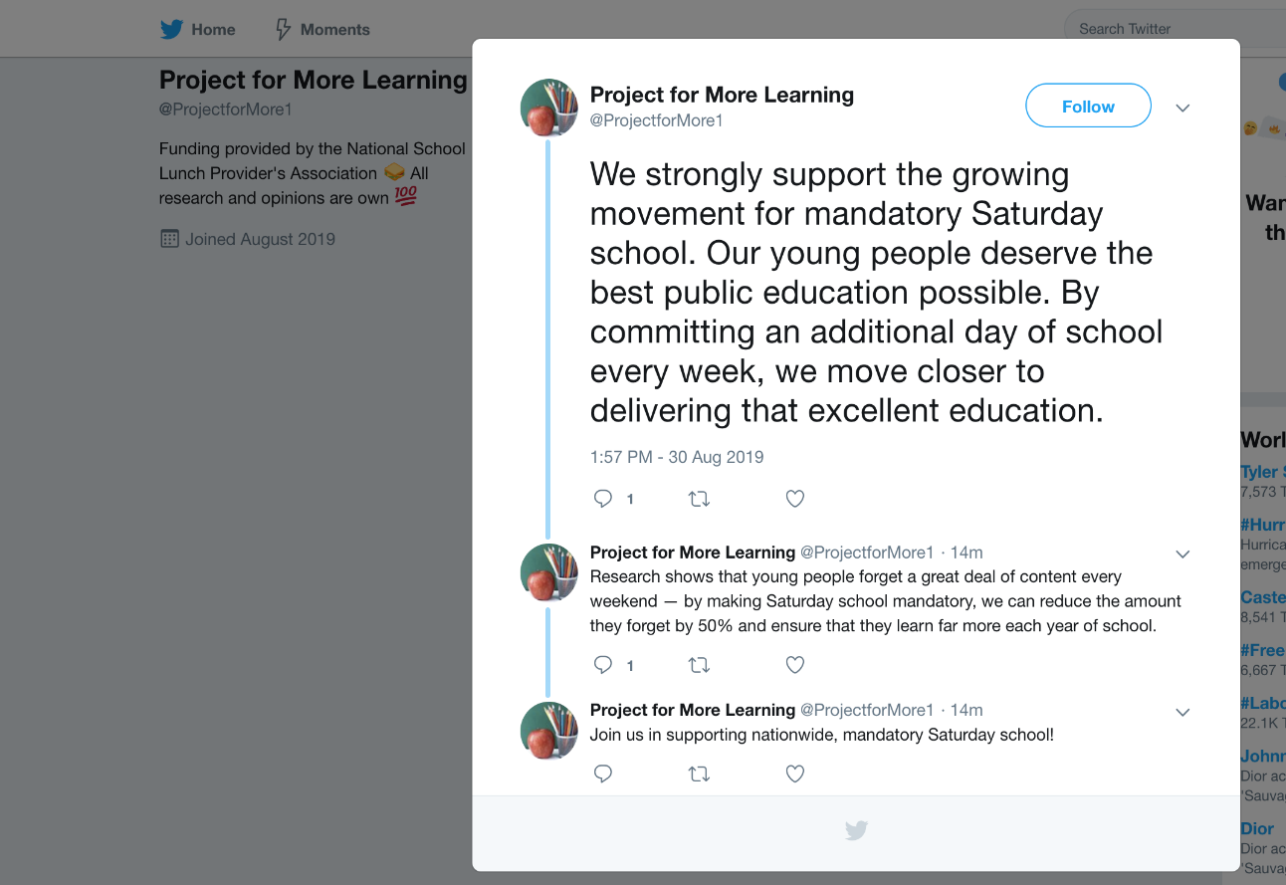

Source B

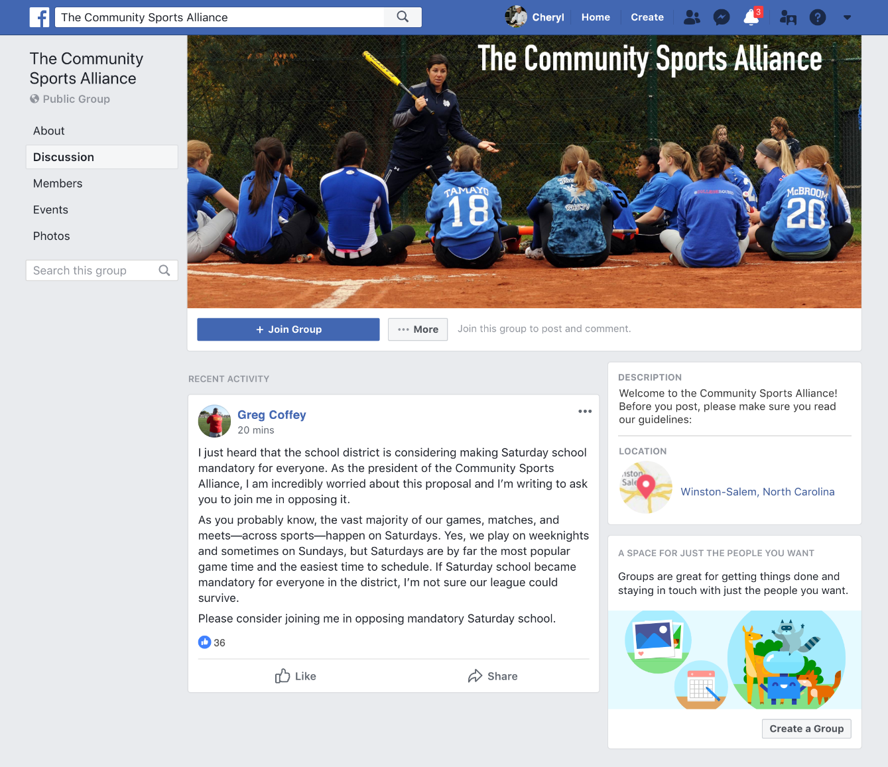
The Community Sports Alliance is a local organization that coordinates all the community sports that share fields and venues. Its members include local football, basketball, volleyball, soccer, track & field, swimming, and water polo clubs. The following message was posted by the current president of the Alliance on the Alliance’s Facebook group page.

Source C

Dr. Turner is a Professor of Education at a local university. She posted the following on her personal blog.
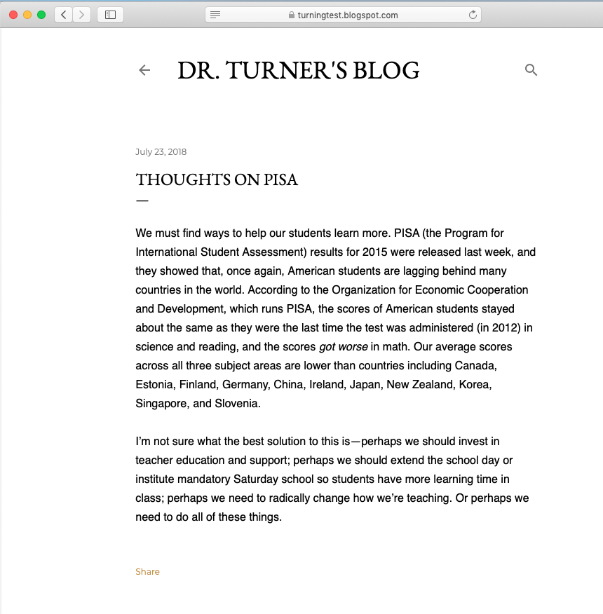

Guiding Questions
Who is behind this information?

Directions: Read the source and answer the questions below.

Source A

1. What argument does this source make about Saturday school?

2. What qualifications or expertise does this source have on the topic of Saturday school? Explain.

3. Why might the source want to make this argument about Saturday school? (Remember that there can be multiple motivations!)

4. Overall, how much do you trust this as a source about whether there should be mandatory Saturday school?

Source B

1. What argument does this source make about Saturday school?

2. What qualifications or expertise does this source have on the topic of Saturday school? Explain.

3. Why might the source want to make this argument about Saturday school? (Remember that there can be multiple motivations!)

4. Overall, how much do you trust this as a source about whether we should have mandatory Saturday school?

Source C

1. What argument does this source make about Saturday school?

2. What qualifications or expertise does this source have on the topic of Saturday school? Explain.

3. Why might the source want to make this argument about Saturday school? (Remember that there can be multiple motivations!)

4. Overall, how much do you trust this as a source about whether we should have mandatory Saturday school?

  - What’s the evidence?
Aim: To teach students to evaluate evidence
Objective: At the end of the lesson, SWBAT retell an existing claim; spot a manipulative piece of evidence, describe strengths and weaknesses of presented claims
Length: 45 minutes
Notes: The lesson plan is based on the teacher materials on the COR website, the “peer-reviewed studies” activity was added, and the materials used for that activity were added as well. Those materials are authentic, and they are connected to one of the original sources used. That said, in the lessons taught, the previous activities took longer than expected, thus this activity was significantly shorter, approximately 3 minutes long.
Stage and aim | Steps & instructions | Material | Timing
Groups | Divide students into 3 groups | none | 2
Recall | Remind Ss of the previous lesson, and ask them to name some principles of evaluating sources (funding, purpose, bias, expertise). Also, remind them of the Saturday School scenario. Then say that they will continue making the case for/against Saturday school and that you will evaluate evidence. | None | 5
Brainstorm | Ask Ss to brainstorm what kind of evidence they could use to support their arguments. Tell them to think of the sources of information from the previous lesson (articles, interviews, surveys). Write the results on the board. | none | 5
Analysing documents | Hand out the 3 articles, each group will get one article, and the accompanying handouts. Ask the groups to answer the questions and to prepare to present the answers. | Articles + handouts | 10
Presentation | Ask the groups to present their answers. Important to things that should be covered: article a) what are “gains in learning”, what do we know about the organisation, how did they find out the results they present; article b) point to the manipulative pictures (and the false choice fallacy), do we know what children do in their free time and whether they enjoy being in school c) it is important to read the study, not simply the retelling of the findings, we don’t know anything about the person posting it, she doesn’t tell us much about the study itself. In all cases, remind Ss to think of the previous lesson and ask them about the sources of the information. What is schoolresearch.org and timeandlearning.org; who is Kayla Silver, can we trust a page called Parents4SaturdaySchool to be unbiased? | Articles + handouts | 13
Peer-reviewed studies | In this section, focus a bit more on argument C. Open the study which is linked in the argument, and open the webpage of the institute (share this via a projector with Ss). First, tell Ss what peer-reviewed journals are and ask them to briefly discuss what are the advantages and disadvantages of peer-reviewed vs self-published (as is the presented study). Ask Ss to share their views. Stress the advantage of reducing individual bias during peer-review. After that is done, let the students read one paragraph from the study (appendix 1) and open the article the paragraph links to (appendix 2). Ask the Ss to read the abstract and to find a mismatch between the study and the summarization (the study mentioned a lot of weaknesses in their argument, while the summarizing paragraph focused only on the positives). | Study mentioned in article C | 8
Wrap-up | Wrap the whole lesson. Remind Ss of these important aspects when evaluating evidence: a) where does it come from, is the source trustworthy? B) does the evidence match the claim? C) is it logically sound or is it manipulative in any way? | None | 2

Articles and handouts:

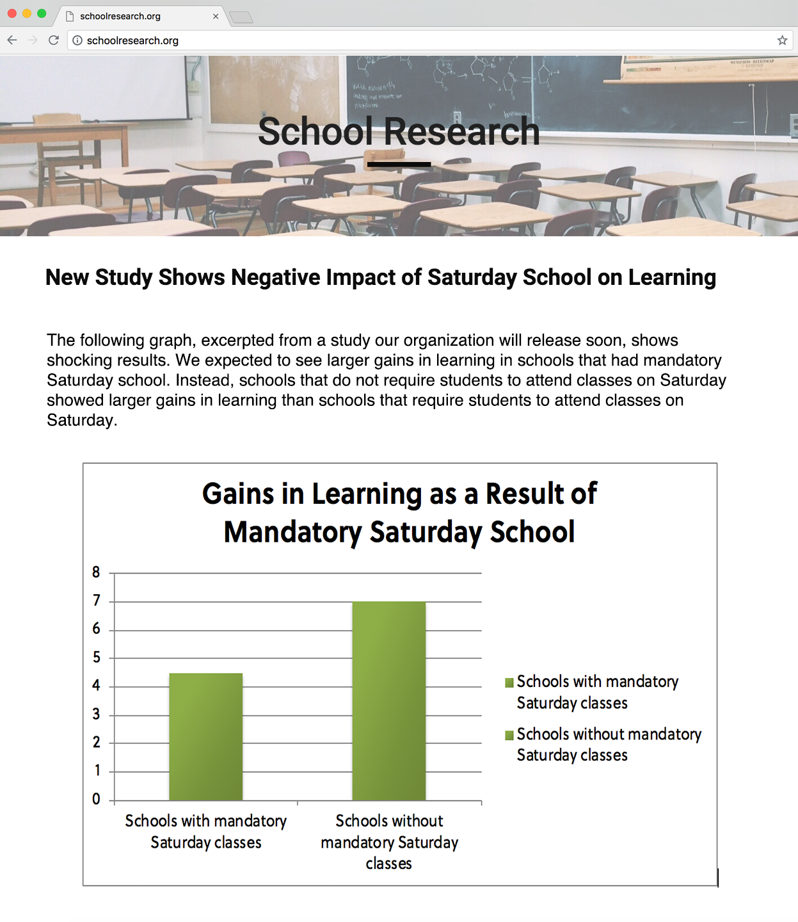
Source A
Source B

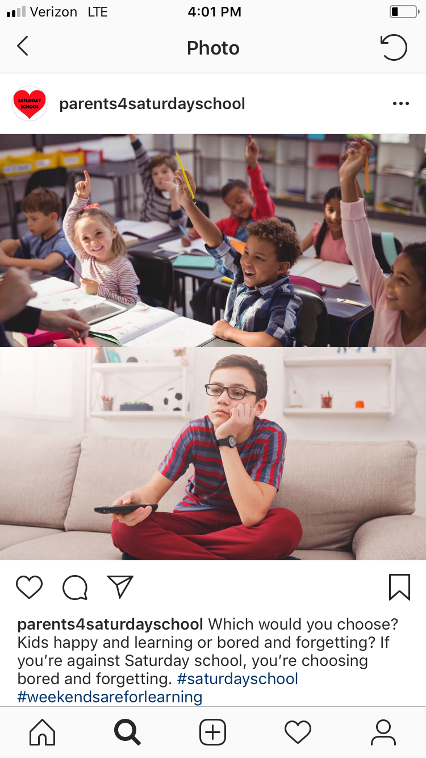

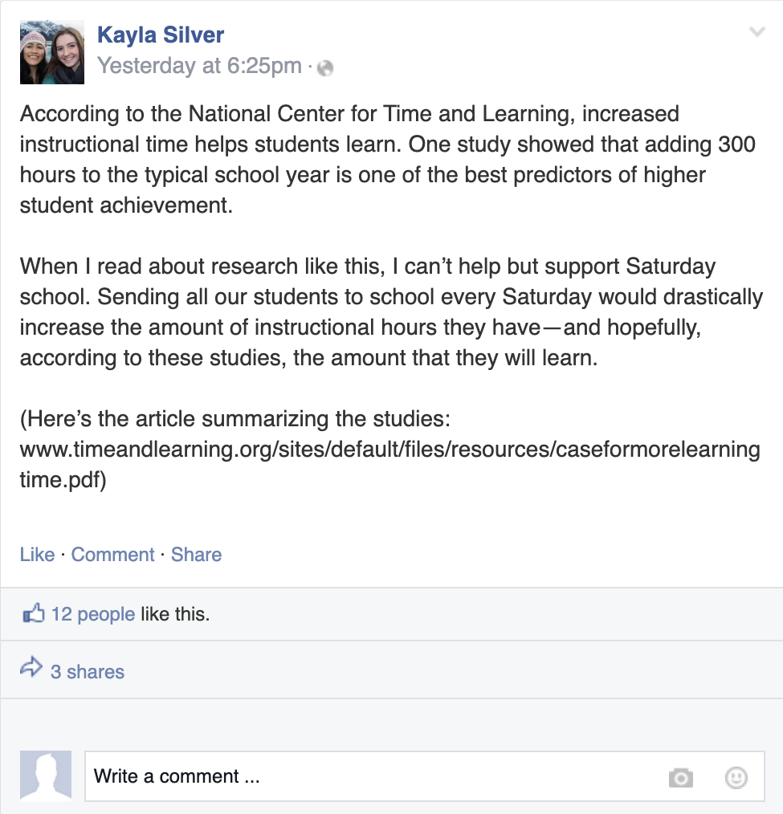
Source C

Guiding Questions
What is the evidence?

Directions: Read sources A-C and answer the questions below.

Source A

1. Where is this source from? Based on this, how much do you trust the source?

2. What argument does this source make?

3. Describe the evidence used to support the argument.

4. What are the strengths of the evidence provided?

5. What are the weaknesses of the evidence provided?

6. Overall, how convincing do you find this evidence? Try to set aside your opinion on Saturday school and just focus on the strength of the evidence.

Source B

1. Where is this source from? Based on this, how much do you trust the source?

2. What argument does this source make?

3. Describe the evidence used to support the argument.

4. What are the strengths of the evidence provided?

5. What are the weaknesses of the evidence provided?

6. Overall, how convincing do you find this evidence? Try to set aside your opinion on Saturday school and just focus on the strength of the evidence.

Source C

1. Where is this source from? Based on this, how much do you trust the source?

2. What argument does this source make?

3. Describe the evidence used to support the argument.

4. What are the strengths of the evidence provided?

5. What are the weaknesses of the evidence provided?

6. Overall, how convincing do you find this evidence? Try to set aside your opinion on Saturday school and just focus on the strength of the evidence.

Excerpt from the study in article C:
With expanded time identified as a key ingredient in successful schools, one group of scholars took a look at 15 empirical studies of schools that had extended days and/or years to determine if students performed better in schools once they had more time. This meta-analysis found that adding time was, more often than not, associated with improved schoolwide outcomes, noting stronger effects among schools serving primarily at-risk students.
Abstract of the meta-analysis:
Attention has been directed toward extended school time as a measure to improve academic achievement. The school year and day length have varied over time and across localities depending on the particular needs of the community. Proponents argue that extending time will have learning and nonacademic benefits. Opponents suggest increased time is not guaranteed to lead to more effective instruction and suggest other costs. Despite noted limitations in the research, past reviewers have argued that any positive relation between allocated time and achievement is tentative and instructional quality needs to be addressed first. After a comprehensive search of the literature, 15 empirical studies of various designs conducted since 1985 were found. The literature revealed that (a) designs are generally weak for making causal inferences and (b) outcomes other than achievement are scarcely studied. That said, findings suggest that extending school time can be an effective way to support student learning, particularly (a) for students most at risk of school failure and (b) when considerations are made for how time is used. Of note, the strongest research designs produced the most consistent positive results. Implications for policy and practice are discussed.
  - What do other sources say?
Aim: To teach Ss to corroborate evidence
Objective: At the end of the lesson SWBAT compare competing points of view about Saturday schooling
Length: 45 minutes
Notes: The lesson plan is based on the teacher materials on the COR website, the “other examples” activity was added. As an add-on, this part can be skipped if time is short. On top of that, the time allotment for the “closure” activity was vastly overestimated, this activity could be done in half the time indicated. The spare five minutes should ideally be added to group discussions of the sources.
Stage and aim | Steps & instructions | Material | Timing
Groups | Divide students into groups of 4 | none | 2
Recall | Remind Ss of the previous lesson, and ask them to name some principles of evaluating sources (funding, purpose, bias, expertise) and evaluating evidence (who claims it, is it manipulative, is it valid). Also, remind them of the Saturday School scenario. Then say that they will continue making the case for/against Saturday school and that this lesson they will learn how to compare evidence from various sources. | None | 5
Recall 2 | Hand out Source A and remind Ss that they talked about it in the previous lesson. Ask them about some of the problems of the source (no peer-review, cherry-picking arguments). | Source A | 3
Source B | Hand out Source B and the accompanying handout with Qs. Ask the groups to answer the Qs. Then proceed to check with the whole class. Make sure to stress a) the science tag, instead of an opinion tag; factual approach; no opinion; no criticism. | Source A + B + handout | 8
Source C | Do the same thing again but with Source C. Stress the following: the bias; the different perspective; more arguments. | Source A + B + C + handout | 7
Debriefing | Ask Ss to make a short list of why checking other sources is important, what are the pros (more complete picture, different points of view, verification) and cons (time-consuming). | None | 3
Other examples | Remind Ss of the first lesson and the Žeru Maso or Agrofert part of it. Ask them to think about where would they look for a different perspective or for the confirmation/refutation of their arguments. | None | 7
Closure | Tell Ss that they will do a wrap-up activity of the last 3 lessons. Tell them to think of all the important questions they need to ask when they stumble upon some information (for example some news story or some claim on social media). Create a template on the board with INFORMATION in the centre, and the 3 main aspects of COR around it (source, evidence, corroboration). Ask the groups to fill in the mindmap on the board with their ideas and then to underline the most important aspects. | none | 10

Articles and handouts:

Source A

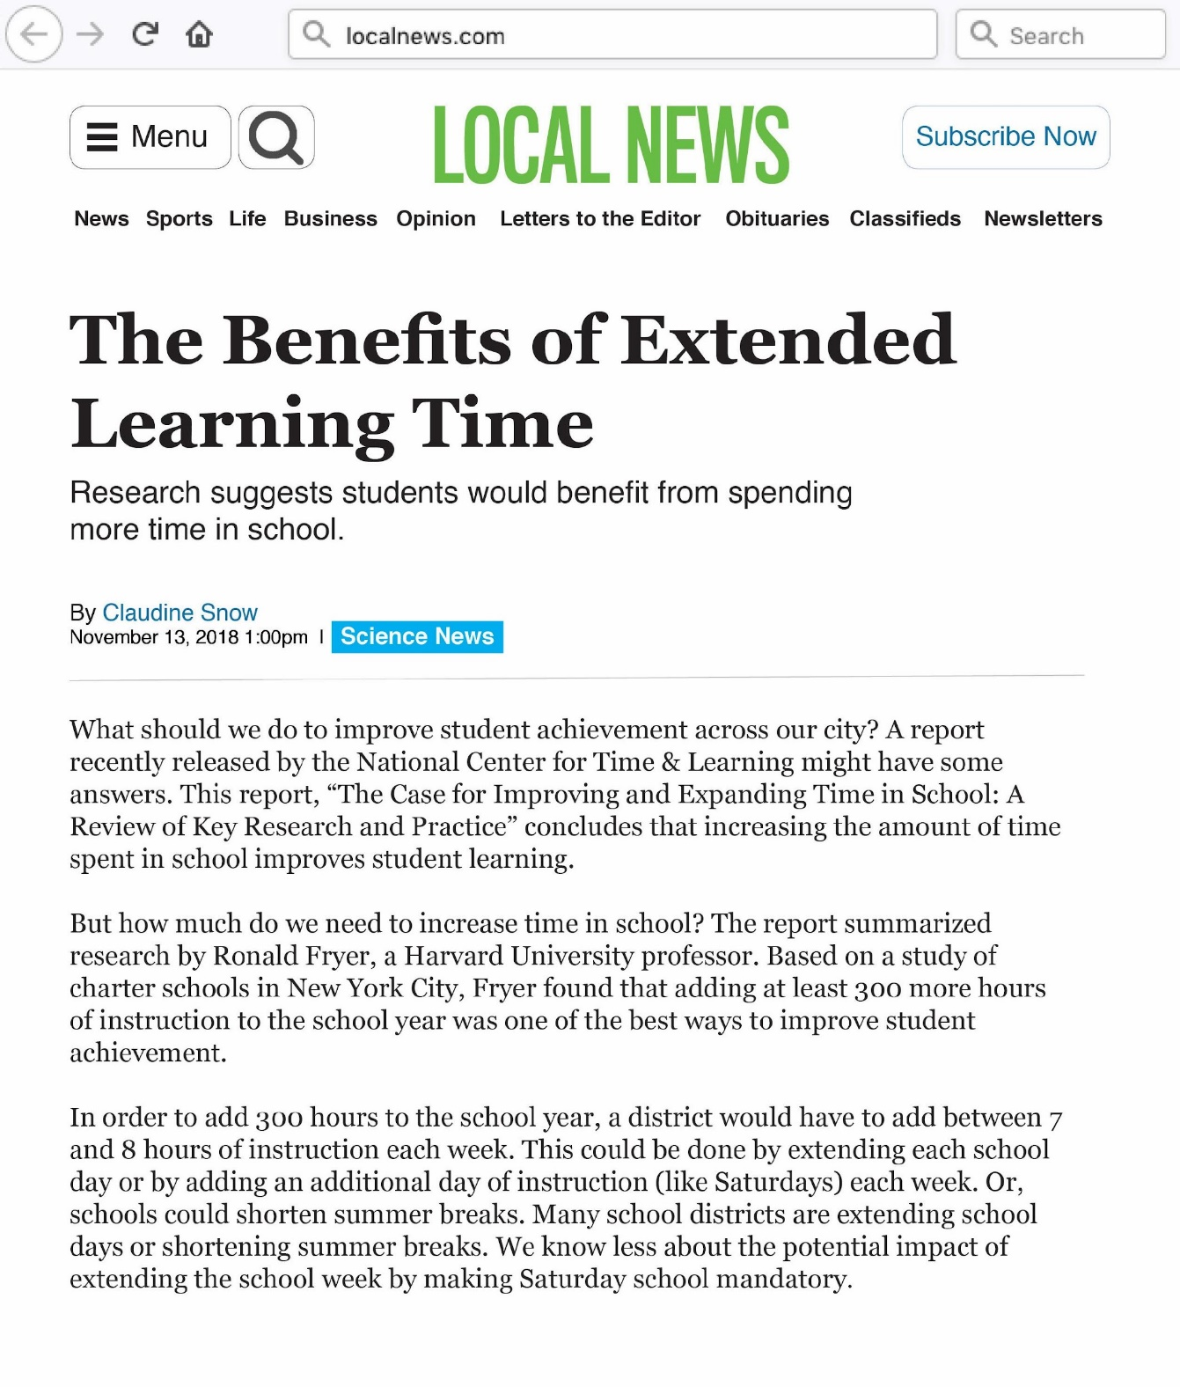
Source B

Source C
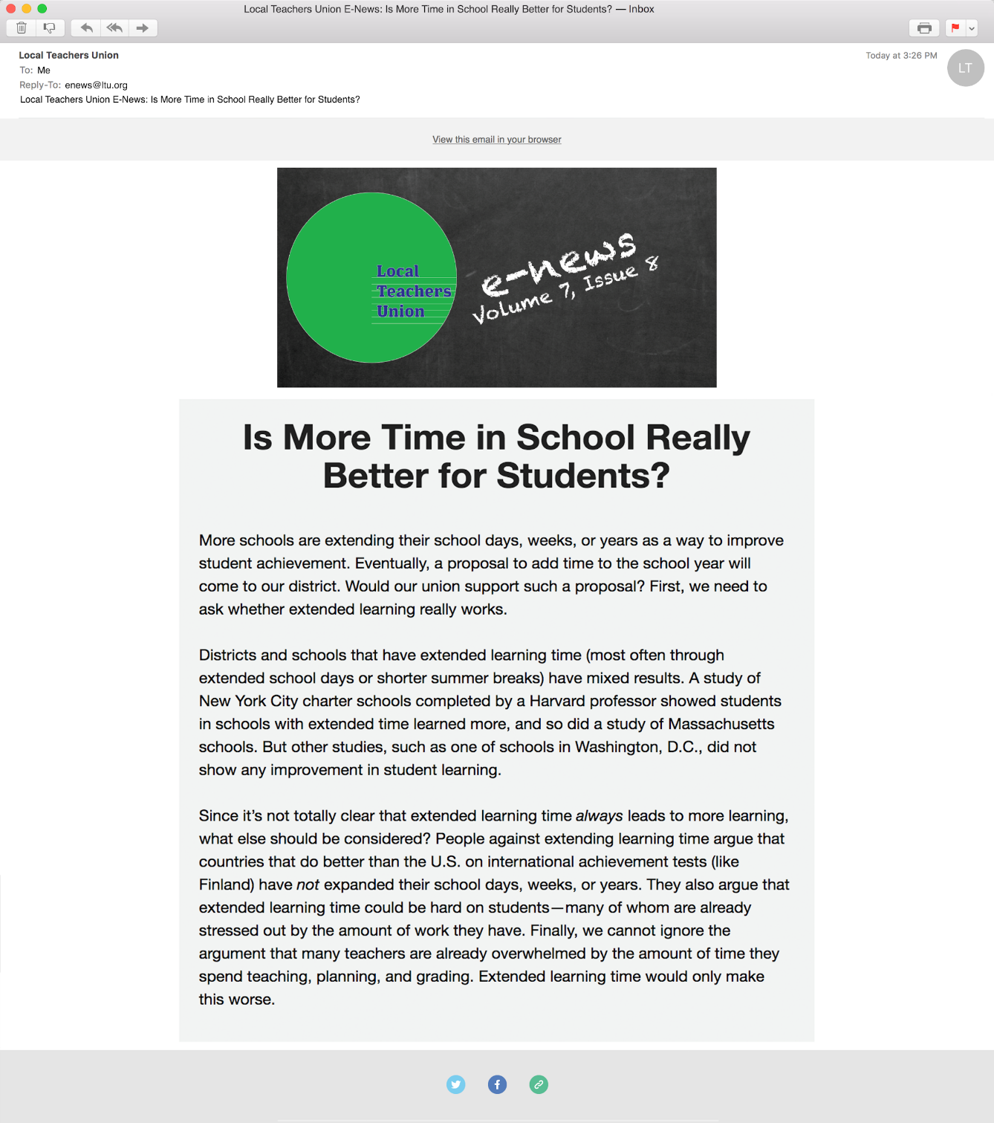

Guiding Questions
What do other sources say?

Directions: Read sources B and C and answer the questions below.

Source B

1. What is this source? Is there a relationship between this source and Source A? Explain.

2. How much do you trust this as a source of information about Saturday school?

3. What argument(s) does this source make? How do these compare to the argument made in Source A?

4. What evidence does this source provide? How does that compare to the evidence presented in Source A?

Source C

1. What is this source? How much do you trust it as a source of information about Saturday school?

2. What argument(s) does this source make? How do these compare to the argument made in Source A? Source B?

3. What evidence does this source provide? How does that compare to the evidence presented in Source A? Source B?

- Evaluation criteria
The fourth lesson in the lesson sets was a lesson in which students created posters in which they presented an opinion of their choice, supported with sources. The students were specifically asked to include source and evidence evaluation in their posters, and were provided with the following framework based on which their posters were evaluated.
 | Source 1 | Source 2 | Source 3 | Bonus sources
Bias (funding + purpose)
Expertise
Evidence
Corroboration
Omission
Other

A following guideline was then used during evaluation (the number of points was not included in the study, as the study was not of a quantitative nature. The framework can be a useful framework for educators as it can help them with evaluation of their students’ creations). These criteria were based on criteria provided by McGrew (2020).

Bias: 0) Students fail to mention any potential bias.
- Students mention a bias without any other explanation.
- Students comment on the bias, but do not provide a complex explanation (e.g. the sports association is interested in having students play sports on Saturdays)
- Students comment on the bias in depth (e.g. the sports association makes money by providing a service for the students, a Saturday school would greatly diminish their income); or students use sources without any bias
Expertise: 0) Students use posts/arguments by people outside the area of interest
- Students use arguments by people involved, but who are not experts and do not speak for a collective (individual teachers, students or parents)
- Students use arguments by representatives of a collective (speakers of various associations)
- Students use arguments by trustworthy experts (researchers)
Evidence: 0) Students do not provide objective evidence, provide only the views and opinions of other people
- Students use unreliable evidence
- Students use reliable evidence, but fail to put it in context (e.g. children attending Saturday schools have better learning outcomes, but students do not question whether it can be attributed to Saturday schooling or to something else)
- Students use reliable evidence, put it in context and mention the limitations of the evidence
Corroboration: 0) Students do not corroborate their sources.
- Students use one flawed corroborative source (when corroborative sources use the same criteria as when evaluating the main sources)
- Students use one or more corroborative sources, but it came from a related source (e.g. a different study by the same researcher)
- Students use one or more corroborative sources, which would score well (2 or 3 in every aspect) at the above-mentioned criteria
Omission: 0) Students use a source that omits vital information and do not mention it
- Students use a source that omits vital information but mention it
- Students use a source that omits interesting but non-vital information, but they do not mention it
- Students use a source that omits interesting but non-vital information and they mention it; or they do not use sources that omit information
Other: For unforeseen aspects

