PEDAGOGICKÁ FAKULTA

La Cosa Nostra: The Influence of the Italian Mafia on American Society

Magisterská diplomová práce

BC. TOMÁŠ STŘÍTESKÝ

Vedoucí práce: Michael George, M.A.

Katedra anglického jazyka a literatury Učitelství anglického jazyka pro základní školy

Brno 2024



Bibliografický záznam

Autor: Bc. Tomáš Stříteský
Pedagogická fakulta Masarykova univerzita
Katedra anglického jazyka a literatury
Název práce: La Cosa Nostra: The Influence of the Italian Mafia on American Society
Studijní program: Učitelství anglického jazyka pro základní školy

Vedoucí práce: Michael George, M.A.
Rok: 2024

Počet stran: 82
Klíčová slova: La Cosa Nostra, Mafie, Spojené státy americké, Vliv, Společnost, Politika, Kriminalita, Doba Prohibice, RFK, Dvacáté století, Migrace, Zákony, Důsledky, Mob, Italská Mafie, Pět Rodin

Bibliographic record
Author: Bc. Tomáš Stříteský Faculty of Education Masaryk University
Department of English Language and Literature
Title of Thesis: La Cosa Nostra: The Influence of the Italian Mafia on American Society
Degree Programme: English Language for Education Supervisor: Michael George, M.A.
Year: 2024

Number of Pages: 82
Keywords: La Cosa Nostra, Mafia, United States, Influence, Society, Politics, Criminality, Prohibition Era, RFK, 20th century, Migration, Law, Consequences, Mob, Italian Mafia, Five Families

Anotace

Tato práce se zaměřuje na působení italské mafie v USA v průběhu 20. století až do přelomu 60. a 70. let. Zabývá se komplexními vazbami mezi americkou společností a organizovaným zločinem. Zkoumá způsob, jakým mafie pronikla do různých vrstev společnosti v jedné z nejdůležitějších zemí světa, a jaký měla její činnost dopad na události mezinárodního významu. Diplomová práce také zkoumá způsoby, jakými se mafie podepsala na životě běžného občana, i přesto, že po většinu své existence působila jako skrytá organizace.

Abstract

This thesis focuses on the influence of the Italian Mafia in the USA throughout the 20th century, up until the turn of the 1960s and 1970s. It deals with complex relationships between the American society and organized crime. It analyzes the way the Mafia infiltrated every social class of one the world’s most prominent countries, and the impact of its presence on events of international significance. Lastly, the thesis explores the ways in which the Mafia shaped the lives of ordinary citizens, despite largely operating as an underground organization for most of its existence.

Declaration

I hereby declare that the thesis La Cosa Nostra: The Influence of the Italian Mafia on American Society that I have submitted for assessment is entirely my original work, and that no part of it has been taken from the work of others unless explicitly cited and acknowledged within the text of my thesis.

Brno, December 1, 2024 .......................................

Bc. Tomáš Stříteský

Acknowledgements

I would like to express my gratitude to Mr. Michael George, M.A., who provided me with invaluable feedback, tips, and information at any needed time. His encouragement and experience allowed me to work on a complex topic with a great oversight and whose professional advice led me throughout the writing process.
I would also like to extend this sincere gratitude to my family, as well as my girlfriend Ashli for their unconditional support and love.

Table of Contents

Anotace 5
Abstract 6
Introduction 12
1. Understanding the Mafia 13
1.1 What is Mafia? 14
1.2 Origins 14
1.3 Migration to the USA – “Little Italy” 15
1.4 The Melting Pot 16
2. Expansion and Influence 20
2.1 Chicago and New York as Mafia Headquarters 20
2.2 The Five Families 27
2.3 Great Depression and Prohibition – Opportunities for Mafia 29
2.4 Spreading to the West 34
3. The Rise of the Mafia 37
3.1 Hierarchy of the Italian Mafia 37
3.2 How Did One Become Part? 39
3.3 Role of Women in the Mob 40
4. (Some)Key Figures of Mafia – As the Time Goes 41
4.1a Al Capone 41
4.1b Wealth of Al Capone 43
4.1c (Little) good vs (much) evil – How Capone Shaped Society in 1930s 43
4.1d The Fall of Al Capone 48
4.2a Frank Costello 50
4.2b Power Throughout the Society – How Costello Manipulated Everyone 51
4.3a Vito Genovese 52
5. What About the Common Folk? a.k.a Mafia’s Influence on Everyday Citizens 53
5.1a The Crimes and Murders of the Cities 53
1920s 53
1940s 54
1960s 54
5.1b Economic Correlation with the Mafia 55
5.1c Lower Social Class Citizens 56
5.1d Criminality and Community Dynamics 56
5.1e Employment Opportunities 57
5.1f Manipulation of City Contracts 57
5.1g Control Over Labor Unions 58
5.1h Blooming Businesses 59
5.1i Social Services and Community Support 61
5.1j The Cycle of Dependency 61
6. The “Firsts” in the World of Mafia – The End is Near? 62
6.1 Apalachin Meeting, 1957 62
6.2 Joseph Valachi – the First Man to Speak, 1963 63
6.3 Rise of Federal Opposition by Robert F. Kennedy, 1960s 64
6.3a The Origins of the Opposition 64
6.3b Crime Control Act of 1968 – Changes on a National Scale 66
6.3c The Enemy Within 67
6.3d RICO Act, 1970 69
6.4 JFK and Fidel Castro – Possible Involvement of the Mafia 70
6.4a The Kennedy Brothers 70
6.4b The Cuban Paradise 71
7. Conclusion 72
Reference List: 74

Introduction

The Italian Mafia had played a major role in shaping the US society in the 20th century. Although it is generally known to have played a role in many social classes, in particular thanks to popular movies and literature, the extend to which the Mafia influenced daily lives of a regular American is not widely recognized.
The topic is significant as the Mob shaped decades of perhaps the most influential country on a global scheme, ranging from a regular citizen to politicians, mayors and possibly even president of the country. The impacts on the economy, as well as national crime were so significant that it forced the hand of the biggest governmental agencies, such as the FBI and CIA, and made government effectively change the laws in order to be able to fight the biggest enterprise of an organized crime in the history of the United States of America.
The aim of the paper is to explore the complex influence the Italian Mafia had on all spheres of the US society, as it dives into statistics, procedures and activities of the Mafia, its spread throughout the country and even beyond, and finally to correctly represent the image of the organization, one, that had been mostly shaped and glorified by popular cinematography and literature.
The thesis consists of six chapters and a conclusion, beginning with the initial presence and migration of the Italian Mafia to the states, all the way to the edge of 1960s and 1970s.
The first chapter discovers the origins and basic information about the Mafia. It also connects this immigration to one of a global significance, covering terms such as the Melting Pot in connection to multiple immigrant communities in the States.
The second chapter follows on such information by presenting their initial influence in the first headquarters – big cities such as New York or Chicago. Following that, the paper explores the Five Families, one of the most crucial parts of the thesis. Lastly, the Eras of the Great Depression and Prohibition are described, uncovering Mafia’s rise to power.
The third chapter displays the mysterious hierarchy of the organized crime Families, as well as roles of each member. Besides that, the third chapter includes the entering process of new recruits, as well as positions of women in the Mafia.
The fourth chapter builds upon the previous information by presenting some of the most influential figures of the organized crime. From Al Capone to Vito Genovese, the paper deals with their influence on the society, the good, bad, and ugly.
The fifth chapter dives deeper into the different aspects in which Mafia influenced a regular citizen and their daily lives. The chapter presents statistics of crime, as well as economy, that paint the image of Mafia’s presence in some parts of the country. It uncovers several schemes with which the Mob controlled multiple areas of society, ranging from Labor Unions or construction services in the cities.
The sixth chapter includes the breaking points in the history of the Mafia, first people to publicly uncover its presence, as well as changes in laws and regulations that had to be implemented in connection to such discoveries. Lastly, the chapter focuses on the significance of RFK as an opponent to an organized crime, as well as controversial topics of Mafia’s possible impact on JFK’ assassination and the Cuban crisis.
Lastly, the summary concludes the influence, reiterates the facts and explored information and briefly describes Mafia’s presence in the 21st century.

Understanding the Mafia

1.1 What is Mafia?
Mafia belongs to a group of particular underworld organizations of an organized crime, and can be defined as “a secret criminal society that originated in Sicily in the mid-19th century” (Abadinski, 2002). However, Mafia can be differentiated by its own hierarchical structure, that very often enforces their control over specific territories, in comparison to other crime groups operating according to the ever-changing circumstances (Albanese, 2020). This thesis will focus primarily at Mafia of the Sicilian origin, strict and intimidating organization, also known as the “La Cosa Nostra”, and its operations in the USA in the early 20th century.

1.2 Origins
The word “Mafioso” derives itself from a dialect around the city of Palermo from the 1850’s, that formerly signified the adjectives of “brave, or self-confident”. The individuals eventually acquired an attribute called “mafia”, which can be roughly translated to “cool” in modern English (Dickie, 2004). The negative connotation was, however, used roughly a decade later, in a profound play written in the Sicilian dialect, where mafiusi portrayed a gang of prison inmates, and eventually leading to its own entry in the dictionary with its alternative meaning (Dickie, 2004).
The history of the Cosa Nostra (or roughly translated – Our Cause), can be traced all the way to the Middle Ages, where the Mafia arose as a secret criminal society (Etter, 2018). However, many scholars argue that this uprising was inevitable as the Sicilian Territory had been historically governed by dozens of foreign powers and cultures, such as the Greeks, Romans, Bourbons, northern Italians etc. (Dileva, 2006). The laws and interests of the Sicilian people were, therefore, secondary and they were quite frequently excluded from any political participations. According to Dileva (2006), this is where the initial sense of community and togetherness surfaced. Being neglected, the common folk of Sicily could not expect any justice from the governing powers, therefore it was up to the individual and their family to handle the situations. The people, distrusting their government, would then in return refuse to testify, introducing the frequently used concept of omertà – an unwillingness to cooperate (Indelicato et al., 2019).
Order was displayed at a very basic level by local men called uomini di rispetto, members of the very first “Mafia” who were, quite ironically, functioning as peace keepers and judges (Dileva, 2006). This concept prevailed until the late 19th century, where Italy was unified and began to introduce a unionized government and law.
The promotion of power of the Northern Italians proved to be quite unwelcomed in Sicily, boycotting some of the rules. The general distrust allowed several Sicilian families to gain power in the local areas (Catanzaro, 1992). The authority of the Italian government was weak (Sciascia, 2013), and members of Mafia from the particular families started to cooperate in bigger organizations, granting both protection, and striking fear into the general society because of its banditry nature, attacking landowners, and exploiting weaker families (Santino, 1994).

1.3 Migration to the USA – “Little Italy”
The end of the 19th century in Italy experienced a noticeable upswing towards more radical political movements. Formerly oppressed poor workers (see Chapter 1.2 – Origins) demanded a quick change of situation, advocating for their own rights. This inevitably transformed into one of the first movements fighting for the freedom and equal rights of the workers, a movement called fasci. However, this movement was naturally not welcome among the families in power, as it would decrease their control over the territory. The Mafia itself proceeded to oppose this movement, as it would display a “lack of respect” (Dileva, 2006).
Eventually, such political instability resulted in an emigration of an unprecedented scale, where within a ten-year span at the beginning of the 20th century, approximately 1,1 million of emigrants left the Sicilian peninsula, out of which roughly 80% headed towards the USA. This process was further enhanced even more by a self-proclaimed Capo dei Capi, or also the “Boss of the Bosses” Don Vito, probably the most prolific Mafioso of the era, who explored the possibilities of the USA in early 1900’s, eventually returning to Sicily in attempt to recruit and convince more members of the families. Despite initially facing several obstacles (The Sicilian Mafia often challenged any absolute authority), by 1920’s, the toll raised up to 4 million immigrants, most of them settling by the eastern coast of the USA(PBS). Naturally, alongside such statistics, large numbers of criminals and Mafia members were bound to be included.
The Sicilian Mafia was, however, quite far from being the first explicit display of an organized crime in the North America or the territory of the USA. The initial settlers had been found guilty of several crimes they evaded on the mainland of Europe, such as avoiding taxes, bribery, or even murder. Afterall, by definition, “organized crime is characterized by planned illegal activities involving multiple offenders…” (Schneider & Schneider, 2005, pp. 345-347).

The Melting Pot

The immigration to the United States was by no means an easy journey for the Italians. Variables such as different values, perspectives and lifestyles resulted in an initial voluntary segregation of the families, as they separated themselves from other communities. This was primarily due to the mistrust and superficiality of the religious Italians, who believed that the foreigners held an “Evil Eye” full of danger and envy (Laurino, 2014). Inevitably, this did not particularly help with assimilation into the life of a regular American, since the Italians even wedded primarily among themselves.

This was perceived as a big contrast in comparison with other communities immigrating to the America. The beginning of the 20th century not only displayed a vast migration of the Italian communities, but also welcomed different nationalities and ethnicities from all around the world. Eastern Europeans such as Russians or Poles inhabited cities such as New York and Chicago, closely followed by the Irish, Jews, Mexicans or even immigrants of an Asian descent, such as the Chinese and Japanese (Higham, 1984). Those communities contributed to the creation of something that we currently call “The Melting Pot”, a term, that was initially coined in a play of the same name.
Israel Zangwill, a Jewish playwriter from London first used this term in the year 1908 to represent the phenomenon of assimilation of the Jewish communities into the life in England (Zangwill, 2017). The play, gaining rapidly on popularity, was then performed in several cities in the USA, such as New York, and Chicago. This play was so popular, that it was displayed to the US president of the era – Theodor Roosevelt, and on more occasions too. Press and spoken word have contributed to the increased popularity of the term, and to practically being used ever since (Zangwill, 2017).
However, the truthful image about the melting pot was slightly different and should not be romanticized. There were predominant features shared among all of the above-mentioned communities – hatred and racism. Some sources from the era describe particular minorities as such:

The Irish Immigrants: According to Higham (1984), there was a hostile sentiment towards the Irish, as the Americans feared the influence of their predominant Catholic religion. Secondarily, they were also seen as a work competition, often leading to discriminatory practices in housing and employment (Higham, 1984, p. 321).
The Chinese Immigrants: Arguably, Chinese citizens were oppressed even further. Afterall, in the year 1882, there happened to be the first significant law that restricted immigration into the States, that was aimed against the Chinese. The Chinese Exclusion Act banned all Chinese citizens to enter the US for the upcoming 10 years. Such act perfectly reflected the attitude the Americans shared against the Chinese in the following decades (Lee, 2003, p. 45).
The Eastern Europeans: The immigrants from the Eastern European countries were often of a lower social and economic status, reinforcing the stereotypes of “lesser beings”. According to Gjerde (1998), such communities were often depicted as a threat to American values and society, mostly due to their different customs.
The Mexican Immigrants: Despite being an older source, Gamio (1930), researchers generally believe Gamio to provide a very authentic description of the era. The Mexican Immigrants, primarily located in the southwestern United States were often exploited by low wages, poor working conditions and systematic abuse and discrimination.
The Jewish Immigrants: We can draw a slightly different case in terms of the Jewish communities. Firstly, they faced harsh conditions both in Europe and the US, as the antisemitic wave was on the rise during the first half of the 20th century. However, despite this, Jewish immigrants established their own authentic communities and eventually significantly contributed to the American economy (Dinnerstein, 2000).
Lastly, we can recognize the pattern that applied even to the Italian immigrants. During the 1890’s, it was generally believed that the Italians were on the same “level” of social discrimination as the members of the black communities. Such an example can be found in a statement written down during a Congressional meeting in 1890, during an official discussion between a member of committee and a head of a construction site, as stated by LaGumina (1999).
Committee: You don’t call an Italian a white man?
Construction boss: No sir, an Italian is a dago (used as an insulting and contemptuous term for a person of Italian or Spanish birth or descent, Merriam-Webster. (n.d.).)
Currently, we are able to recognize the correlating patterns between stereotyping and blatant racism of the era and the new scientific approach that had taken place in the 1890’s called “The Social Darwinism”. This theory compares the dominant theory of Charles Darwin and the survival of the fittest in the animal world with different human races. Promoted primarily by Walter Bagehot in England and William Graham Sumner in the United States, social Darwinists believed that “the weak were diminished and their cultures delimited while the strong grew in power and cultural influence over the weak” (Britannica, 2024). The Italians were undoubtedly treated harshly from the outside communities, and, therefore, opted to stay together in close-knit areas and communities, particularly in larger cities, founding their own neighborhoods. One of the most famous examples can be seen in “Little Italy”, an area in East Harlem, as well as other distinctive neighborhoods housing primarily Italian-Americans in Manhattan and Bronx. These city parts were predominantly occupied with family-owned businesses, restaurants, cafes and markets, while keeping a significant sense of the Italian culture and language (Portelli, 1985).
This negative sentiment was not being held only among the lower social classes, but even reached all the way up to the presidential office. Upon a very mild criticism of the immigration laws by a republican member of the parliament, Herbert Hoover, a former US president from 1929 to 1933 responded in such manner:
It seems to me, a Republican, that you are a little out of your class, in presuming to criticize the President. It strikes me as impudence. You should go back to where you belong and advise Mussolini on how to make good honest citizens in Italy. The Italians are predominately our murderers and boot-leggers.... Like a lot of other foreign spawn, you do not appreciate the country which supports and tolerates you (New York Times, 1930).

Such attitude was held among all social classes, particularly in the initial decades of the 20th century where the Italians were viewed as “lesser beings”, as portraited in the newspaper Life in 1911 (See figure 1). We are also introduced to the derogatory term “Wop”, that was coined as “a slur used by Anglo-Americans to denigrate Italian immigrants”, during the anti-immigration movement that enhanced the stereotypes of the Italians being “inferior or undesirable” (Guglielmo, 2003).
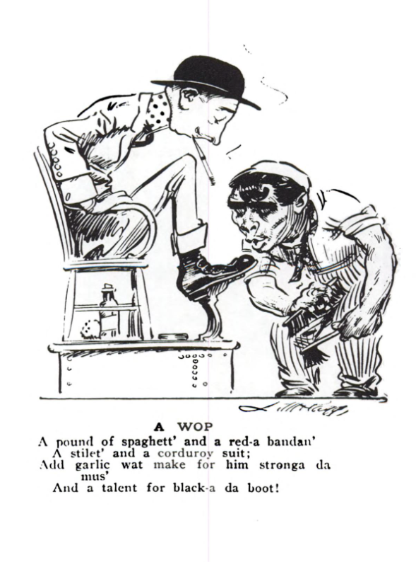
Figure 1, Historical Pictures Service, Chicago, 1911, retrieved from LaGumina (1999).

The poem can be roughly translated as such:
"A pound of spaghetti and a red bandana,
A stiletto and a corduroy suit,
Add garlic to make him stronger than most,
And a talent for blackmailing others."
The negative stereotypes were, therefore, reinforced even in the press, which was the main tool of media and a primary source of the spread of information. Consequently, it is no wonder that the general public attitude towards the Italian community was largely hostile.
However, despite such unfairness and suppressions, “The Melting Pot” was even then used as a symbol of cultural assimilation. In spite of that, it was also contradicting the idea of the “American Dream” where America was pictured as a land of opportunity, in which your race, religion and origins do not prevent you from a success (Hirschman, 1983).

Expansion and Influence

2.1 Chicago and New York as Mafia Headquarters
The reasoning behind the selection of those two cities in particular vary, but scholars generally agree that New York functioned as the initial stop for the Italian immigrants, as it was generally easily accessible. New York was perceived as the “Mecca” of immigration for multiple nationalities and demographic groups, however, there is an argument that Italians favored this city because of an already established trade route – more specifically, a lemon trade from Palermo to New York (Dickie, 2004).
It did not take particularly long for the Italian immigrants to be exposed to the public eye. Just shortly after the massive migration in the year 1900, members of the Italian families were convicted of a murder of a high-ranked police officer. Within a couple of years, the Italians were responsible for a numerous number of crimes, ranging from slight offences such as bootlegging and theft to first-degree murder and manslaughter (Petacco, 2001). Across the span of three years, the Italians had already gained a reputation of a future societal issue, as displayed in the newspaper New York Herald and its warning message to the American citizen: “The boot” unloads its criminals upon the United States. Statistics prove that the scum of southern Europe is dumped at the nation’s door in rapacious, conscienceless, lawbreaking hordes.”
Despite the first intention to accumulate money, and then return to their homeland of Sicily, many Italians found themselves to be grounded within the rural parts of the cities. A regular citizen would often access the American society through a concept called “the padrone system”. As an unemployed individual, you would have to seek a so-called boss, a person in charge of a small business in warehouses or construction sites. Those bosses frequently offered to finance the steamboat tickets for immigrants returning to their homeland, under the condition that the immigrants would work under their management. Even though they often actually did purchase the tickets, they charged them significantly higher interest rates, profiting multiple times over. This frequently meant that the workers were not able to pay their loans off, and they were trapped in working environment with little to no freedom (Dickie, 2004). Consequently, those workers often resorted to different schemes of income, most of which were purely illegal.
In the 1930’s, the so-called Italian Harlem reached its highest number of citizens of Italian origin thus far. The census counted around 100 000 Italians, including merely the area of Small Italy. The living conditions for the majority were not, however, satisfactory. The individuals had to accommodate in overcrowded and run-down apartment complexes, often unemployed, struggling with the consequences of the Great Depression (see 2.3 Great Depression and Prohibition – Opportunities for Mafia). It was, therefore, necessary that the Italians expand to other city parts, a move, that eventually contributed to the spread of Mafia through the city (Jackson, 1995).
According to Hortis (2014), New York is a “city built for the mob“ due to multiple reasons. Firstly, the presence of a port. Ports were the economical crossroads of the country, hosting the majority of its trade. Even though the US eastern coast provides with multiple ports, New York was perceived as the primary engine of the whole coastline. According to the data from the early decades of the 20th century, more than half of all goods – import and export, ran through the New York’s ports and harbors (Rush, 1920).
Secondly, the city itself was the biggest center of manufacture in the whole country, offering numbers of firms and industrial plants, many of which provided a great hiding spot for illegal bootlegging operations down the years. However, this was not the only instance of illegal activities around the area (Lawson, 2013).
Finally, the city bridges and streets were planned quite poorly, in terms of their narrowness and position. This allowed the racketeers to move the cargo swiftly, utilizing the plethera of narrow streets to escape (Lombardo, 2018). The term racketeering, currently being described as “a pattern of illegal activity, typically involving extortion, fraud, or other criminal enterprises for financial gain” (Reuter, 1983) had initially completely different meaning. Due to the hidden and mostly unknown nature of the illegal activity, the initial definition coined by the “Employer’s Association of Chicago” in the early 20th century was a “service that is offered to solve a problem that does not actually exist” (Witer, 2004). This frequently referred to the unwillingness of public figures – be it the government or police, to intervene as they were granted commissions from each act.
Some parts of New York, especially Manhattan, suffered the most from the illegal activities. The Island gave place to many small businesses which were mutually competitive. The business owners often used the power of mafia to gain the upper hand, intimidate the opposition, or simply control the distribution of the cargo under many of the islands’ bridges. To understand the issue, it is necessary to inspect the map of Manhattan thoroughly. 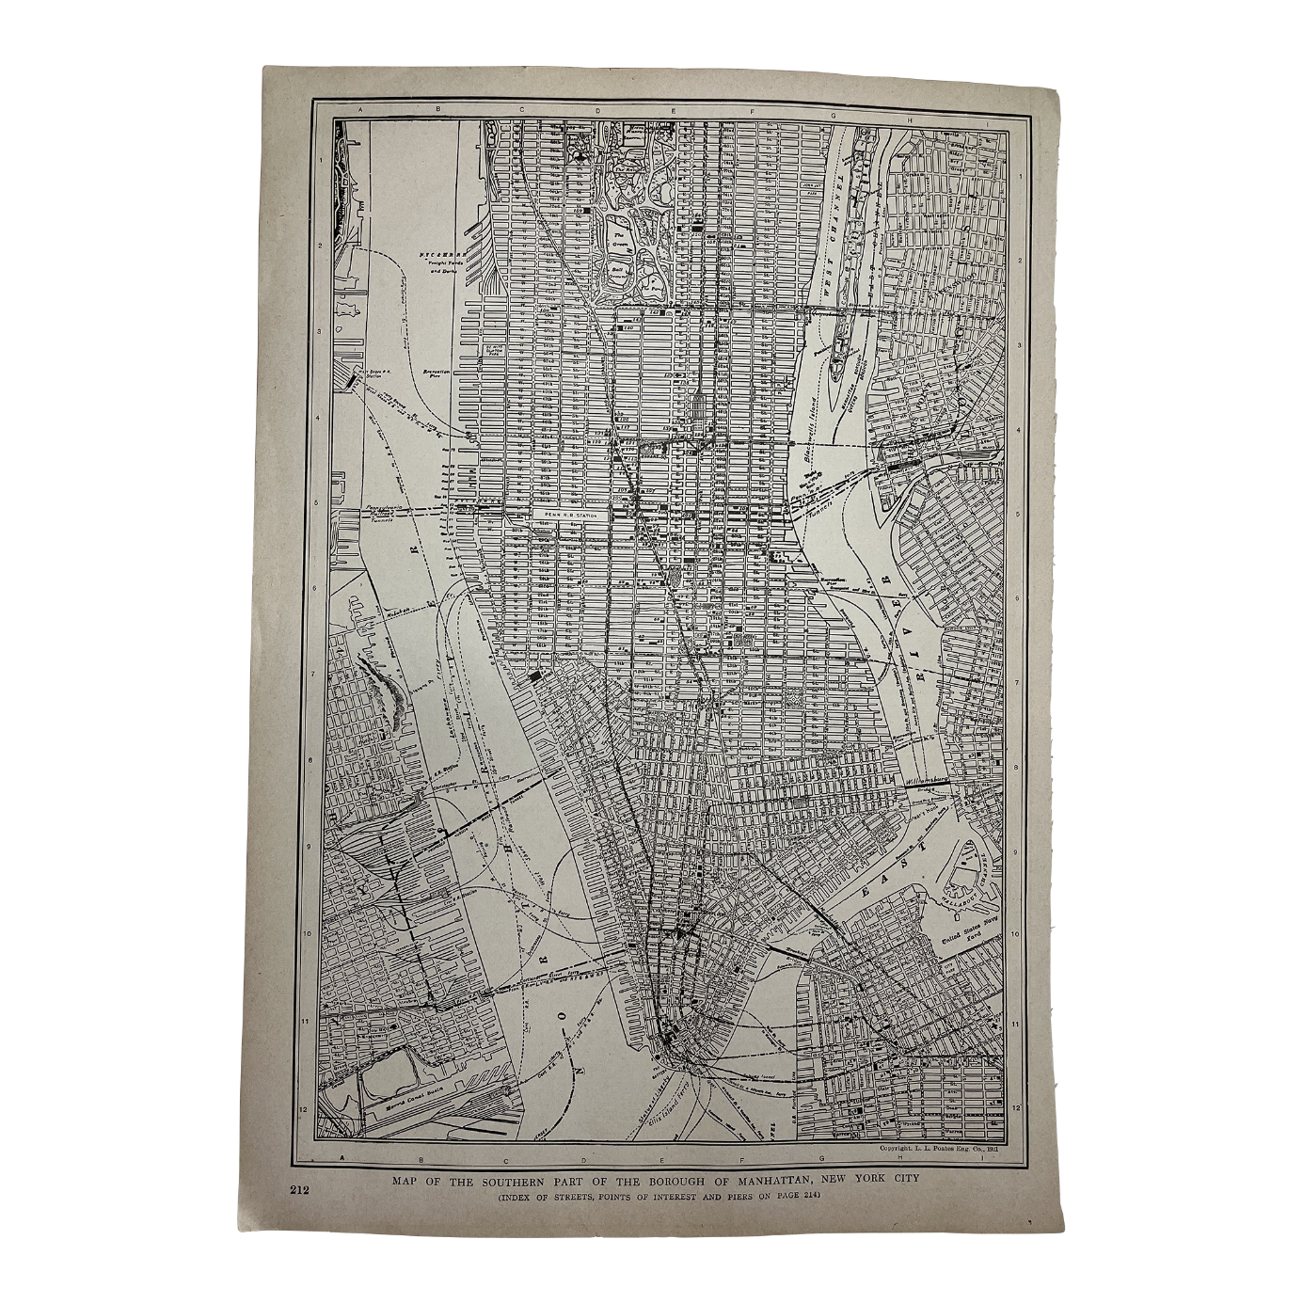
Figure 2, Eden Prarie, The Map of Manhattan in 1920s, retrieved from
https://www.chairish.com/product/5089734/antique-1920s-southern-manhattan-new-york-city-map

Upon closer inspection, one can recognize dozens of bridges connecting Manhattan to other parts of New York. Among those places, ship docks would often be placed on their sides. The workers managing the cargo– often referred to as the “public loaders” would then either cooperate with the Mob, or were forced to obey their conditions under frequent threats. This allowed the families to regulate the amount of cargo, as well as its price. Had the ship merchant refuse to pay such price, he would be put in an “idle”, a state in which they were not allowed to leave the spot, nor unload the cargo. This, of course, had catastrophic results with fresh products that were under the threat of spoiling (Hortis, 2014). The merchants, therefore often decided to pay the price, since even though they were losing money, at least they did not have to get disposed of the whole load. Naturally, such acts were illegal and did not escape the public attention, yet the corrupted government and police were closing their eyes under a promise of a certain commission (Lombardo, 2018). Racketeering and corruption in New York districts grew to such an extent, that the cooperation between police and the mobsters would become popular under the name “Unholy Alliance” (Lombardo, 2018). Such relation will be further discussed in the following chapters.
Chicago
Chicago was considered a sinful city even way before the influence and immigration of the Italian communities. For many decades, Chicago was considered some sort of a last beacon on the way to the West, the last civilized area before heading out to the less occupied places or the so-called “wilderness”. Afterall, just years after the Great Civil War, which is defined as a “pivotal conflict fought between 1861 and 1865 that arose from tensions between the Northern and Southern states over issues such as slavery, states' rights, and economic differences” (McPherson, 1988), Chicago hosted a great variety of saloons, gambling establishments and brothels (McPhaul, 1970).
During this time period, the first instances of organized crime sprung up in Chicago, as the democratic party led by Michael McDonald – an owner of gambling dens and founder of “gamblers trust” elected Harvey Colvin as their major. With Colvin in the office, McDonald had more or less free hand about his presence in Chicago, and is directly responsible for the appearance of the first criminal syndicate, composed primarily of gamblers and rigged politicians (Lombardo, 2018). After his death in the early years of the 20th century, the power over gambling and prostitution facilities was split among different members of the so-called “First Ward Democratic Club”, a group of respected gentlemen from the democratic parties that further offered protection against the law (Harrison, 1935).
Democratic domination had been a thorn in the eye of a regular citizen, as the corruption and illegal activities corrupted the economy and shed a bad light onto the city. Therefore, several Republican candidates started to gain on popularity, in hopes of suppressing the corrupted officials. One of such members was James Colosimo, a second-generation descendant of the Sicilian immigrants. Despite the hopes of the general public for a universal reformation of the state of the city, within the higher social classes, Colosimo was a proud owner of multiple nicknames that reflected his character. Initially, according to Bilek (2008), Colosimo was referred to as the “first vice lord”, a title he earned based on his secret enterprises, such as brothels and gambling dens, that were – at least to the outside world, covered as hotels and motels.
Secondly, Colosimo was familiar as the “Forefather” of the Outfit, “an organized crime syndicate that operated in Chicago, known for its involvement in illicit activities such as gambling, bootlegging, and extortion” (Gusfield, 1981), becoming basically a founder of the traditional Italian mafia in Chicago.
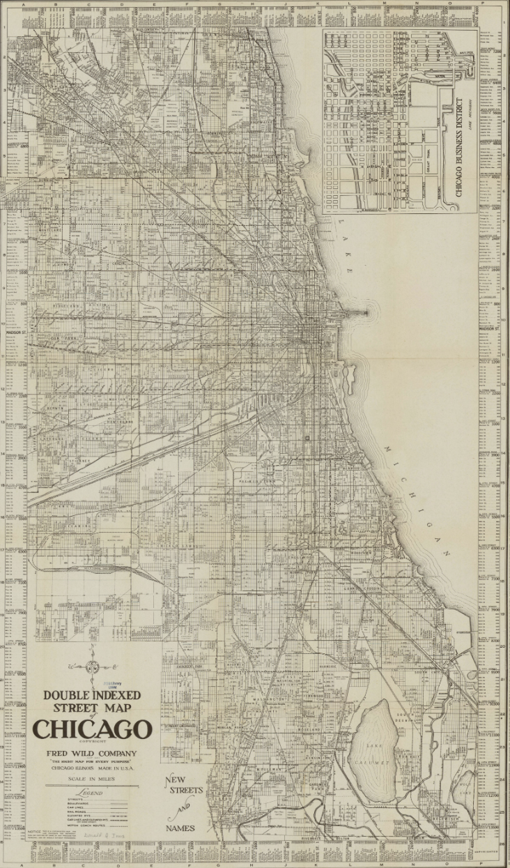
Generally speaking, Chicago assumed a critical part in the early improvement of the Italian Mafia in the US during the start of the 20th century. The city's essential area, modern development, and political environment made it the ideal place for coordinated underworld to thrive, especially among Italian migrant networks (Lombardo, 1981). The geographic area of Chicago additionally played a crucial part in the Mafia's development. Located in the Midwest with simple access to significant transportation lines and the Great Lakes, especially the lake Michigan (see Figure 3), Chicago turned into a main center point for the distribution of illegal products through the nation. This competitive advantage allowed the Mafia organizations to extend their impact past neighborhood limits, furthering their reach of power and associations with other criminal enterprises (Fafinsky, 2018).
.
Figure 3, Double indexed street map of Chicago, Fred Wild Company, 1920
http://collections.lib.uwm.edu/cdm/singleitem/collection/agdm/id/1323/rec/27

2.2 The Five Families
The sheer existence of the Five Families is no surprise to anyone with a basic historical knowledge of the topic, as it prevailed in its existence even until the 21st century. The origins of those families, that ruled New York and close-by areas for decades, can be found in the late 1920’s (Critchley, 2008).
Firstly, it is essential to recognize the common misconceptions about the involved families. A viewer and a reader of contemporary classics such as “The Godfather”, “Goodfellas”, or “The Sopranos” might be familiar with the names of the following families: Gambino, Genovese, Lucchese, Bonanno and Colombo. The afore-mentioned names, as well as the names of their bosses such as Tommy Lucchese or Carlo Gambino will most likely ring a bell as they have been operating-even though on a much smaller scale, up until the present days. However, the thesis will discuss the original five families, sort of the ancestors of the previous families, as they appeared during the 1920s and 1930s. The five most prominent and powerful families were the following: Luciano, Gagliano, Mangano, Maranzano, and Profaci – families, that eventually got renamed into the contemporary ones. (Martin, 2023).
These families were fully recognized in the year 1931, shortly after the Castellammarese War, another conflict of Italian-Americans, particularly between Castellammarese (lead by Salvatore Maranzano) and Masseria (lead by Joe Masseria) crime families. The conflict escalated primarily due to the competition between those families, especially in terms of bootlegging and distribution during the prohibition era – “the period in American history from 1920 to 1933 when the manufacture, sale, and transportation of alcoholic beverages were constitutionally banned in the United States” (Fafinsky, 2018).
Simply put, the bloody conflict had not only cost the lives of many members of the families, but it also impeded their ability to trade and prosper economically. Upon such realization, Maranzano from the Castellammarese family initiated a series of negotiations with the chief lieutenant of the Masseria family – Lucky Luciano. Luciano himself envisioned a different mafia movement, led by generations of young men, second generation Italians, who were adapted to the American system much better (Castro, 2024). Luciano believed that this would cost too much money, and halted the businesses. Shortly after, Luciano made a pact with Maranzano to assassinate his own boss, Joe Masseria, hoping that he would become a head of a family, prioritizing cooperation and business enterprises. In 1931, Luciano conspired in the assassination of Masseria, and created his own family. They would later rejoin forces with Maranzano, meeting in a hotel in New York and officially establishing the existence of the Five Families (Fafinsky, 2018).
This was not, however, the official end of the war. Maranzano found Luciano to be overly ambitious and ordered a hit on his head. Tipped off by his spies, Luciano struck first and successfully ordered an assassination of Maranzano in his office, truly ending the conflict.
Luciano – having the most authority out of any functioning crime families, assembled a meeting of the Five Families, Buffalo mafia family, as well as the Outfit – an organized crime group originating in Chicago (see 2.1 – Chicago), led by Al Capone himself. Even though Luciano maintained majority of his power, he disowned the title of the “Boss of the bosses” as he was fearful of being assassinated. The commission aimed to improve the cooperation and authority of each faction, and has been perceived as the beginning of a new era – modern Italian-Americans overthrowing the traditional Sicilians (Castro, 2024).
Finally, the Five Families and their crucial figures require some background knowledge.
Luciano Crime Family (Later Genovese): this family was named after one of the most prolific figures in the history of the “mob”, Charles “Lucky” Luciano. It is generally believed that Luciano rebranded mafia as the world had known it, and was himself heavily involved in significant crime activities until the year 1936, the year of his incarceration and conviction on 62 counts of compulsory prostitution. The family that most of the world would later know under the name Genovese operated primarily in Lower and Upper Manhattan, specifically the seafront areas of the city, regulating the trade and fish market of the city (Reppetto, 2005). It is generally believed to be the oldest and most prominent in regards to the Five Families.
Gagliano Crime Family (Later Lucchese): founded by Gaetano Gagliano, and eventually working under the boss Tommy Luchese. The Gagliano family are believed to be one of the most peaceful families of the organization. The main source of income of the family would involve racketeering, gambling, and drug trafficking, however, they earned a portion of their wealth through legal clothing and trucking businesses (Sifakis, 1999). While under the hand of Gagliano, the family was operating primarily in Brooklyn and Bronx, nevertheless, so inconspicuously that there is generally not much information about the activities and the Bosses of the family.
Mangano Crime Family (Later Gambino): founded by a second-generation American Italian, Vincent Magano, who was described as a man of old traditions. Magano initiated a large-scale gambling operation, including horse betting and lotteries, alongside other, extremely violent, businesses. Magano founded “The City Democratic Club”, an establishment officially aiming to protect American values. Despite this public image, the club functioned as some sort of disguise for a very lucrative company, Murder, Inc – “A notorious organized crime syndicate in the United States during the 1930s and 1940s…a group of Jewish and Italian-American contract killers who operated primarily under the supervision of the American Mafia” (Fried, 1980). The Manganos had also earned a reputation in the area of construction services, generally legal companies that were occasionally utilized as a tool for money laundering (Allum, 2012). The family operated in Long Island and Westchester County, but also spread its roots to Florida and Nevada – particularly Las Vegas.
Maranzano Crime Family (Later Bonanno this family had experienced the fastest change of its name out of the group, as the original founder, Salvatore Maranzano, was assassinated by the ambitious leader of the Luciano family, Charles “Lucky” Luciano. Consequently, the family was in need of a new boss, that came in the figure of Joseph Bonnano – the youngest mafia leader in the country (Raab, 2002). The main form of income of the family was racketeering, loansharking, and narcotics, allowing Bonnano to gain contacts in different parts of the North America. Besides their initial territory in Long Island and Rochester, the Bonanno family expanded to Montreal, Canada, as well as Arizona and Florida (Bruno, 2012).
Profaci Crime Family (Later Colombo): the youngest out of the Five Families, the Profaci family was founded by Joe Profaci, originally a legal trader with olive oil, a compound that allowed him to legally build his empire. After all, Profaci was widely familiar under the nickname “the olive-oil and tomato paste king of America” (Cage, 1972).
The family operated primarily in Brooklyn, and eventually spread out to the west, to Los Angeles. The Profaci family was involved in regular crime activities, such as extortion, racketeering, and gambling operations (Britannica, 2024).

2.3 Great Depression and Prohibition – Opportunities for Mafia
It is generally believed that the most crucial turning point in the development of organized crime in general was the year 1920, in particular the 18th amendment of the US constitution, an amendment that officially marks the beginning of Prohibition (Dickie, 2004).
Prohibition in the United States refers to a large-spread ban on “production, importation, transportation, and sale of alcoholic beverages from 1920 to 1933” (Burns, 2003). The public opinion of many senators and politicians was that alcohol is an obstruction in multiple areas of American society.
Firstly, one can draw connection to the Women's Christian Temperance Union, respectively their actions in the late 1910’s. The members of the WCTU argued that alcohol consumption frequently led to domestic violence and abuse on women and children. Besides that, poverty or financial instability were among other reasons, as to why the Women fought for prohibition of all alcohol. Feminists across the states widely believed that banning alcohol would improve public health, social conditions and protect families (Tyson, 1998).
Their interests and arguments, therefore, heavily overlapped with the Temperance movement. According to Blocker (2006), the Temperance movement can be described as a social and political campaign, that advocated for ban of alcoholic beverages. Their concerns, similarly to WCTU’s, also included public health, mortality, and inefficiency of an average individual. Not only did the Temperance movement raise general concerns, they also organized anti-alcohol meetings, briefings and educational campaigns that focused on the harmful aspects of alcohol (Blocker, 2006).
Besides that, probably the biggest moving factor (for the majority of politicians) behind the beginning of prohibition was that alcohol supports plethora of societal issues, among which was violence and criminality. It was, therefore, believed that the Prohibition would be some sort of a national solution to both organized and unorganized crimes (Aaron, 1981).
This would not become evident almost instantly, as in the early 1920’s, the local gangs fought for the control of particular territories, such as abandoned factories, private warehouses and others, in order to be involved in the business that – all of a sudden, became the most profitable enterprise in the whole country. Millions of American citizens were naturally unsatisfied with the Prohibition, since having a drink was a popular past time for all the social classes, ranking from the lowest and poorest citizens to highly-ranked politicians.
The peak of such disputes over territory escalated in the late 1920’s, in the event know as Saint Valentine's Day Massacre – a shooting of seven members of one of Chicago’s infamous gangs, where the men were lined up in an abandoned garage and slaughtered by four men that were disguised as policemen (Chicago Daily Tribune, 1929). This event marked the final opposition of the North Side Gang (also known as Moran Gang), against the previously-mentioned Chicago Outfit lead by Al Capone. Scholars also argue that it largely contributed to the beginning of commission and cooperation of the five families (see final paragraphs of 2.2 The Five Families).
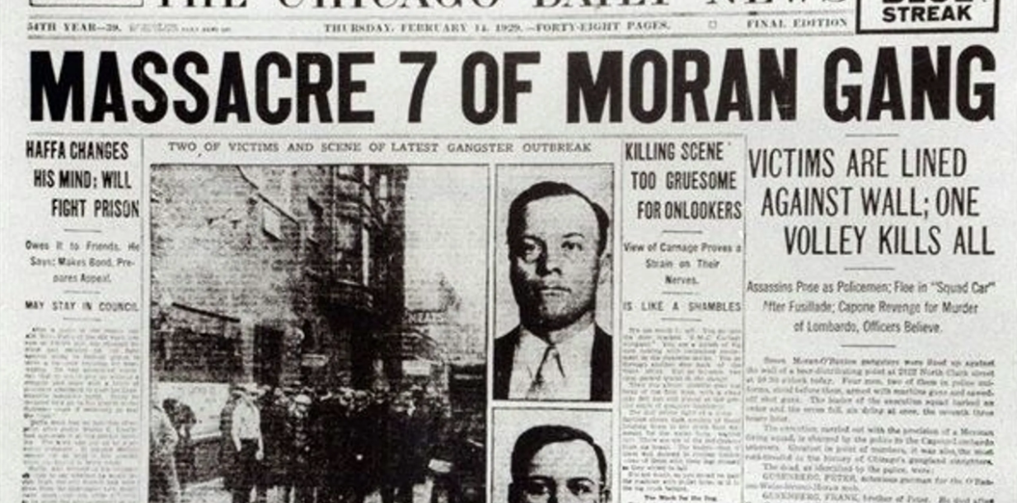
Figure 4, The Chicago Daily News reports on the St. Valentine's Day Massacre, 1929

The Volstead Act- an act providing for enforcement of The Prohibition of the 18th amendment was named after the chairman of the House Judiciary Committee Andrew Volstead, had proven to have an effect quite opposite to the first intentions. It is necessary to realize, that following statistics include organized crime of all illegal parties, not only the Italian-Americans.
Despite this, it was the Italian Mafia who was responsible for a great majority of those numbers. In a study conducted within thirty major US cities during the years 1920 and 1921 – the earliest years of the Prohibition Era, the crime rate skyrocketed on average by 24%, with burglaries rising by 10%, murders by 13% and drug addiction by additional 45% (Towne, 1923). Such numbers, despite being quite alarming, were not applicable to all the cities. A study by Smith (2020) has shown that criminal activities nearly tripled in cities like Chicago and New York, the Mafia headquarters. Once again, one can assign such increase to the Italian Mob, as well as Jewish gangs.
Lastly, the census of the United States showed that during the Prohibition era, there was the highest homicide number in the history of the country, rapidly dropping after the repeal of the 18th Amendment in 1933 (Bureau of the Census, U.S., 1975).
However, this was not an end to the catastrophe that was about to follow. Prior the Prohibition and shortly after, the Italian Mafia was the most violent, and a thorn in a public eye. Nevertheless, accumulated income during the fourteen years of the Prohibition era from illegal bootlegging put on estimate $2 billion dollars into the pockets of the Families (Dickie, 2004). This amount would equal to $41 billion dollars in the current economy. This large flow of cash was earned in a variety of ways. The following methods are displayed in the official “Mob Museum” in Las Vegas, Nevada, retrieved from https://prohibition.themobmuseum.org/.
- Own Production
The Mafia established distilleries in remote places to avoid public attention. It is estimated that tens of thousands of gallons of alcohol have been produced on a daily basis across the states.
- Importation
The Mafia used already established trading routes to bring alcohol from other countries, such as Canada or Mexico, sometimes even utilizing their contacts from the “homeland”, Italy, to bring alcohol such as wine. Naturally, ships were frequently subjected to random checks, however, the gangsters often used ships with a false deck (see figure 5, displayed in Lawson, 2013).
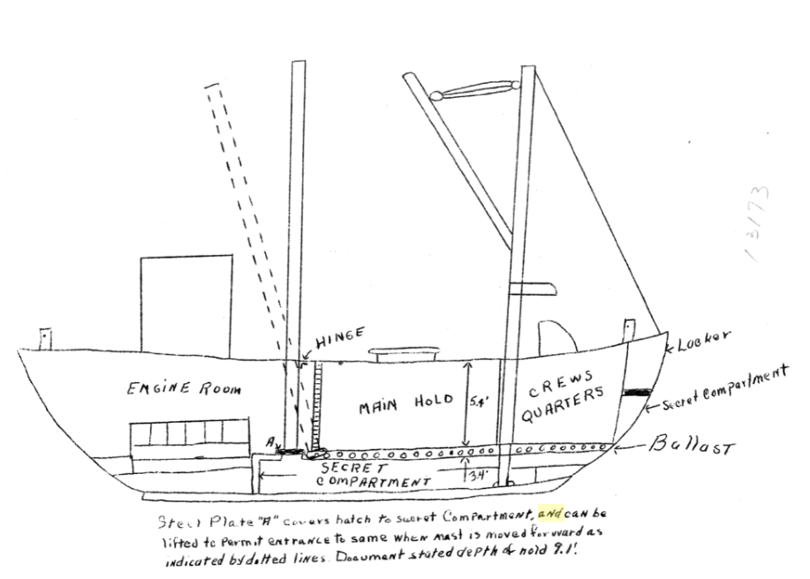
Figure 5, Hidden Compartment for Liquor, Lawson, 2013

- Transportation
To distribute the desired liquid to other states of the US, the Mafia needed to implement a complex transportation structure. This primarily included bribing and corrupting the officials responsible for border controls; however, the Mob purchased a vast collection of boats, trucks and other motored vehicles to ensure the smooth process.
- Networks
Despite having distilleries and liquor-producing factories, the mobsters required a network of safe places to storage their goods away from the law. This included warehouses, and secret delivery routes, as well as supplying speakeasies (“a place where alcoholic beverages are illegally sold, specifically during the period of prohibition in the U.S. “, Merriam-Webster, 2024), charging them $6 for a gallon, while having the production costs of around 50-75 cents a gallon (The Mob Museum, n.d.).

Quite naturally, such a profit surge made the Italian Mob more powerful than ever before. Such money would not only allow them to hide in plain sight and use other parties, people and businesses to earn their share, but it would also allow them to move with the whole economy of the US in general. Bidding, buying unions, or even bribing prominent figure only allowed them to gradually earn more power and control over the states.
Finally, the end of the Prohibition brought another unexpected government enemy, the Unione Siciliana. This was an organization initially intended to provide support and help to early Sicilian immigrants, however, this organization turned into a complex organization supporting criminal activities such as bootlegging and liquor distribution. Lastly, the Unione connected Italian families from across the states, allowing the Mafia to be the most powerful it had ever been (LaGumina, 1999).

2.4 Spreading to the West
The Mafia has never limited themselves purely to one source of income. After the abolishment of Prohibition in the states (see 2.3 Great Depression and Prohibition – Opportunities for Mafia), illegal bootlegging was no longer one of the highest-earning enterprises. The individual families had earned enough money during the Prohibition era to allow them prosper and expand further west, forming some of the most famous western cities as we know them now. Italian Americans – often the ones belonging to particular families, were one of the few that weren’t heavily financially struck by the international crisis, and functioned as “pioneers” that helped to build some of the most famous cities (Balboni, 2006).
Gambling
After the re-legalization of gambling in the early 1930’s, members of mafia had seized the opportunity among the first states that abolished the ban, including California and Nevada. The re-legalization was considered to be an important step towards the recovery of the economy, offering plethora of jobs and a way of an easy revenue (Chang, 2010). Many states eventually reconsidered their stance towards gambling, leading towards a wide spread of gambling the States.
Italian Americans – primarily members of the Mob had already had experience with gambling dens and enterprises in big cities such as New York and Chicago. It was, therefore, convenient that they expand to the west and build the foundations of the modern “Sin Cities”, such as Las Vegas.
According to Balboni (2006), shortly after re-legalization of gambling, there were many instances of new businesses springing up in the west. Members of the Genovese (Luciano) family were the first to build bars and hotels in Las Vegas, in the time period, when its only importance was “to be the major railroad stop between Los Angeles and Salt Lake City” (Balboni, 2006). Tony Cornero was the first to open a plush casino with daily events and paid entertainment in the year 1931 – the very same year of re-legalization of gambling. Frank Detra opened the first-ever casino on the I-10, the Los Angeles highway. Pietro Orlando Silvagni, an Italian American citizen (though not belonging to any family) built the Apache Hotel, quite probably the most elegant hotel in the US in the 1930s and 1940s.
At this point, everything the business owners needed was a constant fluxion of new citizens that would support their growing enterprises. Coincidentally enough, such movement occurred in the 1930’s and 1940’s due to multiple factors. Firstly, the construction of the Hoover Dam – “a massive concrete arch-gravity dam located on the border between the U.S. states of Nevada and Arizona, built during the Great Depression” (Moore, 1999). This project brought in thousands of workers and allowed some new cities to appear on the map, primarily to accommodate the workers and their families.
Furthermore, the presence of a large-scale military conflict, the World War Two, had meant that many military bases and industrial companies moved to the Western Coast of the US, including states such as California and Nevada (Vondruska, 2023). This inevitably attracted a larger number of potential workers, an opportunity that was seized by many illegal investors who saw a prominent future in the area. Among such figures we could assign for example Meyer Lensky, a Jewish figure that closely cooperated and formed alliances with Italian-American Mafia, in particular the familiar persona of Lucky Luciano (Nash, 2017). Another prominent influence could be recognized in the name of Benjamin “Bugsy” Siegel, quite probably the most influential individual of the Las Vegas strip. Bugsy, initially working for Lensky, also closely cooperated with the Italians, and eventually got granted the permission to expand the businesses in their names to California (Vondruska, 2023).
It was during the late 1940’s that the public view of the Mafia was nothing short of astonished, as the general opinion (supported by the majority of the press) quite frankly mitigated the negative aspects and actions of the organization, such as the criminal acts they utilized to strengthen their power, and mainly focused on the positive aspects of entertainment – the glamorous singers and dancers. Even though the Italian-Americans only counted up to approximately 5 percent of the US population, Italian-Americans shined in more than 25 percent of the Las Vegas entertainment industry, including singers, performers and comedians (Balboni, 2006). Afterall, names such as Frank Sinatra or Dean Martin, the two of the most prominent singers, appeared in the headlines of countless newspaper across the States.
Labor Racketeering
One of the other methods that allowed the Mob to expand their power westwards was the use of illegal labor racketeering. According to the definition of Bell (1951), labor racketeering is “the labor corruption committed by, in alliance with, or under the auspices of organized crime group”. In order to force the members of the union to conform to your demands, the mafia used a plethora of actions to empower their positions. The following actions are described in the book by Jacobs & Peters, Labor racketeering: The Mafia and the unions (2003).
- Threatening of strikes or work stoppages
The Mafia often disrupted business operations and threatened workplace sabotage that would cause businesses to lose more money, than what the organization asked for
- “Sweetheart” deal
Mafia-controlled unions frequently received bribes from employers so that the Mafia would allow them to bypass the contracts and terms of conditions
- Violence against the members
The Mafia would often resort to violence as a means of exercising warning to anyone, who would dare to oppose their authority or demands.
- Theft
Members of the Mafia would launder and steal money intended for pensions and worker benefits. This was frequently done by creating false reports and accounts, allowing the individuals to transfer money to their bank accounts instead.
- Illegal cartels
Officially legal Labor unions would often be under the control of illegal cartel paid by the Mafia. This way, had any accusations came to the court, the Labor members would remain innocent, as the so-called “dirty work” was being done by different parties.

3. The Rise of the Mafia

3.1 Hierarchy of the Italian Mafia
In the final stages of the first half of the 20th century, it is estimated that at least 20 families were operating across the span of the United States, many of which cooperated with outside countries (History editors, 2024, retrieved from https://www.history.com/topics/crime/mafia-in-the-united-states). For the majority of them, the structural hierarchy would be quite similar, most likely getting inspired by organized groups on the Italian – Apennine peninsula.
According to Lupo (2009), the hierarchy would be mostly as follows:

Figure 6, Mafia Hierarchy, FBI, retrieved from https://www.fbi.gov/file-repository/mafia-family-tree.pdf/view

To describe the chart, one must look at the roles and duties of each rank. Firstly, we need to differentiate between the two colors. The majority of the roles are signified by a dark blue color, meaning that the ties in the family were mostly a direct ancestral link. In contrast, light blue color signifies outside parties that frequently developed some sort of cooperation indirectly.
Each member had strictly given permissions and obligations.
- The Boss – Head of the family, with basically unlimited power, who would receive a financial share from every operation carried out by any member of his family. Responsible for any major decision.
- Underboss – Oversees daily operations, family-bound to the boss. If necessary, or upon death of the Boss, Underbosses would become the head of the family.
- Consigliere – Alongside the bosses, the 3rd most prominent figure of the family. Even though they were not from the family itself, they functioned as the main counselor and advisor of the Boss. Often a trusted acquaintance of the family, Consigliere would advice on financial and business matters.
- Capos – Also called captains, they shared a similar role to captains in the military. Under their control, Capos had a certain number of soldiers, usually around 10 each, who were bound to them in terms of loyalty and actions. Capos usually reported to the Underboss or the Boss himself, as they were involved in the daily action, managing the group operations.
- Soldiers – The main working force of the family. Despite being lower in the hierarchical ladder, soldiers were well respected within the community, as they had to endure specific processes to enter the organization, such as an oath or other activities (Read 3.2 How Did One Become Part?). Soldiers were most frequently incarcerated, as they were directly bound to the illegal activities (Reppetto, 1994).
- Associates – Members of the organization who were not a part of the family itself. Those individuals worked for the Mafia, or ran illegal businesses, but were not bound under any family oath – even though their full cooperation was still expected, as otherwise they could be facing a cruel punishment.

3.2 How Did One Become Part?
It is important to realize that the families worked basically as a state. It aimed to control its territory through economical and power reasons, therefore it was crucial that the imaginary borders be protected and widely accepted (Critchley, 2008).
According to Gambetta (1996), new members were accepted upon a complicated initiation process that often included multiple key elements. The following steps were widely utilized among different families, although there is no guarantee that each family followed all of these particular steps.
Several scholars, such as Chandler (1975), or Hammel (1998) agree that the whole process roughly went as follows:
Firstly, an existing member of the mafia family – be it the capo, or a soldier picked a suitable candidate, often using individuals in desperate conditions, for whom Mafia was sort of a last step. The member of the Mob would then “sponsor” the candidate, ensuring he had an established connection within the organization. The sponsor would then advocate for the candidate’s abilities, their character and usefulness to the organization. In return, the candidate got an insight on the rules and values of the family, as well as their code of conduct.
Next step would be a so-called trial period. Before being formally accepted by other members of the family, the candidate had to prove their intentions and loyalty to the family. To demonstrate such features, each family had a different approach. Mostly, the candidate would have to get involved in some kind of illegal activity – be it drug trafficking, extortion or in some cases even murder. Candidates were closely monitored during this period, to ensure their reliability and ability to follow order by the bosses. Failing to do so would result in banishment from the family, or worse – violent consequences.
Had the candidate got through those steps, the next advancement would be a so-called Omerta, or an Oath of Silence. This term gained a significant popularity in contemporary literature and cinematography, and origin of this word can be traced to southern Italy (Herzfeld, 2004, p. 107). Omerta can be described as a certain code of honor for the Mafia, and can be interpreted as an obligation to “never, under any circumstances, apply for justice to the legal authorities and to never assist in detection of crimes committed against oneself or others” (Britannica, 2024, p. 1). In cases where any member of the Family was wronged, repercussion was to be carried out by the victim themselves, or members of their Family – in both interpretations of the word, the Mafia, or family relatives.
The next segment is one that varied the most among different Families. According to Varese (2011), the candidate – and soon to be new member of the Family was brought before the rest. This procedure was of a rather formal character, purely to emphasize the grandness of the commitment the member is about to make. Symbolistic items were also part of the process, as the candidate would often hold a burning paper, blood-soaked card, or a knife while being approved by the rest.
Finally, the new member was now a part of the Family. Nevertheless, there was expected nothing short of pure loyalty and respect towards the higher ranks. This included “blindly” following any orders from their superiors, while the feelings thereof were of no interest or consideration. Demonstrations of loyalty could lead to better opportunities for the members, while the opposite suggested ostracism and – in most cases, violence. Such tightly-knit structure played its role in longevity of the organization (Chandler, 1962).

3.3 Role of Women in the Mob
Historically speaking, the role of Women in organized crime has been mostly downplayed, as the Mafia – in particular Italian-American Mafia was publicly viewed as purely patriarchal organization (OCCRP, 2019). Recently, researchers such as Di Maria & Lo Verso (2007), showcase that their involvement might have been underestimated. Among many factors, the researchers highlight the following points of influence:
Firstly, women, as given in a traditional Italian family, were the symbol of family and everything it provides, which is one of the crucial features of the Mafia. Besides introducing the children to the key aspects and moral codes of the Mob, they were helping to form future leaders, and temporarily substituted the head of the family when necessary, particularly in cases of incarceration or death.
Crimes committed by female members of the Families are rarely heard of, however, according to Dino (2007), that could be for a plethora of reasons. Scholars suggest that women are more likely to be excluded from the law-enforcing, as well as any constitutional consequences. This often allowed women to be included in various processes, without raising a suspicion. Another important function was to enforce the code of Omerta within a family, as they were frequently a central figure in keeping the secrets of the Family.
According to Bordero (2019), women in the era were generally not probable to cause a crime, amd furthermore, the public belief in the 20th century was that women could not take responsibility for their actions, therefore they are less likely to be labelled as criminals of mafioso. The public shift happened by the end of the century, as the first woman connected to criminal association was arrested in 1989. Just a few years later in 1995, 89 females were charged with such offense. This allowed for a drastic change in legislation, as up until 1999, a woman could not even be charged with Mafia-related crimes (Selmini, 2020).
Lastly, one of the most famous stories of a female member of the Mafia – Lady Camorra, can provide a better understanding of Women’s true role in the Families. Even though the story is from the Italian peninsula, it clearly represents the values of Women even in American families.
On the verge of the halves of the 20th century, Assunta Maresca was married to Pasquale Simonetti. Upon a murder of her husband by a member of a rival Family - Antonio, Assunta objected to calling the law, and planned a vendetta herself. She tracked Antonio down and executed him in the middle of the day, all while being 18 years old and carrying a half-year baby. She went on to claim a nickname Lady Cammora, one of the most feared females in the organization (Longrigg, 2021).

4. (Some)Key Figures of Mafia – As the Time Goes

4.1a Al Capone
Alphonso Capone – or shortly Al Capone might have earned the title of the most famous Mobster in the history. Known for his public stunts and interaction, as well as a terrific amount of wealth, he has become the epitome of a real “Italian-American Gangster” (Sifakis, 2005).
He was raised by a family of Sicilian Immigrants, many of which faced a plethora if societal issues at the era (Read 1.4 The Melting Pot). Consequentially, Capone had begun to resist authorities even way before his struggles with the law, particularly in his early years of school, as he was opposing the idea of being under any type of control or authority. According to the letters sent to Capone’s parents, he was barely present, did not listen nor comply to the instructions of the teacher and eventually got expelled for attacking his teacher and reportedly beating her up for giving him a slap (Burke, 2016).
Having been without school, Capone decided to start earning money by working in multiple different jobs, such as a candy store, bowling alley, and shop clerk (Kobler, 1971). Those jobs, however, did not fulfil Capone by neither financial, nor mental side. His earliest record of becoming a member of a gang is, therefore, in the early 1910s, where he sided alongside with gangs such as Brooklyn Rippers and eventually a powerful syndicate Five Points Gang from the area of a Lower Manhattan.
During this time period, he received a mentorship from Frankie Yale, who employed him as a bartender and eventually a “bouncer” in one of the clubs in Coney Island, NY. However, it was this job in particular that shaped his future appearance as well as character. Capone frequently offended women while working by the entrance of the club, which inevitably led to a catastrophe. Having offended a woman in presence of her brother, he pulled out a knife and cut Alphonso on his face, hence the future nickname “Scarface” (Bardsley, 2008).
Besides petty crimes, Capone began to get involved in more gruesome acts of violence during his early 20s. There are two instances reported, as in the first case, Alphonso shot a man dead after having been robbed of his prize money in a game of gambling. Following this, another incident occurred where Capone violently murdered a young member of a rival gang -the White Hand, the leaders of which publicly declared their desire for retribution and a hunt on Capone’s head – a main reason why his mentor, Frankie Yale, sent Al and his family to Chicago to protect his life (Britannica, 2024).
Not long after had Capone finally moved to the city of his biggest operations. He was employed by a boss of the Chicago Outfit – Johnny Torrio. This fact became crucial in the development of his future, as Capone took over the Outfit in 1925, after a failed assassination on Johnny Torrio, focusing on a distribution of alcohol as his main source of income, even though according to Iorizzo (2003), he covered up his business as one distributing used furniture. The main focus on bootlegging had proven to be a great step as it was still the time of The National Prohibition act of the 1919, accumulating great amounts of money (Raab, 2005).

4.1b Wealth of Al Capone
The pathway towards wealth was of a very gruesome character. Capone left bloody corpses left and right, basically eliminating every single possible competition. Eye witnesses, or anyone who would dare to report the crimes to police were under constant fear of retribution and violence against their families, and thus many of the crimes went unreported or unconvicted, after the witnesses quickly withdrew their testimonies (Britannica, 2024).
Al Capone started to accumulate wealth in numbers that had never been seen before. Spreading his influence into several spheres of criminal activities, such as gambling, brothels, or his primary source – bootlegging. According to New York Times of 1929, establishments that were reluctant to purchase liquor from Capone were blown up or severely damaged.
In 1927, only two years after taking over the Chicago Outfit, Capone had already had an estimated net worth of $100 million (Britannica, 2024), which is an equivalent to roughly $1,8 billion in 2024, according to the Federal Reserve Bank of Minneapolis (retrieved from https://www.minneapolisfed.org/about-us/monetary-policy/inflation-calculator).
According to Raab (2005), here is a rough breakdown of Capones annual money influx at the peak of his power in 1928,1929 and further on.
$25 million – gambling industry
$10 million – vice, brothels
$10 million – assortment
$60 million – bootlegging.
This amounts to roughly $105 million per year, or $1,6 billion in today’s rate (Federal Reserve Bank of Minneapolis, 2024).

4.1c (Little) good vs (much) evil – How Capone Shaped Society in 1930s
There are disputes over some of the positive actions of Al Capone. When thinking about the criminal enterprise, as well as countless acts of violence, and murder, it is difficult to see Al Capone’s impact on the US society in any other light than just purely negative. Nevertheless, many citizens were praising Capone, describing him with flattering titles such as “The Modern Robin Hood” (Cohen, 2012).
This status was achieved during the Great Depression, that led to high percentage of unemployment, poverty and lack of food, as further discussed in “2.3 Great Depression and Prohibition – Opportunities for Mafia”. We shall never find out the truth about his intentions during the beginnings of his philanthropic campaign in a form of Public Kitchens, yet we can simply state the facts and display how those Kitchens helped countless desperate people and shifted the public image of Capone among the common folk. Even though it is argued that Capone simply wanted to improve his popularity in lower social classes, it is a fact that he was known to help out (Klein, 2019).
Capone’s Kitchen was founded during the Great Depression era in 1930. According to Klein (2019), it offered three warm meals a day – breakfast, lunch and dinner. Upon the launch of the Kitchen, it is estimated that between 2200 – 2800 unemployed impoverished men visited the facility for each of the offered meals. However, the most precise picture can be established when searching through primary sources of the era, in particular newspaper, such as the Chicago Tribune.
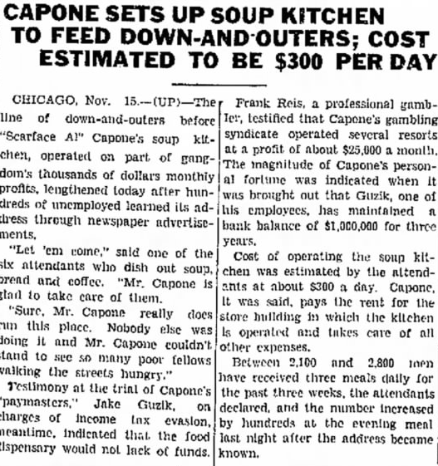
Figure 7, Chicago Tribune, 1930, retrieved from https://www.newspapers.com/search/results/?keyword=food+kitchen&publication-ids=6010
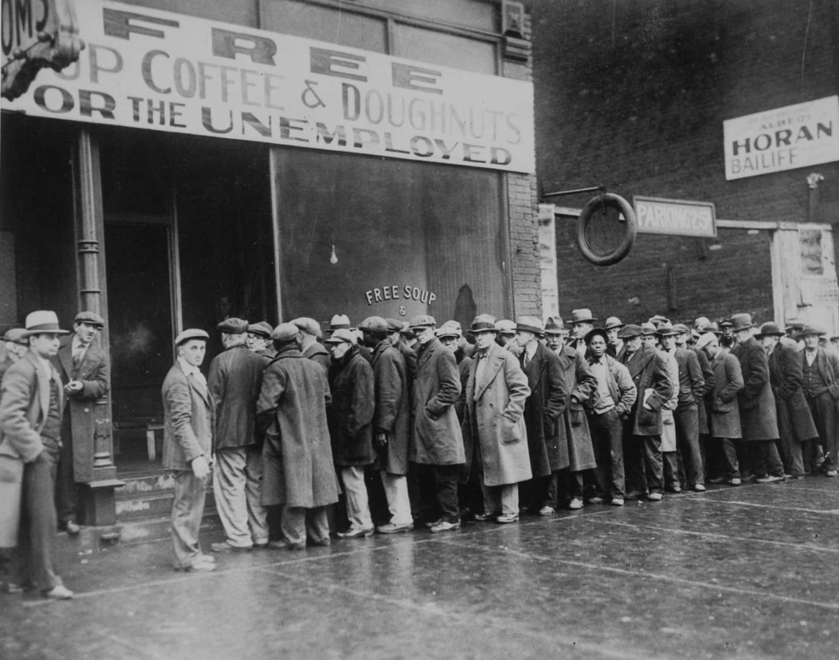
Figure 8, Capone’s Food Kitchen with a line of hungry men, 1931, Wikimedia Commons, retrieved from https://en.wikipedia.org/wiki/Al_Capone#/media/File:Unemployed_men_queued_outside_a_depression_soup_kitchen_opened_in_Chicago_by_Al_Capone,_02-1931_-_NARA_-_541927.jpg

It is undoubtable that Capone’s establishment helped many in need. When inspecting the headlines of the primary sources, we can access the daily cost of such act.
In 1930s, the daily operation cost amounted to approximately $300 daily, which equals to roughly $5,660 in today’s economy. According to the Library of the University of Missouri (2024), the annual salary of a white male in 1930 was roughly $1,900, and $1,100 for black male respectively. This meant that on average, a white male earned roughly $5 a day, whereas a black male only around $3. This statistic highlights the importance of Capones food Kitchen, that had an annual cost of $110,000. This amounts to a very small percentage of Capone’s wealth, when compared to the statistics from 4.1b – Wealth of Al Capone, yet generally, such amount of money would be quite significant in a view of a common folk, which is a reason why Capone’s public view started rapidly changing.
More primary sources report, that during the Thanksgiving of 1930, Capone gave out 5,000 meals (Klein, 2019). Furthermore, Capone also provided clothes for those in need, as well as a weekly distribution of milk to schools. It is not difficult to imagine the popularity Capone swiftly gained. In Klein (2019, p. 2), this quote perfectly summarizes the viewpoint of a regular citizen: “When the government deprived them of beer and alcohol during Prohibition, Capone delivered it to them. When the government failed to feed them in their desperate days, the crime boss gave them food”. Furthermore, the newspaper Bismarck Tribune (1930), states: “a hungry man is just as glad to get soup and coffee from Al Capone as from anyone else.”
Lastly, many other primary sources offer even closer inspection upon the hypocrisy, in which illegal activities, such as gambling were basically “praised” as they allowed Capone to use the money to feed the poor, as seen in Figure 10.
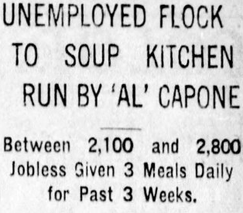
Figure 9, Green Bay Press Gazette, November 15, 1930, retrieved from https://www.myalcaponemuseum.com/id230.htm

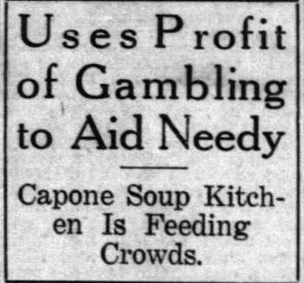
Figure 10, Muncie Evening Press, 1930, retrieved from https://www.myalcaponemuseum.com/id230.htm

To summarize, Capone’s Kitchen was helpful for both common folk, who got fed for free in an era of social and economic crisis, as well as Capone who rapidly gained popularity for a very small cost.

4.1d The Fall of Al Capone

The decline of one of the most powerful men in the world was quite sudden. Al Capone had over the years miraculously avoided any convictions connected to his gruesome and violent acts, as it is estimated that he caused – both directly and indirectly, around 200 deaths during his presence in New York and Chicago (Nicholas & Chen, 2009). Some argue that Capone himself directly killed at least 5 people.
Surprisingly enough, his fall began with non-violent charges. The first instance of Capone being arrested was in 1929, where he got convicted of carrying a concealed weapon, a crime that made him serve 9 months in a prison (Schoenberg, 1992, p. 238). However, such crime did not particularly influence his position in the society, as proven in the previous chapter 4.1c, as Capone opened his famous food Kitchen the following year.
More serious charges were yet to come though. In 1931 Capone was charged with over twenty charges of federal income-tax evasion from the previous decade. Between the years 1925 to the end of the decide FBI - Federal Bureau of Investigation had thoroughly collected evidence of any illegal activities that would lead to Capone in prison. The final charges were 22 counts of tax evasion and various accounts of violations of the Volstead Act (Britannica, 2024). Capone was sentenced to 11 years in federal prison, most of which he spent in Alcatraz, a prison infamously known for its high-level security (IRS, 2024)
Capone got released after 9 years for good behavior, however, it was too late to stop the ship from sinking. While incarcerated, the FBI alongside the government had slowly worked on bringing his empire down. Being isolated from his companions, Capone started to lose control over his territories. Many of his illegal bootlegging establishments and hidden spots fell to the arms of the government, essentially making Capone’s empire to diminish (Hipango, 2023).
It is ironical that despite being accountable for possibly hundreds of deaths, including the St. Valentines Masacre (read chapter 2.3 Great Depression), Capone got incarcerated through tax evasion.
After being released for good behavior in 1939, Capone had to be immediately transferred to a hospital, as he was suffering from latter stages of syphilis, a genital disease that he likely acquired while working in a brothel. Both his physical, as well as mental health had gradually been deteriorating, making Capone insufficient of further leading his empire. Capone’s condition eventually became so dire that he was one of the first subjects to test the effects of Penicillin (Smee, 2018). Nevertheless, such treatment could only postpone the inevitable, albeit giving Capone a few extra years of life.
His conditions only worsened, as he suffered a stroke just several years after his release. Shortly after, a cardiac arrest followed and Capone dies aged 48 in his home in Florida (Chicago Sunday Tribune, 1947).
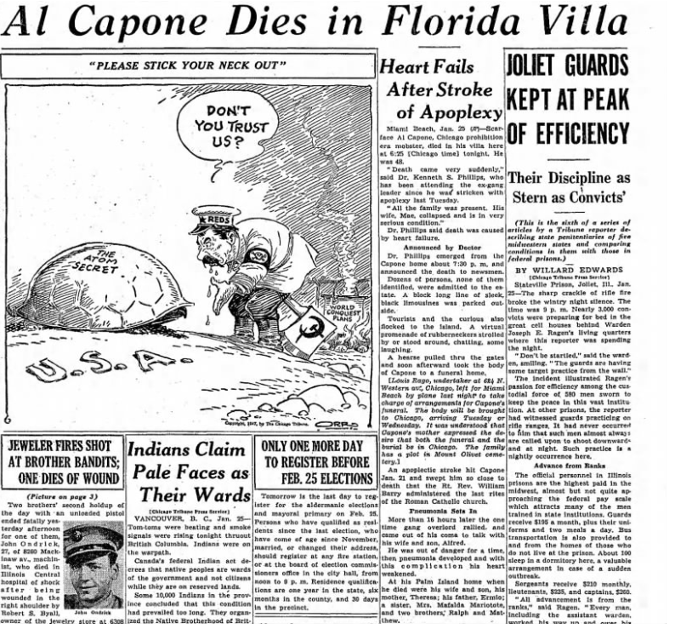
Figure 11, Capone dead in his Villa, Chicago Sunday Tribune, 1947, retrieved from https://www.newspapers.com/article/chicago-tribune-al-capone-dies/14735502/

4.2a Frank Costello

Frank Costello is a significant figure of the era and a Mobster with a long-lasting history in the Luciano family. Unlike Capone, Costello was not particularly fond of the public attention and tried operating from the underground. Nevertheless, Costello still moved the strings of the politics in certain cities, such as New York (Britannica, 2024).
Starting off his criminal career, Costello joined a local gang of Italian-Americans at the age of thirteen. Shortly after, he got arrested for a possession of a firearm, and sentenced to 10 months in prison. This episode might have been the turning point of Costello’s life, because shortly upon his release, Castello began to cooperate with other big names of the Mobster sphere, primarily with Charles “Lucky” Luciano, Vito Genovese or Tommy Luchese – The members of the infamous Five Families (Raab, 2005).
Being in such a powerful company, Costello wasted no time in spreading his influence over the States. Similarly to Capone, he began to utilize the Prohibition for his benefit, bootlegging and distributing alcohol over several States. Besides that, Costello bet his cards on gambling, extending his gambling dens primarily into southern states, for example Louisianna and Florida (Britannica, 2024).

4.2b Power Throughout the Society – How Costello Manipulated Everyone

Costello’s campaign was bound to be long-lasting, as he had worked with all social classes in attempt to maintain his power. He realized that political connections are the key to avoid legal prosecutions, as well as to hide the ongoing illegal operations.
Scholars such as Raab (2005), were able to describe the crucial steps that allowed Costello to hold onto the power.
Firstly, it is necessary to highlight the importance of cooperation with various political figures. Among the most crucial was a partnership with New York City Mayor William O'Dwyer, in the late 1940’s. Costello was seeking protection from the prosecution of his illegal activities, such as the afore-mentioned gambling, and drug trafficking. In return, O’Dwyer requested a help during the electoral campaigns. Costello – being a prominent figure among the immigrant communities rallied the voters to vote for O’Dwyer, in a promise of better living conditions. Subsequently, Frank Costello provided financial support for the campaign, funded from his illegal activities.
Through the established connection with the Mayor, Costello was able to spread his influence even to the higher ranks. Raab (2005), describes, how his connections to the Governor of the New York State – Thomas Dewey, led to even higher prominence of the Mobster’s presence.
Thomas Dewey was infamous among the underworld communities for strict prosecution and attitude towards any kind of organized crime. Previously, Dewey prosecuted many famous members of the Five Families, such as “Lucky” Luciano or Tommy Luchese. Costello, however, once again promised a financial support as well as support from the immigrant communities, resulting in Dewey protecting Costello’s illegal businesses.
Lastly, Costello’s influence spread even into the popular culture. Similarly to Capone, he became a symbol of high-end glamorous lifestyle of the Mobsters. His persona was then further portraited in movies and books, which eventually lead to fascination with mafia, rather than a respect from it (Simon, 1991). This representation of this rather dangerous world influenced the opinions of younger generations, many of which had a completely different perception of the Mafia world, primarily because of the spread of the popular culture and their coverage of people who had previously been simply called criminals.

4.3a Vito Genovese

Even during the following decades, the Five Families were still the most dominant in terms of the area of control on the US territory. However, Vito Genovese – or as the name suggests, the Boss of the Genovese Family spread his influence even beyond the borders. According to the National Museum of Organized Crime and Law Enforcement (NMOCL, n.d.), Genovese fled back to his homeland, Italy, in order to avoid possible prosecution for his violent crimes, in particular his involvement in the Castellammarese war (Read 2.2 Five Families), as well as a murder of a fellow Mobster, Ferdinand Boccia.
It was during the time of the World War II when Genovese fostered a certain level of intimate friendship with the most prolific and influential person in the whole country – Benito Mussolini. According to Grutzner (1959), Vito provided Mussolini’s family relatives with drugs, closing the distance towards the leader himself. Shortly after, Genovese donated nearly $5 million to the Fascist party in Italy.
It was drugs, in particular cocaine, that sustained Vito’s income while being abroad. With the help of Mussolini, he smuggled narcotics to New York (Britannica, 2024). Naturally, such actions demanded a cooperating person on the other end. Such individual was none other than Frank Costello from the previous subchapter.
By the end of the World War II, Vito realized the shift of power in the conflict and fled back to New York. Not only did he offer to betray Mussolini, but also to support the military interests of the US army in Italy, all while disclosing private information (NMOCL, n.d.).
Such cooperation was, however, not appreciated by the US government officials, as Genovese gets arrested in 1944, beginning his long-term skirmish with the law enforcement.
Similarly to Costello, and sometimes even in collaboration with him, Genovese realized that bribery of high-ranked political members in New York city and New York state would provide him with preventive measures to run his illegal businesses. According to Kessler (1993), Genovese manipulated political processes in both the city and the state of NY, bribing high-ranked officials, supporting political campaigns and push towards favorable legislation.

5. What About the Common Folk? a.k.a Mafia’s Influence on Everyday Citizens

5.1a The Crimes and Murders of the Cities

The presence of the Mafia influenced the society, no matter the social class. Naturally, the most vulnerable to their power were lower-class citizens. Criminality and mob-related murders vastly outnumbered the national average, in particular in cities that were under the influence of the Mob.
The following statistic provides us with a comparison of murder rate in Mob-controlled cities, compared to those that were not.

1920s
Mafia-controlled cities: During the Prohibition Era, the Mafia flourished in bigger cities such as New York, Chicago, and Detroit. In those cities, the murder rate reached about 10 per 100,000 people, primarily due to Mafia’s violent enforcement of their policies (Hughes, 2006).
Non-Mafia-controlled cities: Cities that were not controlled, or only to a certain extent faced much lower murder rate, despite their similar size. Western or Southern cities, such as Houston, Phoenix, or Denver had on average 4 murder per 100,000 capita (Klein, 2019).

1940s
Mafia-controlled cities: During 1940s, there was a shift of focus for organized criminals, as they began to operate on a larger scale and national level, with the exploitation of Labor Unions or contracts. Bigger Mob-controlled cities recorded 8.3 per 100,000 capita murder rates, out of which vast majority was Mafia-related (Hughes, 2006).
Non-Mafia-controlled cities: Large cities that were mostly unaffected by the organized crime, such as St. Luis, Philadelphia or the afore-mentioned cities recorded a homicide rate of approximately 4 people per 100,000, essentially a half of cities like New York or Chicago (Klein, 2019).

1960s
Mafia-controlled cities: Despite some governmental efforts to reduce the presence of Mafia (Read Chapter 6. The “Firsts” in the World of Mafia – The End is Near?), the organized crime remained dominant in large Mob-regulated cities. New York kept a murder rate of 7.3 per 100,000 people, while for example Chicago’s murder rate rose to 9.1 per 100,000, mostly due to exert control over Unions and drug trafficking (Blakey, 1995).
Non-Mafia-controlled cities: Even though the murder rate rose to roughly 6 per 100,000 in cities such as LA, Detroit or Houston, it was not mostly because of the presence of the Mafia (or rather lack of thereof), but rather heated wave of civil rights movement and regular street crime (Klein, 2019).

Murder rates remained significantly higher in cities that were under the influence of the Mafia, compared to those that were not. While the reasons differed across the decades, a conclusive connection to the Mob-related activities can be drawn, in particular because of drug-related crimes, area control or witness elimination.

5.1b Economic Correlation with the Mafia

While it is nearly impossible to draw a conclusive connection between the presence of the Mafia and economic income without considering all outside factors, scholars, such as Hughes (2006), Raab (2005) or Klein (2019) presented a picture that shows how significant the presence of the Mob really was. In Mafia-controlled cities, organized crime had a large influence on legitimate businesses, which often had a reduced economic outcome due to the criminal activities (paying for protection etc.).
Mafia-controlled cities: Cities such as Chicago or New York experienced significant economic distortions due the factors such as Mafia’s control over industries (garbage, construction), Labor Unions, or small businesses. As an example, legitimate business that would try to operate outside of the reach of the Mafia would find themselves to be utterly disadvantaged, due to higher operational costs, inefficient practices and higher cost of doing business (Klein, 2019).
In the peak-era of the Mafia, the 1930s, New York recorded an average income of $1,500, Chicago $1,300 annually (Raab, 2005).
Non-Mafia-controlled cities: In contrast, cities that were not heavily influenced by an organized crime, such as LA, Denver, or Colorado generally had a more significant legitimate economic development, as they were not exploited by the tendencies or practices of the Mafia, allowing for more competition and innovation (Hughes, 2006).
Owners of smaller businesses would also easily grow their business without the fear of corruption or extortion. Despite outside factors that influenced the economic growth in the areas (oil, industrialization, manufacturing), it is important to reflect on the annual income in several cities outside of Mafia’s influence. In the 1930s, an average in Las Angeles was $1,800, whereas Houston could pride themselves with $2,000 annual income (Raab, 2005).

While the Mafia’s involvement in illicit businesses created vast profits surpassing the average, it disrupted economic stability, in particular in the afore-mentioned industries of construction and garbage disposal.

5.1c Lower Social Class Citizens

While it had been mentioned that some of the most prominent Mobsters contributed beneficially to the lower-class citizens in one way or another, the influence of their daily practices, criminality, and violence can bring a display of a completely different image.
According to Sean McWeeney (1987, p.1), an inspector from the FBI central in Washington DC, the “The Sicilian Mafia has, through corruption, guile, assassination, extortion, terror, and manipulation” created an extensive environment where criminal activities and enterprises were on a daily basis.
The extent of influence was, however, often way beyond the scheme of crime, shaping the socio-economic momentum of the communities.
Jacobs (2020), states, that members of the Mafia Families often obtained the power and wealth purely by being recognized by the Family. In other words, "businessmen, union ofﬁcers, and politicians are likely to comply with a family member’s “requests” because of the family’s reputation for wielding power through violence and other means” (Jacobs, 2020, p. 25). This sentence simply highlights the complexity of influence of the criminal enterprises on families in lower social spheres, as presented in the following subchapters.

5.1d Criminality and Community Dynamics

The presence of the Mob in lower-income areas shaped the direction of lives for many. While the criminal activities of the Mafia, such as afore-mentioned extortion, loan-sharking or illegal gambling were primarily criminal, it presented a system of social order in areas where legitimate law enforcement lacked behind, particularly in terms of weakness or corruption – nevertheless, also connected with the Mafia. Blumenthal (2003, pp. 45-48), suggests that the Mafia intentionally substituted the police in order to offer protection to the citizens against other criminal elements, be it individuals or rival Families. Such illusion of a protection often created a close-knit environment where citizens might tolerate, or perhaps even support the Mafia, despite not being personally involved (Blumenthal, 2003).

5.1e Employment Opportunities

Various employment opportunities also influenced the lower-class citizens in the major cities. Even though the majority of Mafia-owned businesses were not legal in the general scheme of things, they provided families with necessary income and certain level of financial stability (Raab, 2005, pp. 120-125).
In order to cover illegal income, Mobsters, in particular the Five Families frequently used a money-laundering scheme of legitimate businesses, such as restaurants, or construction services that mostly employed local residents, people that the Mafia was familiar with and vice versa. However, despite being displayed as a mostly positive factor, this only deepened the individuals’ dependence on organized crime enterprises.

5.1f Manipulation of City Contracts

As previously mentioned in Chapter 4, it was not particularly uncommon for government officials or politicians to get bribed, using the Governor of New York State or the Mayor of the New York City as examples. Naturally, people of lesser power and wealth were also quite prone to bribery, often fearing the consequences of the Mob in case if disobedience, as in many cases, small-business owners suffered damage on their property.
According to Tyler (2013, pp. 45-50), the Five Families frequently secured themselves beneficial contrasts for city construction projects, often with inflated prices. Using bribery and fear, the poor communities got even less wealthy, as the unfair pricing stripped areas of funds that were meant to go towards other community-oriented programs.
The consequences were often multiplied by the fact that Mafia profited from such contrasts, making the Mob richer, with more control and wealth, while doing quite the contrary for the community. Naturally, such practices were uncovered in the future, meaning it did not particularly influence the (un)popularity of the Mafia.
Lastly, the Families were able to control what areas of the city are under whose influence, meaning that only citizens that were not deemed a threat to the Mobsters were allowed to work in such premises. Furthermore, Jacobs (2020, p. 26) states that the Families were allowed to control the prices of other bidders, in other words “decided which companies could bid on contracts and how much they could bid. In short, they designated who would win contracts”.

5.1g Control Over Labor Unions

Mobsters generally sought control over Labor Unions as well, using, once again, bribery as their primary weapon. So-called Labor racketeering was one of the initial concepts criminals used to acquire money. According to Jacobs and Panarella (1998), breaches into the Unions began in the early 1910s, when businesses hired Mobsters to break strikes.
Having infiltrated the Unions, the Mafia usually advanced in a similar manner. Crime Families started to take over by setting up their own members as the primary officers in charge. This was mostly done by “force or election fraud” (Jacobs, 2020, p. 25).
For nearly a half century, Mafia controlled or influenced the most prominent Unions in the States, including for example:
- International Longshoremen’s Association (ILA): Included dockworkers and longshoremen. Their job was mostly to unload and load cargos. They played a significant role in advocating for workers’ rights and safety measures (Heller, 2005, pp. 45-68).
- Laborers’ union: Includes a range of construction and labor workers. This union controlled to a certain extent working conditions, as well as job security for communities (Taft, 2005).
- Hotel Employees and Restaurant Employees Union (HERE): impacts workers in gastronomy, food service industries, hotels and other hospitability workers (Sturchio, 2006).
- International Brotherhood of Teamsters (IBT): One of the largest and compact labor unions in the States, including those in public services, transportation, storage etc. Once again, fought for improved wages, and improved conditions (Weiner, 1996).

(Specific Unions were found in Jacobs, 2020).

The Mafia then threatened the employers by conducting strikes, from which, however, the employer could buy himself out. The Mafia then controlled key factors of the Unions, such as welfare funds or pension (Reuter 1985, p. 56). According to Jacobs (2020), the Families could then further strengthen their power by acquiring ownership interests, as well as managing the members of each Union.
Lastly, this worked as a double-edged sword for the poor communities. While some citizens benefited from the job opportunities provided by the Mafia, the corruption stripped them of some fair and democratic aspects and rights, and making them further rely on the Mobsters (Yablonsky, 1976, pp. 25-50).

5.1h Blooming Businesses

As the Mafia gained power over many of the most prominent Unions in the country, it was not particularly difficult to control businesses in many different areas. From local-scale operations, such as control over construction services, fish markets, sea cargo and dock operations, as well as the garbage industry, all the way to the state-wide enterprises of poultry business and racketeering, the Mafia learned to get involved in spheres where they would be scarcely expected (Hortis, 2014).
In terms of operations specific to New York – naturally besides visibly illegal activities mentioned in the previous chapters, the Five Families did not hesitate to get involved in any type of industry.
For instance, the poultry industry had become one of the most lucrative businesses for Mafia in the 1940s and 1950s (Reuter, 1985). The demand for distribution and supply persisted in the whole country, as poultry was one of the main sources of food. The Mobster exploited such industry through intimidation and fear, while slowly establishing their own chain of processing plants, supply chains, distributions, and partnerships within the country (Reuter, 1985, pp. 54-57). The results? Many laborers, as well as ordinary people found themselves in a position relying on Mafia to shape the industry, including selling costs of poultry, as well as salaries of the laborers.
According to Jacobs (2020, p. 29), in the 1950s, the Gambino Family – one of the Five Families, supplied poultry to over 300 different stores and supermarkets in New York city. Besides that, any upcoming new shops, or small butchers were not allowed to acquire meat from anyone else besides the Gambino Family. This is, once again, a brilliant example as to how the Mafia shaped the lives of ordinary citizens.
Similarly, the garbage industry in New York – from the 1940s onwards, showcased another connection between the Mafia and their engagement in legal activities; of course, legal in terms of a specific type of business, the acquisition of power, and maintaining it using corruption, fear, and violence were far from legal.
Waste management operations allowed the Mobsters to get closer to city officials, as well as members of the Unions, to secure themselves the best possible deals and contracts. Jacobs and Panarella (1998, pp. 135-139) argue that the involvement of Mafia brought nothing but inflated contract prices, mediocre service delivery and overall worsened and exploited the welfare of lower communities. Such steps were the so-called “Sweetheart contracts”, where corrupted officials overlook violations of regulations and norms. The power over such business allowed the Mafia to reduce competition, resulting in a financial burden on the regular taxpayers (Jacobs and Panarella, 1998).
Lastly, it is necessary to mention a business on an international level. As this thesis only deals with the topic until mid-1960s, the inclusion of the control over JFK Airport in New York will be quite brief, as the control was established in the late 1950s (O’Brien, 2014). During an approximately twenty-to-thirty-year long period, the Five Families control a large part of the Airport’s operations, covering the transport of goods and personal, baggage handling, and even ticket sales to a certain extend (Blumenthal, 2003, pp. 112-115). Subsequently, corrupted officials allowed the Families to operate without interference, eventually resulting in their control over transportation Unions and drug trafficking through the airport.
To summarize, the control over such industries, whether on a local, national, or international level brought nothing but more power and wealth to the hands of the Mobsters. Besides that, it considerably shaped the social and economic status of ordinary people, as previously mentioned. Reuter (1995, p. 60) then further states that this endless cycle was quite harmful to the lives of the regular citizens, often limiting their ability to pursue fully-legal employment and strongly strengthening the influence of organized crime on their lives.

5.1i Social Services and Community Support

Despite the unlawful and violent acts of the Mafia, it is important to point out some social services for lower-class citizens.
While they were not necessarily done purely from the good of heart (Read the previous chapter about Al Capone that dwells upon the mental dilemma of good/bad nature of the acts), for many people those particular conflicts did not really matter. The Mafia often engaged in charitable and beneficial events of their communities, providing people with material wealth, or even basic needs such as food or clothing (Kessler, 1993). Families and individuals that had received aid in any form imaginable are then much less likely to reject the influence of the Mobsters, let alone oppose them.
Several scholars, such as Gambetta (1996, pp. 19-54) or Varese (2011, pp. 1-30) argue, that organized crime groups are quite likely to have an effect on unorganized crime in the area. The frequent occurrence is that as the Family overtakes control over a particular place, no criminal outside of the said Family will dare to get involved in anything that might upset the favor of the Boss, usually from the fear of consequences. One can, therefore argue, that ironically enough, organized crime might benefit the area in terms of safety in general.

5.1j The Cycle of Dependency

In conclusion, the influence of Mafia among the lower classes should not be underestimated. The effects of the actions of the Mob created a cycle of dependency, where citizens frequently had to comply with their wishes or orders, or otherwise face harsh repercussions. Many individuals were relying on the Mobsters to control almost every aspect of their lives, ranging from the Mafia controlling jobs, Unions, and conditions for lower-class workers, or even the more positive aspects of protection and charitable events that, no matter the intention, helped countless individuals. In this vicious cycle arises a question: Would there even be a need for such events or protection, had it not been for the involvement of the Mafia in the first place? How differently would the economy and lifestyle in the big cities look?

6. The “Firsts” in the World of Mafia – The End is Near?

The gradual loss of power and influence of the American Mafia in the 1950s and 1960s can be attributed to many groundbreaking events, sort of “firsts” in the world of Mafia. The events ranged from public disclosure, governmental changes, or even betrayals previously unheard of in the world of Mobsters. The following subchapters will deal with each occasion that changed the world of Mafia how it had been known, chronologically, and up until late 1960s.

6.1 Apalachin Meeting, 1957

In the mid-1950s, Apalachin Meeting, named after the place of residence of one of the most prominent participants Joseph Barbara, was a groundbreaking event in terms of public exposure (NMOCL, n.d.).
An approximate number of 110 Mobsters from the States, as well as some from Italy, participated in the discussion over control and operations of different Families. However, during this procedure, the New York city law enforcement broke into the premises and raided the meeting. Naturally, such meetings had been attended annually for decades, and the raid therefore caught the Mobsters unprepared. It is assumed, that the raid was conducted upon cooperation of a whistleblower within the meeting, and outside police forces (Raab, 2005, pp. 311-330).
Eventually, more than sixty important figures of the American underworld were captured and arrested, among which were even some bosses of the Families, such as Vito Genovese or Carmine Lombardozzi.
The importance of such event, however, was not based purely by the number of arrests. Despite its importance, the Apalachin Meeting brought pressure on the head of the biggest government agencies, such as the FBI.
The Director of the Federal Bureau of Investigation, J. Edgar Hoover, had continuously refused to admit the existence of organized criminal Families. With an event of such prominence, he had no other choice but to publicly expose the national scale of Mafia operations, having done so for the very first time in the history of the States (Reppetto, 2010, pp. 183-184).
According to the historian David Critchley (2009), the aftermath led to scrutinizing of Mafia’s activities by federal agencies and law enforcement. In his notes, Critchley states that the meeting “revealed the scale and national nature of organized crime in America” (pp. 78-79), leading to first comprehensive approach on organized crime, most prominently the Senate’s hearing, one that would eventually uncover more information, thanks to Joseph Valachi and his testimony.

6.2 Joseph Valachi – the First Man to Speak, 1963

“The primary purpose always of congressional investigation is to search for knowledge and information to serve as instruction and guide to the Congress with respect to its duty to legislation; to examine into conditions, to ascertain if existing laws are adequate; to deal with those conditions, also to ascertain whether the tools that we have provided by law to our law enforcement agencies are adequate, that they are up to date, if they are effective or if they are deficient and what we should do about it.”(McClellan, 1963).

With those words began the infamous testimony of Joseph Valachi. Senator John L. McClellan began to investigate and question a member of the Genovese Family, the first person to ever break the omerta, or the oath to remain silent, in front of law enforcement or government agencies in the United States of America. (NMOCL, 2016). It is also assumed that Valachi helped popularize the term “La Cosa Nostra” or in translation Our Thing, two words that the Mobsters used to refer to themselves. According to the interrogation before the public testimony itself, as described in Raab (2005), Valachi enclosed that the term Mafia, despite being frequently used, is one that is being used by the society outside of the Families or Italian heritage.
Valachi was serving a fifteen-year-long sentence for drug charges in the same prison, where his Boss – Vito Genovese, would serve upon their capture during the Apalachin meeting. Valachi began to suffer with paranoia, and assumed that Genovese wants to send hitmen to get rid of him. Fearing for his life, he murdered another inmate whom he assumed to be the said assassin. Now, facing other charges, Valachi would make a decision that would uncover the most delicate information from the inside circles – all because he blamed the Mafia for destroying his life and ambitions (Maas, 1968, pp. 183-210).
His testimony provided the government agencies with information of great value, as he gradually uncovered basically every hidden aspect of the Mobsters. Valachi shed light upon the hierarchy, codes of secrecy, entering rituals, as well as the criminal activities and enterprises. Loan sharking, extortion or narcotics trafficking were merely a few examples of the long list of discovered secrets (Oster, 2000, pp. 149-150).
Furthermore, the hearings uncovered the legal aspects of the Mafia, including their ties to Labor Unions, contract management or legitimate businesses. Those admissions eventually lead to more legal actions in terms of laws, as well as police interventions (Critchley, 2009, pp. 74-75).
Despite not directly leading towards an arrest of other Mobsters, Valachi provided the government with much-desired information, that would allow them to combat the organized criminals. Besides legal repercussions, Valachi gave the public a new image on the Mafia, essentially changing how the society worked forever.

6.3 Rise of Federal Opposition by Robert F. Kennedy, 1960s

6.3a The Origins of the Opposition

Even prior to the afore-mentioned events, the government had slowly begun to realize the extent of power the Mafia holds. More rapid and severe changes, however, came in place with the appointment of the U.S. Attorney General Robert F. Kennedy in 1961 (Critchley, 2009).
Robert Kennedy was proclaimed to be a sworn enemy of the Mafia and organized crime, as he recognized the threat and expansion of the Mob in the United States. His journey into such fight was quite deeply personal. In the late 1950s, RFK worked as a lawyer with a primary scope in criminal justice, developing his sense of social responsibility (Yablonsky, 1976). During the presidency of his brother, John F. Kennedy, the 35th president of the United States of America, Robert Kennedy pushed towards changes in legislature, as well as attitude towards the Mobsters. He recognized that the strength of Mafia lies not only within its huge wealth, but primarily within the corruption of many officials and public figures, including government agencies (102-130).
According to Wills (2004), RFK directed the Justice Department to intensify the efforts in combating the Mafia’s influence. For such changes, he supported the implementation of several steps.
Firstly, one of RFK’s first major decisions was a focus on prosecution of high-ranking Mafia figures, a law that was eventually known as the RICO Act from the 1970, yet had its roots during the office time of both Robert and John Kennedy. This act enabled law enforcements to target individuals or organizations that were somehow related to them (Yablonsky, 1976, pp. 110-121).
Following this, as well as the Valachi Testimonies, RFK sought to gain more insight into the organizations themselves. Due to natural high secrecy of the Families, and their limited range of people they had been willing to cooperate with, it was nearly impossible to infiltrate such families with certain and groundbreaking evidence, that was, under the current laws of the era (Raab, 2005, pp. 189-211).
One of the most significant results of RFK’s fight was the incarceration of Vito Genovese, a well familiar figure and a boss of one of the Five Families. This victory for the law enforcement was a blend of the cooperations of RFK’s employees and close and thorough work of FBI director J. Edgar Hoover, as well as other government agencies. It is crucial to realize the magnitude of Robert Kennedy’s impact, due to the fact that his aggressive tactics towards Mafia led to a complete shift in a way government agencies fought the organized crime (Yablonsky, 1976).
A major breakthrough in the Mafia hunt followed after the assassination of his brother, 35th president of the USA, John F. Kennedy. Despite still being surrounded by uncertainties and secrets, some scholars connect the assassination to the wrongdoing of the Mobsters (Read 6.4 The Kennedy Brothers).
More than ever, the opposition of RFK became a matter of a personal character, pushing towards even more relentless methods of combat.

6.3b Crime Control Act of 1968 – Changes on a National Scale

During RFK’s administration, several laws and federal changes were enacted in order to effectively infiltrate the Families. In the early 1960s, government agents began to use wiretaps as a method of infiltration. However, despite being very effective, such method was frequently not a legal procedure, therefore the usage had to be kept in secret, as it would have had to be approved by the courts in very specific cases (Raab, 2005, pp. 189-211).
This was naturally not convenient, and with a growing sense of urgency, RFK fought to get approval of a new law, the Omnibus Crime Control and Safe Streets Act of 1968 (also referred to as the Crime Control Act of 1968), a change in legislature indirectly caused by the presence of the Mafia, and thus mostly addressed the character of organized crime.
The short overrun of the law, as taken from Omnibus Crime Control and Safe Streets Act of 1968, 18 U.S.C. § 2510 et seq. (1968), showcases some of the changes passed in order to effectively fight the Mafia.
- First and foremost, this law authorized the agents and law enforcement to use wiretaps and electronic surveillance to investigate major crimes, in particular crimes of organized character. This has been quite a milestone, as the agents would not have to considered the Fourth Amendment while carrying out their mission (In a sense of using illegal procedures or methods). However, as a sidenote, usage of wiretaps was meant to be only as a last resort where every other approach failed.
- The law allocated federal funds to local agencies and police departments, with the intention of fighting corruption (the police would be less lenient to take bribes under better conditions), as well as to improve police equipment, training and techniques. These federal grants were issued by the Law Enforcement Assistance Administration (LEAA).
- The Act also introduced the so-called Right to a Speedy Trial, that made it mandatory to bring criminal defendants to the judge within a given period of time, as a matter of effective combat against the unnecessary legal delays.
- Regulation of federal firearms was imposed on firearms sales, and created a more thorough background check while purchasing a firearm.
- The Act further regulated police practices, directly connection to the establishment of Criminal Justice Standards and Goals that set policies at local, state and federal level.
- Changes were issued to the admissibility of evidence, stating that “Whenever any wire or oral communication has been intercepted, no part of the contents of such communication and no evidence derived therefrom may be received in evidence in any trial” (Title III of the Act, 1968). Generally speaking, this meant that illegally obtained evidence, no matter how convincing, could not be used during trials. This aimed to protect the rights of individuals granted by the Fourth Amendment.
However, at the same time, the Act granted law enforcement a permission to use such materials, in particular in cases of a court order, or a probable cause.
- The Act demonstrated importance of Crime Prevention Programs, allocating funds into courses reducing juvenile delinquency.
- Finally, the Law granted law enforcement agencies more tools to combat organized crime. This was done by improving cooperation on local and federal levels, as well as the expansion of investigative powers.

To summarize, the Crime Control Act of 1968 issued primarily matters connected to the organized crime, generally granting the law enforcement and government agencies more power and resources, while maintaining the rights of the individuals granted by the Amendments.

6.3c The Enemy Within

It did not take particularly long for RFK to realize that the Mafia should not be treated purely as a group of individual criminals, but rather as a complex and evolving powerhouse throughout the country. The enactment of the Crime Control Act of 1968 surely did help in executing the power of the government, nevertheless, the law enforcement still lacked evidence to convict top leaders, or the Bosses of the Families, as they operated through dozens of subordinates (Sullivan, 2007, pp. 120-140).
Even though Kenedy’s focus was on eradicating the organized crime, he realized that it was equally as convenient to concentrate on the other side of the issue – individuals, that were frequently tasked with opposing the Mafia, within the federal and local ranks, yet they were subjected to bribery, be it from a fear of their safety or desire of a financial gain. The Mafia had maintained cooperation with plethora of politicians, judges or police for an extended period of time (Read 5.1d or Chapter 4 as simple examples), in order for the Mob to avoid prosecution or undesirable attention (Kennedy, 1969, pp. 45-70).
It was, therefore, crucial to confront these alliances and bring justice within the ranks. Corrupt politicians have utilized the Mafia’s influence on the poor communities in order to gain votes and favors, resulting in a distorted image of democracy. Kennedy understood that taking down Mafia would require breaking the whole grip over political institutions.
One of the initial steps for such breakthrough was Kennedy’s thorough investigation of the Teamsters (Read 5.1g Control over Unions), one of the most prominent unions that had been under the influence of the Mafia (Neff, 2001).
RFK’s campaign against the corruption was primarily focused on Jimmy Hoffa, the leader of the Union and an individual responsible for a significant portion of the cooperation with the Mafia. In cooperation with FBI and the Department of Justice, RFK was able to infiltrate the union, utilizing wiretapping as a crucial method in the process. Wiretaps were able to provide the law enforcement with convincing evidence of Hoffa’s connection to the Mob, and the money laundering and influence over political decisions in particular (Neff, 2001, pp. 140-170).
Nevertheless, the confrontation of the Teamsters did not prove to be simple, uncovering even more complicated system of corrupted individuals within the country. Several members of the Congress, as well as local officials were discovered to be allies with Hoffa, and therefore with the Mafia itself, preventing Kennedy to build a solid case against the leadership (Collier & Horowitz, 1996). Furthermore, many instances of Mafia’s interference were recorded as – upon realization of the immediate danger they were in, Mobsters began to influence the political hearing, intimidating witnesses who often withdrew their testimonies. This, once again, demonstrates the general power of the Mafia, that was able to influence the political movements across the country.

6.3d RICO Act, 1970

It is undoubtable that RFK’s influence and legacy reached even beyond his time in the office. His work against the organized crime laid the foundation for the passage of the RICO act of 1970 (Racketeer Influenced and Corrupt Organizations Act). This Act gave the government even more powerful tools to combat the Mafia, proving to be a significant step in the legal battle against the Mobsters (Sklar, 1997).
RICO enabled the government to utilize even more tools necessary for the combat, as displayed in Gleason (1991, pp. 249-266). RICO Act attempted to make it easier to prosecute top-ranking members of the Families, as well as to create new offenses in the law system.

- RICO’s new legal framework allowed the government to convict individuals that participated in any kind of illegal activity under much harsher laws, as long as they were part of an organized crime group, rather than to access the crimes as offenses of individuals.
- The Act also expanded the power of wiretapping and surveillance by allowing the investigators to tap phones and intercept communications. This ability was crucial in order for them to be able to convict the Capos or the Bosses of the Families, who were not directly connected to any crime.
- One of the most significant aspects was the option to charge individuals for participating in a criminal enterprise, aka any organized crime group or a Family, even if they were not directly connected to any crime. This had changed the game significantly, as every member of the Mafia Family needed to be cautious about their actions.
- The law also made it much simpler to seize illegally obtained assets and properties, or those connected to a criminal activity, such as money, property or other assets.
- RICO Act enacted the change of civil compensation, as it newly allowed individuals or businesses harmed by the wrongdoing of the Mafia to sue for compensation of damages. When successful, businesses gained up to three times the amount in damage, further stripping Mobsters of their wealth and influence.

The RICO Act had proven to be of great success, as it led to lowering the power of the Families, as well as conviction of members of the most prominent ones, such as Gambino, Luchese or Genovese. To summarize, RICO shifted the focus from individual criminal offenses to bringing down the Mafia as an institution (Blakey, 1989).

Finally, it is essential to recognize the vast influence of RFK’s action on the events throughout the country. His tireless prosecution led to weakening of the power of the Mafia, as well as reduced corruption within the ranks of the government and the law enforcement. Consequently, his actions created a plethora of enemies, resulting in an assassination in 1968. Nevertheless, his legacy and work continued even beyond, as seen in an example of the RICO Act of 1970 (Sklar, 1997, pp. 1097-1124).

6.4 JFK and Fidel Castro – Possible Involvement of the Mafia

This subchapter briefly deals with scenarios that are a subject of extensive debate of many scholars (Blakey, 1995; Savino, 2009; Garrison, 1988; Lane, 1991) as an example, yet which is up until this date surrounded by mysteries and uncertainties. This thesis deals with matters of a factual character, and thus will cover those topics – despite its importance, only briefly.

6.4a The Kennedy Brothers

As mentioned in the previous chapter, the Kennedy Brothers have been adamant in their fight against an organized crime, in particular RFK. However, there is a general assumption that the Mafia might have been involved in the assassination of JFK, as a means of retaliation.
According to Lane (1991), the Mafia had both the opportunity, as well as motive to carry out an assassination of such character, primarily because of the aggressive approach of RFK and actions of the governmental agencies that had not been seen before. Mobsters had all rights to be upset with the administration of the Kennedys, that eventually led to shutting down prosperous businesses, imprisonment of prolific members, or even shutting down their lucrative connections to the Labor Unions, as discussed in the previous chapter.
Nevertheless, some Mobsters had more reasons to carry out the assassination than others. Sam Giancana and Carlos Marcello had longstanding animosities against the brothers, in particular after the election betrayal of 1960. Some scholars, such as Blakey (1995, pp. 82-101) discuss the connections between those members and one of the most prolific and important citizens on the American social scale – the Kennedy family.
Allegedly, the Mafia assisted the 1960 Kennedy campaign by swaying the votes in the battleground states, such as Illinois and Louisiana. Chicago (under Giancana’s influence) and New Orleans (under Marcello’s control) eventually voted in the favor of JFK, mostly due to the influence of the Mafia and their cooperation with the Kennedys, in exchange for disregarding their illegal activities (Blakey, 1995). Naturally, upon the successful elections, JFK and RFK changed their approach rapidly, essentially betraying the “partnership” with the Mafia.
Evidence suggests that Mafia used their control over particular areas of Dallas – the city of the assassination, in order to set up a position for the act (Savino, 2009, pp. 134-138). District Attorney of New Orleans, Jim Garrison (1988) points out that the effort of the Mafia, in cooperation of some CIA operatives was a result of Kennedy’s foreign policy, in particular Cuba, where the Mobsters had significant investments.
The assassination can be connected to several members of the organized crime Families, and despite its controversy, several scholars are confident that the evidence found is enough to conclude a certain amount of involvement of the Mob in the deed.

6.4b The Cuban Paradise

The Mafia’s involvement in the Cuban affairs has been confirmed and there has been an abundance of proof connecting the Mobsters to country in the 1950s and early 1960s.
Prior to Fidel Castro’s rise to power in 1959, the Mafia had established considerably profitable businesses in Cuba, in particular casinos and hotels, that were mostly under control of figures such as Meyer Lensky. Havana became a popular tourist destination and a hub for an organized crime, including money laundering or drug trafficking that flourished during Batista’s presidency (Blakey, 1995, pp. 72-80).
However, shortly after Castro’s revolution, Cuba recorded a significant shift towards nationalization (Castro was, after all, a leader with communist principles) which resulted in harsh loss of profit millions of dollars for the Mobsters (Hersh, 1998, pp. 256-261), fueling adversity towards the regime.
In the early 1960s, the Mafia began to cooperate with the CIA, as efforts towards Castro’s assassination were of a mutual benefit. Sam Giancana or Johnny Roselli were among the key figures involved in the assassination attempts of the leader.
One of the most frequent efforts included for example poisoned cigars or a plan to contaminate Castro’s alcoholic beverages and food, as well as the involvement of exiled Cuban groups with adverse attitude towards Castro (Hersh, 1998; pp. 256-261; Talbot, 2007, pp. 112-118).
While the attempts failed, it was another recorder instance of the cooperation of the Mafia with governmental agencies such as CIA or FBI, groups, that were officially tasked with combating the organized crime. According to Savino (2009, pp. 98-104), Mafia’s interests of a businesses gain and prosperity were in correlation with the efforts of the CIA to suppress the spread of communism, offering a background on a much wider scale.

7. Conclusion

The presence of the Mafia in the United States of America played a major role in all social classes.
What began as an immigrational wave from the country of Italy, alongside the harsh conditions and exploitation of the minority, quickly turned into one of the biggest enterprises of an organized crime in the history of the world.
The Five Families managed to seize control over large areas and one of the most prominent cities in the USA, influencing daily lives of millions. In connection to their expansion to the west and abroad, there had rarely been an individual who would be completely unaffected by their power and practices.
From higher murder rates and criminal offenses, to exploitation of common folk in terms of economic standards, Mobsters controlled every aspect of the society.
Nevertheless, not even the highest-ranked individuals in the country were safe. High-end politicians, government officials, or even government agencies such as CIA and FBI were subjected to the harsh reality that the Mafia often imposed.
From the control of New York docks, money laundering, drug trafficking, all the way to Labor control, contract regulation and possibly even an assassination of the US president, it is undoubtable that the Mafia seized power that had never been seen before.
After the 1970s, drug trade became the most prominent source of income and some Families, such as Gambino or Genovese started to cooperate with international drug cartels to increase their profits. Furthermore, new technology allowed the Mobsters to move their scope of focus into sophisticated areas of money laundering, cybercrime or international trafficking.
In the contemporary era, introduction of online money transfers allowed the Mafia to be efficiently laundering the illegal money without much attention. Cybercrime, as well as online fraud swiftly became the crimes of choice, as the Families remain adaptive, utilizing the seemingly interconnected world of the new century.
Thanks to decades of governmental changes, hard fights of officials such as RFK, and newly indicted law acts such as RICO, despite Mafia’s presence even in the 21st century, the Families wield nowhere near the power and wealth they had once while ruling the daily operations of perhaps the most influential country in the world.

Reference List:
Aaron, P., & Musto, D. (1981). Temperance and prohibition in America: An historical overview. In M. H. Moore & D. R. Gerstein (Eds.), Alcohol and public policy: Beyond the shadow of prohibition (p. 157). National Academy Press.
Abadinsky, H. (2002). Organized crime. In D. Levinson (Ed.), The encyclopedia of crime and punishment (Vol. 3, pp. 1184–1187). Sage Publications.
Albanese, J. S. (2020). Organized crime in America: Concepts and controversies. Sage Publications.
Allum, F., & Gilmour, S. (Eds.). (2012). Deconstructing organized crime: An analysis of the dynamics and organization of criminal collectives. Routledge.
Allum, F., & Marchi, I. (2018). Analyzing the role of women in Italian mafias: The case of the Neapolitan Camorra. Qualitative Sociology, 41(3), 361–380. https://doi.org/10.1007/s11133-018-9389-8
Associated Press. (1947). Al Capone dies in Florida villa. Chicago Sunday Tribune, p. 1. Archived from the original on October 29, 2017. Retrieved October 28, 2017, from https://www.chicagotribune.com
Balboni, A. (2006). Beyond the mafia: Italian Americans and the development of Las Vegas. University of Nevada Press.
Bardsley, M. (2008). Scarface: Al Capone. Crime Library. Archived from the original on November 4, 2013. Retrieved from https://www.crimelibrary.com
Bell, D. (1951). Labor racketeering and organized crime: The relationship between labor unions and organized crime in the United States. Princeton University Press.
Bilek, A. (2008). The first vice lord. Cumberland House.
Blakey, G. R. (1989). The RICO predicate: A guide for prosecutors. Fordham Law Review, 58(2), 298–326.
Blocker, J. S., Jr. (2006). American temperance movements: Cycles of reform. Routledge.
Blumenthal, S. (2003). The rise and fall of the American Mafia. St. Martin’s Press.
Bordero, L. (2019). The rise and fall of mafia women. OCCRP (Organized Crime and Corruption Reporting Project). https://www.occrp.org/en/blog/9642-the-rise-and-fall-of-mafia-women
Britannica, T. Editors of Encyclopaedia. (2024, June 2). Joseph Profaci. Encyclopedia Britannica. https://www.britannica.com/biography/Joseph-Profaci
Britannica, T. Editors of Encyclopaedia. (2024, October 9). Frank Costello. Encyclopedia Britannica. https://www.britannica.com/biography/Frank-Costello
Britannica, T. Editors of Encyclopaedia. (2024, June 27). Social Darwinism. Encyclopedia Britannica. https://www.britannica.com/topic/social-Darwinism
Britannica, T. Editors of Encyclopaedia. (2024, September 13). Mafia. Encyclopedia Britannica. https://www.britannica.com/topic/Mafia
Britannica, T. Editors of Encyclopaedia. (2024, October 13). Vito Genovese. Encyclopedia Britannica. https://www.britannica.com/biography/Vito-Genovese
Bruno, A. (2012). The Bonanno family: "What's there to say?". TruTV Crime Library. https://web.archive.org/web/20120514000000/http://www.trutv.com/library/crime/gangsters_outlaws/family_epics/bonanno/1.html
Bureau of the Census, U.S. (1975). Historical statistics of the United States: Colonial times to 1957. Government Printing Office.
Burke, R. (2016). Al Capone: The rise and fall of a mob legend. Skyhorse Publishing.
Burns, K. (2003). The Prohibition era. In A. J. R. Constable (Ed.), The Oxford companion to American law (pp. 721–723). Oxford University Press.
Cage, N. (1972). Part II: The Mafia at war. In The Mafia: A history (pp. 27-36). New York.
Castro, M. (2024). Castellammarese War. Encyclopedia Britannica. https://www.britannica.com/topic/Castellammarese-War
Catanzaro, R. (1992). Men of respect: A social history of the Italian Mafia. Free Press.
Chandler, A. D. (1962). Strategy and structure: Chapters in the history of the industrial enterprise. MIT Press.
Chandler, D. L. (1975). Brothers in blood: The rise of the criminal brotherhoods. Clarke, Irwin & Company Limited.
Chang, J.-J., Lai, C.-C., & Wang, P. (2010). Casino regulations and economic welfare. Canadian Journal of Economics/Revue canadienne d'économique, 43(3), 1058-1085. https://doi.org/10.1111/j.1540-5982.2010.01598.x
Chicago Daily Tribune. (1929). Slay doctor in massacre. Chicago Daily Tribune, p. 1.
Cohen, A. (2012). The notorious Al Capone: A biography. Greenwood.
Collier, P., & Horowitz, D. (1996). The Kennedys: An American drama. The Viking Press.
Critchley, D. (2008). The origin of organized crime in America: The New York City Mafia, 1891–1931 (Vol. 1). Routledge.
Critchley, D. (2009). The origins of the American Mafia. Oxford University Press, 72-75.
Destination America. (n.d.). When did they come? PBS. Retrieved from https://www.pbs.org/destination-america/when-did-they-come
Dickie, J. (2004). Cosa Nostra: A history of the Sicilian Mafia. Palgrave Macmillan.
Di Maria, F., & Lo Verso, G. (2007). Women and the Mafia: Female roles in organized crime structures. Springer.
Dileva, A. V. (2006). La Cosa Nostra: The historical Sicilian Mafia's influence on American organized crime (Doctoral dissertation, ProQuest Dissertations Publishing).
Dinnerstein, L. (2000). America and the survivors of the Holocaust. Columbia University Press.
Dino, A. (2007). Women and the Mafia: Female roles in organized crime structures. Miami, FL: Miami University Libraries.
Editors of Encyclopaedia Britannica. (2024). Al Capone. Encyclopedia Britannica. Retrieved from https://www.britannica.com/biography/Al-Capone
Etter, G., Knox, G., & Smith, C. (2018). Gangs & organized crime.
Fafinski, J. (2018). Gang violence during Prohibition. Mr. Skemp.
https://mrskemp.com/gang-violence-during-prohibition/
Finckenauer, J. O., & Albanese, J. (2013). Organized crime in North America. In J. S. Albanese (Ed.), Organized crime in North America (pp. 483-500). SAGE Publications. https://doi.org/10.4135/9781452281995.n26
Fried, A. (1980). The rise and fall of the Jewish gangster in America. Columbia University Press.
Gambetta, D. (1996). The Sicilian Mafia: The business of private protection. Harvard University Press.
Gamio, M. (1930). Mexican immigration to the United States. University of Chicago Press.
Garrison, J. (1988). On the trail of the assassins: My investigation into the murder of President Kennedy. Carroll & Graf.
Gjerde, J. (Ed.). (1998). Major problems in American immigration and ethnic history: Documents and essays. Houghton Mifflin.
Gleason, M. (1991). RICO and its impact on organized crime prosecutions. Criminal Law Bulletin, 27(3).
Grutzner, C. (1959, February 16). Ruled 'family' of 450. Genovese dies in prison at 71. 'Boss of bosses' of Mafia here. The New York Times. Retrieved from https://www.nytimes.com/1959/02/16/archives/ruled-family-of-450-genovese-dies-in-prison-at-71-boss-of-bosses.html
Guglielmo, T. A. (2003). White on arrival: Italians, race, color, and power in Chicago, 1890-1945. Oxford University Press.
Gusfield, J. R. (1981). Symbolic crusade: Status politics and the American temperance movement. University of Illinois Press.
Hammel, L. (1998). An induction ritual or mafia slaughter? Former Worcester FBI head testifies. Telegram & Gazette.
Harrison, C. (1935). The stormy years. Bobbs-Merrill.
Heller, M. (2005). The Longshoremen's Union: A history of the International Longshoremen’s Association. Labor History, 46(1), 45-68. https://doi.org/10.1080/00236360500055486
Hendley, N. (2008). Al Capone: Chicago's king of crime. St. Martin's Press.
Herzfeld, M. (2004). The cultural dynamics of organized crime: Anthropology and the Mafia. University of Chicago Press.
Higham, J. (1984). Strangers in the land: Patterns of American nativism, 1860-1925. Rutgers University Press.
Hipango, W., et al. (2023). Prohibition and the American Dream: An analysis of the entrepreneurial life and times of Al Capone.
Hirschman, C. (1983). America’s Melting Pot reconsidered. Annual Review of Sociology, 9, 397–423. http://www.jstor.org/stable/2946072
History.com Editors. (2024). Mafia in the United States. HISTORY. A&E Television Networks. https://www.history.com/topics/crime/mafia-in-the-united-states
Hortis, C. A. (2014). The mob and the city: The hidden history of how the Mafia captured New York. Skyhorse Publishing.
Indelicato, M., Lynch, O., & Windle, J. (2019). Cosa Nostra: A study on the Sicilian Mafia. From the origins to the Maxi-Trial and the. Publisher information not provided.
Internal Revenue Service. (2024). Historical documents relating to Alphonse (Al) Capone, Chicago.
Iorizzo, L. J. (2003). Al Capone: A biography. Greenwood Press.
Jackson, K. T. (Ed.). (1995). The Encyclopedia of New York City. Yale University Press.
Jacobs, J. B., & Panarella, C. (1998). Organized crime. In M. H. Tonry (Ed.), The handbook of crime & punishment (pp. 366-396). Oxford University Press.
Jacobs, J., & Peters, E. (2003). Labor racketeering: The Mafia and the unions. Crime and Justice, 30, 229-282. https://doi.org/10.1086/652232
Jacobs, J. B. (2020). The rise and fall of organized crime in the United States. Crime and Justice, 49(1), 17-67. https://doi.org/10.1086/704353
Kennedy, R. F. (1969). The enemy within: The crime of organized crime. Doubleday.
Kessler, R. (1993). The FBI: Inside the World's Most Powerful Law Enforcement Agency. PublicAffairs.
Klein, C. (2019). Mobster Al Capone ran a soup kitchen during the Great Depression. HISTORY. A&E Television Networks. https://www.history.com/news/al-capone-great-depression-soup-kitchen
Kobler, J. (1971). Capone: The life and world of Al Capone. Harper & Row.
LaGumina, S. J. (1999). Wop!: A Documentary History of Anti-Italian Discrimination in the United States (No. 32). Guernica Editions.
Lane, M. (1991). Rush to Judgment: A Critique of the Warren Report. Holt, Rinehart & Winston.
Laurino, M. (2014). The Italian Americans: A history. WW Norton & Company.
Lawson, E. N. (2013). Smugglers, bootleggers, and scofflaws: Prohibition and New York City. State University of New York Press.
Lee, E. (2003). At America's gates: Chinese immigration during the exclusion era, 1882-1943. University of North Carolina Press.
Lombardo, R. M. (1981). Italians and crime in Chicago: The formative years, 1890-1920. The Journal of Ethnic Studies, 9(1), 35-55.
Lombardo, R. M. (2018). The causes of traditional organized crime: Comparing Chicago and New York. In Historical Perspectives on Organized Crime and Terrorism (pp. 37-51). Routledge.
Longrigg, C. (2021). ‘She understood her power’: The death of mafia boss Pupetta Maresca. The Guardian. https://www.theguardian.com/world/2021/dec/31/she-understood-her-power-the-death-of-mafia-boss-pupetta-maresca
Lupo, S. (2009). The Sicilian Mafia: A history of growth and decline. Columbia University Press.
Maas, P. (1968). The Valachi Papers. Doubleday.
Martin, R. (2023). Five Families. Encyclopedia Britannica. https://www.britannica.com/topic/Five-Families
Merriam-Webster. (n.d.). Dago. In Merriam-Webster.com dictionary. Retrieved from https://www.merriam-webster.com/dictionary/dago
Merriam-Webster. (n.d.). Speakeasy. In Merriam-Webster.com dictionary. Retrieved from https://www.merriam-webster.com/dictionary/speakeasy
McPhaul, J. (1970). Johnny Torrio. Arlington House.
McPherson, J. M. (1988). Battle cry of freedom: The Civil War era. Oxford University Press.
McWeeney, S. M. (1987). FBI law enforcement bulletin, 56(2), NCRJS.
Moore, D. (1999). The Hoover Dam. Stanford University Press. Retrieved from https://www.romanconcrete.com/docs/hooverdam/hooverdam.htm
National Museum of Organized Crime and Law Enforcement. (n.d.). Vito Genovese: Mob Boss. Mob Museum. https://themobmuseum.org/vito-genovese
Nash, J. R. (2017). Gangsters of Miami: True tales of mobsters, gamblers, hit men, con men and gang bangers from the Magic City. Strategic Media Books.
Neff, J. (2001). Vendetta: Bobby Kennedy versus Jimmy Hoffa. Houghton Mifflin.
Nicholas, T., & Chen, D. (2009). Al Capone. Harvard Business School Case.
O'Brien, J. (2014). Gangland: The Rise of the American Mafia.
OCCRP. (2019). The rise and fall of mafia women. Washington D.C.. Retrieved from https://www.occrp.org/en/feature/the-rise-and-fall-of-mafia-women
Omnibus Crime Control and Safe Streets Act of 1968, 18 U.S.C. § 2510 et seq. (1968).
Petacco, A. (2001). Joe Petrosino. Milan.
Portelli, A. (1985). The death of Luigi Trastulli and other stories: Form and meaning in oral history. State University of New York Press.
Raab, S. (2002). Joe Bonanno dies; Mafia leader, 97, who built empire. The New York Times. Retrieved from https://www.nytimes.com/2002/02/02/nyregion/joe-bonanno-dies-mafia-leader-97-who-built-empire.html
Raab, S. (2005). Five Families: The rise, decline, and resurgence of America's most powerful Mafia empires. Thomas Dunne Books.
Reppetto, T. (1994). American Mafia: A history of its rise and fall. Henry Holt and Company.
Reppetto, T. (2005). East Side, West Side: Organizing crime in New York, 1930-1950. Knopf.
Reppetto, T. (2010). American Mafia: A history of its rise to power (pp. 183-184). Henry Holt and Company.
Reuter, P. (1983). Disorganized crime: The economics of the visible hand. MIT Press.
Reuter, P. (1985). Disorganized crime: Illegal markets and the mafia. Cambridge University Press.
Rush, T. (1920). The Port of New York. Doubleday.
Santino, U. (1994). Per una storia sociale della Mafia. In A. Cavadi (Ed.), A Scuola di Antimafia (pp. 36-47). Centro Impastato.
Savino, M. L. (2009). Mafia and the American political system: The Cold War and the Mafia’s influence on US politics. Princeton University Press.
Schneider, E. M., & Schneider, L. (2005). Crime and justice in the U.S. (pp. 345-347). LexisNexis.
Schoenberg, R. J. (1992). Mr. Capone. William Morrow and Company, Inc.
Sciascia, L. (2013). La storia della Mafia. Barion.
Selmini, R. (2020). Women in organized crime. Crime and Justice, 49, 1-35. https://doi.org/10.1086/708622
Sifakis, C. (1999). The Mafia encyclopedia. Checkmark Books.
Sifakis, C. (2005). The Mafia encyclopedia. Facts on File.
Simon, D. (1991). Homicide: A year on the killing streets. HarperCollins.
Sklar, M. (1997). The development of RICO: A new weapon in the battle against organized crime. Journal of Criminal Law & Criminology, 87(4).
Smith, C. M. (2020). Exogenous shocks, the criminal elite, and increasing gender inequality in Chicago organized crime. American Sociological Review, 85(5), 895–923. https://doi.org/10.1177/0003122420948510
Smee, T. (2018). Legendary gangster Al Capone was one of the first recipients of penicillin in history. The Vintage News. Archived from the original on May 26, 2020. Retrieved from https://www.thevintagenews.com/2018/08/27/al-capone-penicillin/
Sturchio, J. (2006). The Role of UNITE HERE in the Hospitality Industry: Challenges and Opportunities. Journal of Labor Research, 27(4), 455-477. https://doi.org/10.1007/s12122-006-1009-8
Sullivan, J. P. (2007). The Mafia and the Machine: The Story of the Chicago Outfit. University of Illinois Press.
Taft, P. (2005). The Laborers' Union and the American Labor Movement. Industrial Relations Research Association. https://www.jstor.org/stable/27726744
The Mob Museum. (n.d.). Prohibition era exhibit [Exhibit]. The Mob Museum, Las Vegas, NV.
Towne, C. H. (1923). The Rise and Fall of Prohibition: The Human Side of What the Eighteenth Amendment Has Done to the United States. Macmillan.
Tyson, L. D. (1998). The Women's Christian Temperance Union: The First Organization of the Progressive Era. American Quarterly, 50(2), 298-300. https://www.jstor.org/stable/30041842
University of Missouri. (2024). Prices and wages by decade: 1930-1939. Retrieved from https://libraryguides.missouri.edu/pricesandwages/1930-1939
Varese, F. (2011). Mafia, markets, and morality: The economics of crime. Oxford University Press.
Varese, F. (2011). The structure and dynamics of Mafia organizations: An analytical framework. In In the shadow of the Mafia: Organized crime in Italy and beyond (pp. 37-51). Springer.
Vondruška, V. (2023). The history of Mafia in Las Vegas from Anthony Cornero until Howard Hughes (Bachelor's thesis). Masaryk University.
Weiner, M. (1996). The Teamsters: A History of the International Brotherhood of Teamsters. Labor Studies Journal, 21(1), 81-100. https://doi.org/10.1177/0160449X9602100105
Wills, G. (2004). Robert Kennedy: In his own words. Houghton Mifflin.
Witer, D. (2004). The most racketeer-ridden union in America. In E. Krieke & W. Jordans (Eds.), Corrupt Histories. University of Rochester Press.
Yablonsky, R. M. (1976). The Italian-American experience. Harper & Row.
Zangwill, I. (2017). The melting-pot. Broadview Press.

